SANDAL CASTLE PRIMARY SCHOOL
SWIMMING POLICY



- Aims and objectives
- Health and safety
- Swimming syllabus

Rationale.
The ability to swim competently and with a sound knowledge of water safety, survival techniques, rescue principles and procedures appropriate to age and ability, and swimming for enjoyment, are key features of our swimming policy at Sandal Castle. It is vital that children learn to swim and are given opportunities to improve their skills for their own safety, personal development and good health.

Aims.
To promote swimming as a leisure activity, encouraging the pupils to feel safe, happy and confident in the water.
To enable the pupils to swim unaided in at least two strokes competently and safely, for at least 25 meters.
To foster an understanding of the need for good personal hygiene.
To develop an understanding of water safety in swimming pools and in open water.
To develop and improve technique in all strokes and various skills:
- Breaststroke
- Front crawl
- Backstroke
- Butterfly
- Survival Skills
To develop a basic understanding of the principles of propulsion.
To provide opportunities for the children to assess their own progress.
Pupils' Entitlement.
Swimming is included as one of the six areas of activity in the Key Stage 2 Physical Education program of study. As our pupils will not have completed the swimming program in Key Stage 1, they are therefore, entitled to be taught swimming at some point during KS2. Pupils at Sandal Castle Primary are fortunate in that they receive one swimming lesson every week for the duration of the Key Stage due to the excellent facilities available on site.
Teaching and Learning Methods.
At Sandal Castle Primary we adopt a multi-stroke method of teaching. The four main strokes (Breaststroke, Backstroke, Front Crawl and Butterfly) are introduced alongside one another, with an equal emphasis on the basic technique for each stroke. This allows individuals to find a stroke that gives early success. It is important that teachers should develop styles of working which are "personal" to them as individuals. Within this context teachers should then use a range of styles and strategies in order to motivate and encourage children's learning.
Such methods would include:
- Setting achievable goals,
- Offering praise,
- Providing feedback,
- Using a variety of ideas and practices,
- Demonstrating improvement by showing peer performances,
- Making sensible use of incentive schemes (graded certificates),
- Varying the lesson format from time to time,
- Providing appropriate equipment to give the level of support required,
- Ensuring that the learning experience is enjoyable.

In swimming there are set patterns of movements specific to each stroke for the technique to be acceptable. The teacher is constantly comparing the learners' performance with an 'ideal' model. The teacher must foster the desire to learn and provide visual models especially in the early stages of learning. Teaching methods which maximize this situation are the most beneficial for all learners. Demonstrations enable learners to visualize the teaching points being made and provide a model that is far easier to understand than that resulting from verbal instruction only. Whilst it is important that the teacher provides activities which allow frequent repetition of a skill, it is vital that he/she is aware of physical fatigue or boredom, which can result from over-practicing and must guard against this by devising short, intense practices.
Swimming skills are usually taught by the Whole-Part-Whole Approach, whereby the whole skill is performed, followed by the practice of any parts of the skill which are weak, and finally, reverting to the whole skill practice. This method is particularly effective when teaching stroke technique. Each stroke can be broken down into sections where skills' practices can relate to the correct body position, leg action, arm action and the timing of the breathing. It is always important for the whole stroke to be repeated after the practice of any individual part.

Differentiation.
Individuals differ in many ways: physically, psychologically, in intelligence, maturity, innate ability, previous experience and motivation. These are all learner variables with which the teacher is confronted and he/she has then to devise lessons which take into account all the possible combinations of such factors.
"The good teacher, therefore, will try to understand the needs of the individuals with whom they are working, and adapted their approach accordingly. Effective teaching means that realistic outcomes are established for the learner and that there is a good match between the task and the ability/needs of the learner so that outcomes can be achieved"
At Sandal Castle Primary, skills practices are graded according to the ability of the child and the level of difficulty can be adjusted to suit the child, as can the number of repetitions. So, for example, when practicing backstroke kicking there can be several different levels within the same practice, governed by whether or not arm-bands are being worn, a float is used, the required position of the arms (by the side or overhead) and whether sculling is allowed.
We divide our swimmers into three broad bands: non­ swimmers/beginners, improvers and advanced swimmer, and set different targets for each group:

Non-Swimmers/Beginners
- To develop water confidence,
- To swim unaided,
- To develop a variety of means of propulsion on front and back,
- To understand the principles of water safety

Improvers
- To improve technique and confidence in breaststroke, backstroke, front crawl.
- To attempt dolphin legs leading into butterfly.
- To consolidate previous water confidence skills,
- To progress through the school certificate awards,
- To revise water safety aspects,

Advanced Swimmers
- To improve technique and stamina in the four main strokes,
- To correct breathing technique, particularly in front crawl,
- To consolidate previous skills,
- To revise water safety,

Curriculum Content.
At Sandal Castle Primary, pupils are taught:
- Pool hygiene and water safety,
- Water confidence skills,
- Skills to improve the technique of the three main strokes,
- Different floating positions,
- Sculling/forward and backwards rolls
- Starts and turns
The children are also given opportunities to experience water play, individually, in pairs and in groups in a variety of situations:
- Free play with or without equipment,
- Structured play where specific tasks are set,
- Team games such as water polo,
- Team races/activities.

We use a varied approach to the teaching of swimming and one which incorporates different aspects of swimming and all activities are suited to the shallow water of our pool. Consequently, there is no diving from a standing position. Whilst there are aspects of the swimming program which are common to each year-group, a change in emphasis is placed on certain skills, or activities, as the children progress through school. In Year 3 greater importance is placed upon developing water confidence skills and providing opportunities for play. As the children progress through school, less time is devoted to these aspects of swimming and there is a gradual increase in time spent on developing stroke technique and other skills such as floating and sculling. During the summer term, there is a series of lessons devoted to water safety particular, to the principles of lifesaving and the practice of land-based rescue

Organization.
A variety of different approaches is used within the given framework. The children usually work in ability groups. These groupings are based on reasoned judgment and take into account aspects such as safety, water depth,technical ability and confidence. Thus, our weaker, or more nervous swimmers, are positioned near to the side within easy reach of the rail.
Facilities and Resources.
Sandal Castle Primary School is very fortunate in having a learner pool on site, which gives easy access and affords no loss of classroom time to travel. The pool is approximately 11m x 5.5m and the depth of water is 1m - 1.20m.
There are separate changing rooms for girls and boys and both have shower areas. The pool is maintained daily by the pool plant operator and the water is checked monthly with a water sample taken and sent to the lab. The pool is covered overnight to reduce heat loss.
There is a selection of different types of arm-bands and numerous floats. In addition, there is a variety of play equipment such as balls, sinker sticks and rings, junior diving bricks, plastic hoops (weighted and un-weighted) and finally, poles, ropes and buoyancy aids for effecting land-based rescues.
Procedures.
Set procedures are followed upon each visit to the swimming pool in order to establish a well-known routine, to ensure safety and promote good personal hygiene:

- A letter is required from parents when a child is unable to swim and that child watches the lesson.
- Shoes and socks are removed and are placed under the bench.
- Clothes are removed in the changing rooms and pupils are encouraged to leave their clothes inside their bags with a towel put on top.
- Children use the toilet (if necessary) and shower before swimming.
- With the teacher's permission, the children enter onto the pool-side and line up quietly, away from the edge of the water.
- Any valuables are placed in a container on the poolside, or left in their Classroom.
- At the end of the lesson the pupils take a shower and get changed.
- Valuables are returned by the teacher.
- When dressed, the children line up quietly in the corridor and wait until they are dismissed by the teacher.

Multi-Cultural Awareness.
Alternative dress to the usual trunks/costumes is acceptable for multi-cultural reasons, providing a request to school is made by the parents.

Assessment and Recording.
As pupils enter the school, they are carefully assessed and are checked over a maximum distance of three lengths. Within the lesson structure, they are set carefully graded goals for the pupils to achieve. These targets are used as the basis for teacher assessment and, because these steps are known to the children, they also provide opportunities for the children to assess their own progress.

SWIMMING HEALTH AND SAFETY POLICY
The safety of the children is of paramount importance and is the first priority of the school. Several procedures, and some extremely important rules, are laid down for the children to follow in order to ensure that the swimming lesson is conducted in a safe, hygienic and caring environment.
Sandal castle Primary School follows the guidance set in the Swimming Teachers Association Code of practice.
Safety
The pool and changing room doors are locked at all times unless there is a member of staff on the pool-side.
Details of the emergency procedures are clearly visible in the swimming area and are placed at strategic points:
- By the double doors on the pool-side,
- In both changing rooms,
- In the outer corridor near to the fire exit door.
There is an alarm system in operation during school time, which rings in the school office. A member of the office staff will proceed to the pool to assist urgently.
Teaching staff have appropriate life-saving qualifications as recommended by the STA/ASA and such qualifications are to be up-dated every two years.
There are two poles (one on each side of the pool) for reach-in rescue purposes. Two throw bags are also easily accessible on each side of the pool by the fire alarms. These remain a permanent and accessible feature of pool-side safety equipment.

Following STA recommendations, there is no teaching of diving from the pool-side in class lessons, as the depth of the water is not adequate for head-first entry practices to be carried out safely by novices.
There is a clearly marked first-aid kit on the poolside.
No food or drinks are allowed in the changing rooms and glass bottles are forbidden in the pool area or changing rooms.
The swimming pool temperature and chemical levels are regularly checked and maintained by the pool plant operator and are also monitored each month by a lab with a water sample taken.

Class Discipline Procedure.
It is important to establish with classes of children a clearly understood code of discipline which applies whenever they visit the pool. Children are made aware of the dangers as well as the joys of being in the water and follow a short list of 'do's' and 'don'ts' for safety in the pool:
- line up quietly away from the edge of the pool.
- always walk on the pool-side,
- do not dive into the pool,
- never push others into the pool,
- a short blast of the whistle means stop and listen,
- Always get into and out of the pool safely using the method taught at school in the first lesson.

Hygiene.
It is important to establish and maintain a good pool hygiene routine with children. Therefore, the children are encouraged to:
- Use the toilet before the lesson,
- Use the shower before and after the lesson,
- Dry themselves thoroughly when dressing.

Use of talcum powder should be avoided. (Asthma and slippery floor)
It is vital to maintain high standards of cleanliness, disinfection and hygiene of the swimming pool surroundings and changing areas to prevent the spread of foot infections and such work is carried out by the pool plant operator.

Teaching Ratios
The table below states the maximum recommended teaching ratios, a ratio may need to be reduced depending on the risk assessment and to ensure a high quality swimming lesson.
Type of Participant | Participant to Swimming Teacher Ratio
Baby and pre-school | 12 : 1 adult and child pairs for a STA BPS Teacher
Learners aged 3 – 4 years (with a swimming teacher delivering the lesson and their accompanying adult on the poolside) | 6 : 1 for a STA Award Teacher and STA Certificate Teacher
Non swimmers and beginners when the swimming teacher is in the water | 6 : 1 for a STA Award Teacher and STA Certificate Teacher with appropriate safety cover on the poolside
Non swimmers and beginners | 12 : 1 for a STA Award Teacher  12 : 1 for a STA Certificate Teacher
Improvers | 12 : 1 for a STA Award Teacher  12 : 1 for a STA Certificate Teacher
Advanced | 20 : 1 for a STA Certificate Teacher
Disabled participants | 1 : 1 or 4 : 1 for a Disabilities Teacher depending on a participant’s needs

A swimming teacher should not operate / teach in a lone worker environment
If a swimming teacher is taken ill and needs emergency assistance, there needs to be someone available to respond, initiate the Emergency Action Plan and take control of the other learners within a lesson.

In order to protect themselves from safeguarding concerns, swimming participants should not be alone with a participant or participants.

A detailed and thorough risk assessment should be undertaken to ensure the safety of all.
Medical Conditions.
Opinions on whether children should swim while suffering from certain common medical conditions vary and where there is any doubt, professional advice is taken from a doctor or a school nurse. Individual parents' wishes for exclusion of their child from swimming are complied with, providing a letter is sent to school.
It is generally accepted, and therefore, adopted as part of our school policy, that children should be excluded from swimming with the following medical
Conditions:
infectious diseases,
open wounds,
heavy colds and related infections such as catarrh, sinusitis,
sore eyes,
ear infections,
Children with grommets should not swim unless authorized by a medical specialist.

Asthma.
Children suffering from asthma are requested to bring their inhalers (clearly named) onto the pool-side, where they are readily available should they be required. The teacher should be aware of such children as they may have potential breathing problems.

Epilepsy.
A child suffering from epilepsy may swim, providing another adult is present on the poolside with the sole responsibility for that child.
Verrucae (Plantar Warts)
See NHS Verrucae leaflet.
Athlete’s Foot.
This is a fungal infection which is carried by the skin scales which are deposited on the floor and picked up by another person. Therefore, it is school policy that the infected foot be treated and covered by an impervious sock for swimming.
Exclusion from swimming, regarding the two latter conditions, may sometimes be advised by a doctor or a chiropodist while treatment is being carried out, and school would obviously follow this professional judgement.
Swimming at Sandal Castle Primary School
Sandal Castle Primary provides school swimming lessons taught on site to pupils in Key Stage 2.
Children are assessed throughout the year with baseline distances in Front crawl, Backcrawl and Breaststroke taken at the start of every new term (3 x per year) From this, children who need additional support are selected for small group swimming lessons with sessions tailored to the child’s individual needs.
Children who can already complete the national guidelines of 25m unaided are timed in each stroke to show continued improvement. The fastest boys and girls from each year group are selected to train for the swim squad in a gifted and talented group. The level of skills and techniques are increased along with trips taking place to Normanton swimming pool to practice competitive dive starts and turns. From this, children are selected to represent the school in competitions.
The lessons follow the International Learn to swim program and gives pupils the opportunity to work through 3 key areas:
- Water confidence/Skills
- Stroke Development
 | Goldfish 1 (first certificate performed unaided) | Goldfish 2 | Goldfish 3 | Angelfish 1 | Angelfish  2 | Angelfish  3 | Shark  1 | Shark  2 | Shark  3
Swim Competently, Confidently and Proficiently over a distance of at least 25 metres |  |  |  |  |  | LO:5,6,7 | LO:5,6,  7,8,9 | LO:4 | LO:3,4,  5,6,9
Use a range of strokes effectively (for example, Front Crawl, Back crawl and Breaststroke) | LO:510 | LO:5,6,7 | LO:3 | LO:5,6,7 | LO:4,5,  6,10 | LO:5,6,  7,8 | LO:5,6,  7,8,9 | LO:4,6  ,7,9 | LO:3,4,5  ,6,7,9
Perform a safe self-rescue in different water based situations. | LO:2 | LO:10 | LO:2 | LO:2 | LO:1,2 | LO:1,2 | LO:1,2 | LO:1,2,3 | LO:1,2
- Water safety
In order to meet National Curriculum guidelines and create a well-rounded swimmer, water skills, water safety and stroke expectations are included in every lesson and varied/scaled for each ability group.
Our main aim is that every child will be safe and confident in the water and be able to demonstrate at least 2 recognized strokes with the ability to swim 25m unassisted/aided by the end of year 6.
The table below demonstrates how the ILSP enables pupils to complete the National Curriculum outcomes.

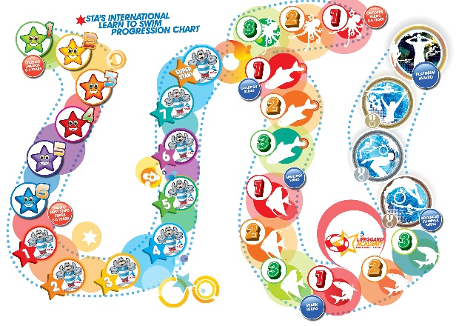
The International Learn to Swim Program aims to provide a complete progressive aquatic pathway for learners of all ages to progress from their first water experience through to becoming safe proficient swimmers, the scheme aims to build on knowledge and skill development at each level and reward achievement through a range of exciting awards and certificates.
Octopus series
An exciting series of 3 progressive awards specifically designed for children aged between 5 to 8 years’ old.


Octopus 1 Learning Outcomes

Swimming teacher or assistant in water is optional. Buoyancy aids may be used.
- Answer 2 water safety questions
- Enter the pool safely, steps, ramp, swivel
- Move through the water confidently in different ways – walk, hop, jump, skip, gallop, march
- Use a woggle to swim front paddle and back paddle for 5 metres
- Push and glide on the front and back
- Attempt a simultaneous circle action with legs while on the back for 2 metres, using a woggle or floats
- Travel under a woggle waterfall, experiencing water over the head
- Return to standing from a star float on the back
- Perform a treading water action with legs using a woggle (sea horses), or floats
- Exit the pool safely and unassisted


Octopus 2 Learning Outcomes

Swimming teacher or assistant in water is optional. Buoyancy aids may be used.
- Answer 2 water safety questions
- Enter the pool safely with a step or jump
- Swim 2 metres of front paddle, and 2 metres of back paddle, unaided
- Use a woggle to kick across pool while blowing bubbles
- Demonstrate front crawl arm action while standing
- Demonstrate back crawl arm action while standing
- Push and glide on the front with face in the water
- Push and glide on the back arms by the side
- Rotate from back float to front float, and return back to a back float, using a woggle
- Submerge under water and retrieve an object

Octopus 3 Learning Outcomes


Swimming teacher or assistant in water is optional. Buoyancy aids may be used.
- Answer 2 water safety questions
- Enter the water with a step or jump entry, turn around and swim back to poolside
- Push and glide into either front crawl or breaststroke for 5 metres
- Push and glide into back crawl, and swim for 5 metres
- Perform a star float on the front or back, and hold for 3 seconds
- Perform dolphin leg kick on the front or back for 2 metres
- Scull head first, using a woggle
- Attempt breaststroke – may use a woggle for support
- Tread water for 10 seconds
- Swim forward for 2 metres and then roll onto back, swim on the back for 2 metres and roll into a standing position (regaining feet)

Goldfish series

This programme is designed to be the next stage for swimmers who have progressed through the Octopus Series. On completion of this series, swimmers will be able to swim 15 metres without any aid as well as perform basic floats.


Goldfish 1 Learning Outcomes

Buoyancy aids may not be used, unless stated. Learners may work towards the 5 metre Distance award.
- Answer 2 water safety questions
- Enter the water with a step or jump entry, tread water for 5 seconds, swim to poolside
- Push and glide, and hold the streamlined position for 5 seconds
- Push and glide, or swim to the bottom of the pool, to retrieve an object
- Swim 5 metres on front, roll over and swim 5 metres on back
- Perform dolphin leg kick on the front or back for 5 metres
- Scull head first for 2 metres
- Scull feet first, using a woggle for support
- Show rhythmical breathing in front crawl for 10 metres, using a woggle or float
- Swim a recognisable breaststroke for 5 metres


Goldfish 2 Learning Outcomes

Buoyancy aids may not be used, unless stated. Learners may work towards the 10 metre Distance award
- Answer 2 water safety questions
- Perform a back float, tuck to a front float and return to a standing position
- Scull head first for 5 metres, and feet first for 3 metres
- Push and glide on the back, tuck, rotate to the front and return to the starting point
- Swim 10 metres of a recognised front stroke, either front crawl or breaststroke. Learner’s first choice
- Swim back crawl for 10 metres
- Swim 5 metres of a recognised front stroke. Learner’s second choice
- Push and glide to the bottom of the pool, tuck, place feet on the bottom and spring up
- Perform a mushroom float and hold for 3 seconds, extend to a front float and return to a standing position
- Enter the water with a step or jump entry, swim 5 metres on the front, then swim to poolside and exit water safely

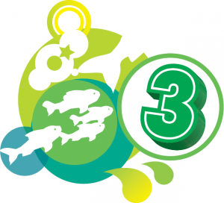
Goldfish 3 Learning Outcomes

Buoyancy aids may not be used, unless stated. Learners may work towards the 15 metre Distance award
- Answer 2 water safety questions
- Perform 2 different types of entries and tread water for 15 seconds each time; performed in shoulder-deep water
- Swim 15 metres of back crawl
- Swim 15 metres of a recognised front stroke, either front crawl or breaststroke
- Swim 10 metres, holding a float under each arm, using lifesaving backstroke leg kick
- Swim 5 metres, dolphin leg kick on front
- Swim 5 metres, dolphin leg kick on back
- Perform a handstand with both hands on the pool floor; performed in chest-deep water
- Perform a horizontal float on the back and hold for 5 seconds, roll on to the front, hold for 5 seconds, roll to the original back float position and hold for 5 seconds
- Submerge, push and glide on the side, roll to a face down position

Angelfish series

Once swimmers have completed the Goldfish Series they can progress to the Angelfish Series. On completion of the 3 progressive awards in this series, swimmers will be capable of swimming 25 metres without aid, perform butterfly stroke as well as mastering sculling techniques and entries to the water.


Angelfish 1 Learning Outcomes

Buoyancy aids may not be used, unless stated.
- Be rescued by a reaching aid
- Perform a straddle entry and tread water for 30 seconds. If the water is too shallow, substitute step entry and support scull for 30 seconds.
- Push and glide into a forward somersault
- Scull head first for 5 metres and feet first for 5 metres
- Swim 15 metres of a recognised front stroke with correct breathing. Learner’s first choice
- Swim 10 metres of front stroke with correct breathing. Learner’s second choice
- Swim 20 metres of back crawl
- Swim 10 metres on the front, using dolphin leg kick, without aids
- Start in a crouch position in the water, spring up before gliding to bottom of pool, then glide to surface
- Swim 5 metres of lifesaving backstroke without aids


Angelfish 2 Learning Outcomes

Buoyancy aids may not be used, unless stated. Learners may work towards the 20 metre Distance award
- Be rescued by catching a buoyant aid
- Perform a straddle entry, tread water for 30 seconds, perform a 360° turn in a vertical position while wearing a T-shirt. If the water is too shallow, substitute step entry and support scull for 30 seconds and a 360° turn in a vertical position while wearing a T-shirt
- Swim 5 metres, perform a forward somersault and continue to swim forward for 5 metres
- Swim 20 metres of a recognised front stroke using a correct touch finish. Learner’s first choice
- Swim 15 metres of a recognised front stroke using a correct touch finish. Learner’s second choice
- Swim 20 metres of back crawl using a correct touch finish
- Swim 5 metres on the back using a double arm action and dolphin leg kick
- Swim 5 metres on the side using a dolphin leg kick
- Start in a crouch position in the water, spring up before gliding to the bottom of the pool, tuck, place both feet on the bottom of the pool and spring up. Perform in chest-deep water
- Swim underwater for 5 metres


Angelfish 3 Learning Outcomes

Buoyancy aids may not be used, unless stated. Learners may work towards the 25 metre Distance award
- Be rescued by catching a rope
- Perform a straddle entry and tread water for 30 seconds while wearing a T-shirt. Remove the T-shirt and climb out unassisted. If the water is too shallow, substitute step entry and support scull
- Perform a head-first and feet-first surface dive. If in shallow water, perform an underwater push and glide to pool floor
- Scull feet first for 10 metres and head first for 10 metres
- Swim 25 metres of back crawl using a correct finish
- Swim 25 metres of a recognised front stroke, incorporating a correct finish. Learner’s first choice
- Swim 20 metres of recognised front stroke, incorporating a correct finish. Learner’s second choice
- Swim 5 metres of butterfly
- Push and glide into a handstand – must be performed in tummy-deep or to chest-deep water
- Perform a sitting dive, depending on the depth of water. If in shallow water, perform underwater push and glide, roll onto back while underwater and surface in a back glide

Shark series

On completion of the Angelfish Series, learners progress to the Shark Series. This series educates learners in basic water rescue and survival techniques as well as starts and turns for each of the strokes. On completion of the series learners will be able to swim 100 metres.
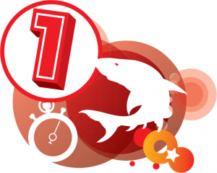

Shark 1 Learning Outcomes

Learners may work towards the 50 metre Distance award
- Perform a shout and signal rescue to a weak swimmer, 5 metres away
- Enter the water with a slide-in entry, swim 10 metres in a T-shirt, tread water for 30 seconds, remove T-shirt, and climb out
- Swim 5 metres of a recognised front stroke, perform a head-first surface dive and swim 5 metres underwater
- Swim 5 metres of a recognised front stroke, perform a feet-first surface dive, tuck, and swim 5 metres underwater
- Swim 50 metres of a recognised front stroke. Learner’s first choice
- Swim 50 metres of back crawl
- Swim 25 metres of a recognised front stroke. Learner’s second choice
- Swim 25 metres of Old English backstroke
- Swim 25 metres of front crawl, demonstrating bilateral breathing
- Perform a kneeling dive, depth of water permitting. If in shallow water, perform underwater push and glide for 5 metres


Shark 2 Learning Outcomes

Learners may work towards the 75 metre Distance award
- Perform a reaching rescue to a casualty up to 2 metres from the side
- Throw a buoyant aid 3 metres to a target point in the pool
- Enter the water with a step-in entry, swim 10 metres of a recognised stroke in a T-shirt and shorts, tread water for 1 minute, swim 5 metres of a recognised stroke, surface dive, swim 3 metres underwater, surface, climb out of the pool unassisted
- Swim 75 metres during which the learners perform 3 recognised strokes with a smooth transition and the correct turns
- Scull head first for 20 metres
- Swim 10 metres of butterfly
- Swim 20 metres of side stroke, wearing a T-shirt and shorts
- Perform a plunge dive, swim width of pool or 7 metres, depth of water permitting. If in shallow water, submerge and push and glide on your side, roll onto the back and return to the surface with dolphin leg kick
- Swim 4 x 1 width of individual medley, incorporating the appropriate transition procedure at the end of each stroke
- Perform a backwards somersault

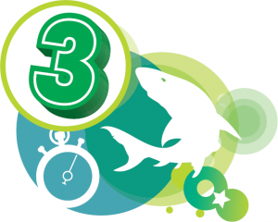
Shark 3 Learning Outcomes

Learners may work towards the 100 metre Distance award
- Throw a rope over 5 metres
- Enter the water with a straddle entry, swim 25 metres in a recognised stroke in a T-shirt and shorts, tread water or scull support for 1 minute, tread water for 1 minute waving one arm, surface dive, swim 5 metres underwater, surface and remove clothing. If in shallow water, substitute straddle jump for step- in or slide-in entry
- Swim 100 metres of a recognised stroke on the front, incorporating the appropriate start, turns, and finish. Learner’s first choice
- Swim 50 metres of a recognised front stroke, incorporating the appropriate start, turns and finish. Learner’s second choice
- Swim 100 metres of back crawl incorporating the appropriate start, turns and finish
- Swim 25 metres of a fourth recognised stroke, not undertaken in the other tests
- Swim 4 x 1 length of individual medley, incorporating the appropriate transition procedure at the end of each stroke
- Perform a competitive start for two separate strokes using two different stances that is legal for the depth of water available
- Swim 50 metres of side stroke or old English backstroke
- Perform a head-first surface dive and pick up a sinkable toy from the bottom of the pool, minimum depth of 1.5 metres

Swimmer Definitions and aims.

Non Swimmers
Non swimmers are those who are not able to swim, they may be of any age. Non-swimmers may have no confidence in water and may be very fearful in a swimming pool environment, especially at first.

The main aim with these learners:
• To gain the confidence to move freely in the water
• Be able to regain the feet and stand up in the water
• To submerge and open the eyes under the water
• To float and achieve mobility in the water as quickly as possible.
Children will acquire these skills by structured play in the water and may achieve them very quickly.

Beginner Swimmers
Beginner swimmers are those who are mobile in the water but who would not be safe out of their depth without buoyancy aids.
Learners who are able to move in the water and have the confidence to submerge need to acquire the aquatic skills to propel themselves through the water in the prone and supine positions using good basic stroke technique which can be improved as confidence, stamina and skills increase. It is important that a streamlined body position and correct limb movements are attempted from an early stage so that time is not wasted correcting mistakes which have been practiced incorrectly.

Beginner swimmers should:
• Be introduced to all four of the major competitive strokes even if butterfly has only been introduced using the leg kick action
• Be attempting correct breathing in the strokes
• Be able to swim a distance of at least ten meters without putting the feet down in both the prone and supine body positions
• Have a sound knowledge of the safety aspects of swimming in a swimming pool and the hazards which may be encountered in open water
• Be able to tread water before being introduced to deep water.

Improving Swimmer
Improver swimmers are those who can swim 15 meters front and back.

Improving swimmers should:
• Be improving their strokes so that good streamlining is apparent and the limb movements are correct for the stroke in front crawl, back crawl and breaststroke.
• Be improving breath control
• Develop the timing of the strokes as competence increases
• Acquire a wide range of aquatic skills such as surface diving, sculling and survival skills
• Be introduced to and perform butterfly over a distance of five meters
• Be increasing the distance that the swimmer can swim continuously without the stroke deteriorating

Advanced Swimmer
These swimmers should be capable of sustaining a good stroke over increasing distances.
Advanced swimmers should:
• Be able to swim front crawl, back crawl and breaststroke competently.
• Have a good knowledge of the laws associated with the strokes including starts, turns and finishes
• Have an increasing knowledge of survival skills and water safety.

SEND Swimming

Children who have an EHCP who are unable to access school curriculum lessons have a 1-1 swimming lesson each week allowing lessons can be adapted to meet their individual needs, and to ensure that continued progression takes place.
The swimming teachers liaise with the class teacher and support staff to plan lessons that meet EHCP targets including Motor skills, self-care, communication and curriculum skills.
This gives the child achievable development goals when they may not be able to meet national curriculum requirements.
These pupils are taught the Rockhopper scheme from the STA through fun, play based lessons and self-discovery.
The Rockhopper series is an exciting programme consisting of 9 awards which introduce learners with disabilities to the joy of water. The series develops water confidence and water skills as well as increasing water safety awareness and knowledge.

Learning Outcomes
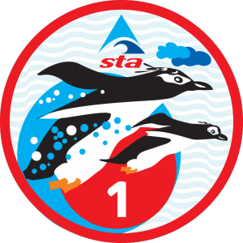
- Enter the water with support
- Respond to water being gently sprinkled over limbs
- Show enjoyment of being in the water
- Lie on the back or front with adult support and be towed around the pool
- Push a floating toy around the pool using any part of the body
- Blow through a straw, whistle or blow a floating toy or watch, listen or feel a toy being blown
- Move limbs in an alternating action

Learning Outcomes
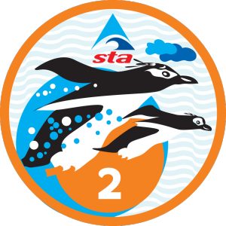
- Enter the water using any means
- Look, listen or feel for splashes, enjoy water being sprinkled over head or body
- Move limbs whilst moving around the pool
- Float on the back or front whilst in a relaxed position
- Watch, listen, feel or mimic blowing action while attempting to place mouth close to the water
- Swing from back to front and return to back or side swing
- Respond to light/sound and/or smell changes
- Exit safely

Learning Outcomes
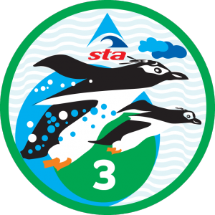
- Show an understanding of being in the pool area
- Enter the water using an appropriate method
- Move through the water on the front or back for 5 metres
- Float with a piece of equipment for 10 seconds or float with a piece of equipment for 10 seconds and return to an upright position
- Roll from back to front and return to the back
- Splash the water using own limbs or equipment or hum with nose in the water for 5 seconds
- Respond to floating toys or move through the water to collect floating toys
- Push a toy around the pool
- Enjoy water being sprinkled over limbs or head or travel through a hoop at the water’s surface
- Move across the pool in an upright position

Learning Outcomes
- Enter the water safely with a jump or show an awareness of entering the pool safely
- Touch a floating toy or perform a jellyfish or mushroom float
- Reach for a toy and return it to poolside
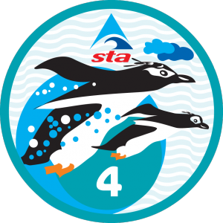
- Move across the pool or swim 5 metres on the front, roll onto the back and float
- Move limbs in response to the actions of an adult or swim 5 metres on the back, stand up or adopt a safe position at poolside
- Use a watering can to sprinkle water
- Blow a toy across the pool or watch/listen to an adult blowing a toy across the pool or pick up a submerged toy from the bottom of the pool

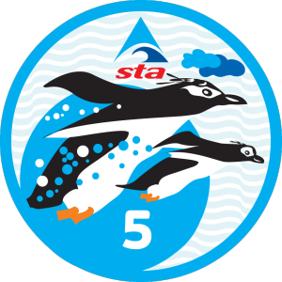
Learning Outcomes
- Enter the water safely or enter the water safely, submerge and swim to the poolside and show a safe support
- Move across the pool to collect a toy and return to poolside or tread water in an upright position for 10 seconds
- Play with a toy or blow bubbles rhythmically while moving forward through the water
- Move through the water under a woggle rainbow on the front or back or swim through a hoop held just below the water’s surface
- Push a toy towards an adult or peer or push and glide on the front
- Float on the back for 10 seconds
- Move through the water using any style for 10 metres
- Exit the pool safely

Learning Outcomes
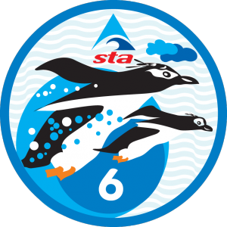
- Move around the pool avoiding floating toys or enter the water safely, using any method, roll onto the back and float for 10 seconds
- Copy the swimming movements of an adult or swim 15 metres using any style
- Move across the pool using arms or swim 5 metres on the front, roll onto the back and swim a further 5 metres
- Jump up and down in the water with support or push and glide through a hoop held below the water’s surface, swim and adapt a safe breathing position
- Look or feel for submerged toys with the face in the water or breathe rhythmically while swimming for 10 metres on the front or back
- Play a movement game that involves splashing and kicking
- Move through a woggle waterfall, having water sprinkled over the head or tread water for 20 seconds

Learning Outcomes
- Swim across the pool on the front using any style for 20 metres
- Swim across the pool on the back using any style for 20 metres
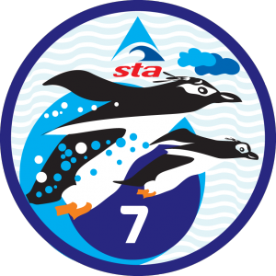
- Jump into the water safely with a partner or recover a submerged toy from chest depth water
- Lift feet off the pool floor, using a woggle or float for 15 seconds
- Blow bubbles into the water or holding the poolside, rail or woggle, submerge completely and blow bubbles
- Perform one of the following:
  - Change body position from back to front or front to back, from a push and glide
  - Propel a floating toy for 2 metres
  - Perform a treading water action with legs using a woggle (sea horses), or floats
  - Kick across the pool with an aid on the front or back

Learning Outcomes
- Answer a pool safety question
- Enter the pool safely from poolside or exhale rhythmically with face submerged 4 times
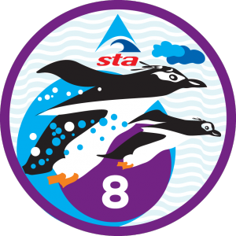
- Swim 5 metres unaided using any style or swim 25 metres unaided using any style
- Push and glide from the poolside on the front
- Perform a star float and the stand up or float in a relaxed manner for 20 seconds
- Perform two of the following:
  - Attempt breathing when swimming on the front
  - Attempt treading water
  - Recover a toy from the bottom of the pool, from a swimming position
  - Swim 10 metres on the front, roll onto the back and swim 10 metres, regain feet or secure a safe position at the poolside
  - Swim 25 metres, collect a floating toy and return to the starting position
  - Rotate on the surface of the water with the body sitting or lying back, for two complete revolutions

Nurture/Sibling swimming
These sessions comprise of fun-based learning with a focus on communication with adults and peers, water safety, and following rules. Sessions are used as an incentive for behaviour with minutes being lost or a reward of bringing a friend as a reward for a spectacular period. Within this time children also learn self-care skills such as dressing, showering, and modesty/respect for other people’s privacy.
There is an understanding of the safety required around the water by all children which will transfer into the outside world when children are faced with open water scenarios.
Within sibling swim sessions, children who do not have the opportunity to go swimming with their family are able to spend some quality time together. Children spend time helping each other learn and building strong family bonds. Children are provided with a swimming kit which they oversee bringing to a session and leaving to be washed at the end providing a sense of independence and belonging within their peer group.

