Year 6 Writing Spine 2026 - 2027
 | Autumn 1 | Autumn 2 | Spring 1 | Spring 2 | Summer 1 | Summer 2
Week 1 | Baseline | 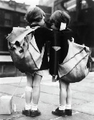 |  | 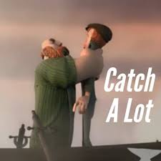 | 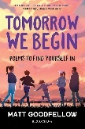 | 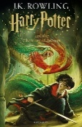
Week 1 | Baseline | T: Balanced Argument  A: Y6 Teachers  P: To inform | T: Formal Letter  A: Mrs Butterworth  P: To inform/persuade | T: Narrative  A: Y4 Pupils  P: To entertain | T: Poetry (Spoken Word)  A: Chosen adult  P: To entertain | T: Advertisement  A: Y6 Pupils  P: To persuade
Week 2 |  |  |  |  | 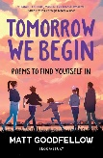
Week 2 | T: Persuasive Speech  A: Peers  P: To persuade | T: Balanced Argument  A: Y6 Teachers  P: To inform | T: Formal Letter  A: Mrs Butterworth  P: To inform/persuade | T: Narrative  A: Y4 Pupils  P: To entertain | T: Poetry (Spoken Word)  A: Chosen adult  P: To entertain | T: Advertisement  A: Y6 Pupils  P: To persuade
Week 3
Week 3 | T: Persuasive Speech  A: Peers  P: To persuade | T: Balanced Argument  A: Y6 Teachers  P: To inform | T: Formal Letter  A: Mrs Butterworth  P: To inform/persuade | T: Narrative  A: Y4 Pupils  P: To entertain | T: Poetry (Spoken Word)  A: Chosen adult  P: To entertain | T: Advertisement  A: Y6 Pupils  P: To persuade
Week 4 |  | 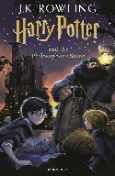 | 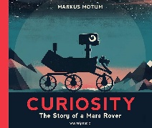 | 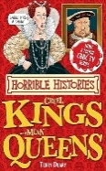 |  | 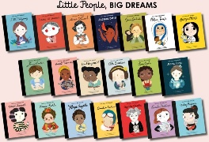
Week 4 | T: Persuasive Speech  A: Peers  P: To persuade | T: Setting Description  A: Parents/Carers  P: To entertain | T: Explanation  A: Mr McFarlane  P: To inform | T: Newspaper Report  A: SLT  P: To inform | T: Non-chronological Report  A: Miss Goodwin  P: To inform | T: Biography  A: Chosen friend  P: To inform
Week 5 | 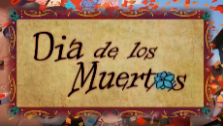 | 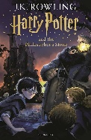 |  | 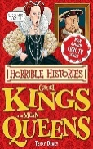
Week 5 | T: Narrative  A: Y5 Pupils  P: To entertain | T: Setting Description  A: Parents/Carers  P: To entertain | T: Explanation  A: Mr McFarlane  P: To inform | T: Newspaper Report  A: SLT  P: To inform | T: Non-chronological Report  A: Miss Goodwin  P: To inform | T: Biography  A: Chosen friend  P: To inform
Week 6
Week 6 | T: Narrative  A: Y5 Pupils  P: To entertain | T: Setting Description  A: Parents/Carers  P: To entertain | T: Explanation  A: Mr McFarlane  P: To inform |  | T: Non-chronological Report  A: Miss Goodwin  P: To inform | T: Biography  A: Chosen friend  P: To inform
Week 7 | Assessment Week (Mock SATs)
Week 7 | Assessment Week (Mock SATs) | T:  A:  P: |  |  | T:  A:  P: | T:  A:  P:
Week 8
Week 8 | T: Narrative  A: Y5 Pupils  P: To entertain

