Year 4 Writing Spine 2026 - 2027
 | Autumn 1 | Autumn 2 | Spring 1 | Spring 2 | Summer 1 | Summer 2
Week 1 | Baseline | Narrative  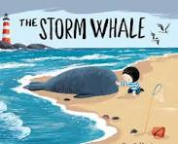 | Narrative  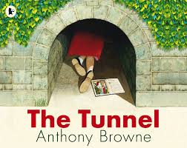 | Explanation Text  How do Tsunamis happen | Explanation Text  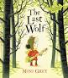 | 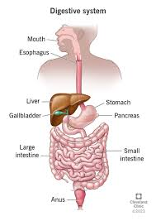  Non Chron
Week 2 | Recap | Narrative | Narrative | Explanation Text  How do Tsunamis happen | Explanation Text | Non Chron
Week 3 | Narrative  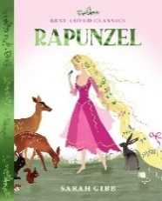 | Narrative | Narrative | Explanation Text  How do Tsunamis happen | Explanation Text | Non Chron
Week 4 | Narrative  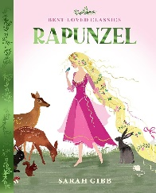 | Description  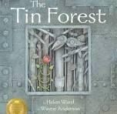 | 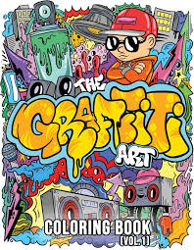  Balanced Argument | Instruction Text | Residential | Letter to new teacher
Week 5 | Narrative | Description | 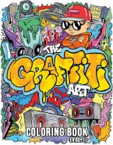  Balanced Argument | Instruction Text | Newspaper report  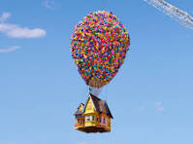 | Letter to new teacher
Week 6 | Description  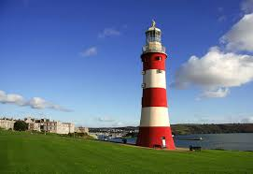 | Christmas poetry |  |  | Newspaper report
Week 7 | Description | Christmas poetry |  |  | Newspaper report
Week 8 | Description  

