Year 2 Writing Spine 2026 - 2027
 | Autumn 1 | Autumn 2 | Spring 1 | Spring 2 | Summer 1 | Summer 2
Week 1 | Baseline | 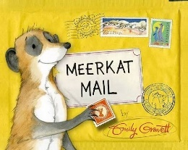 | 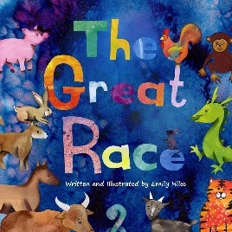 | 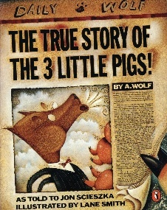 | 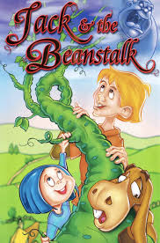 | 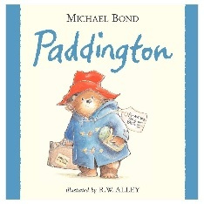
Week 2 | Recap Yr. 1
Week 3 | 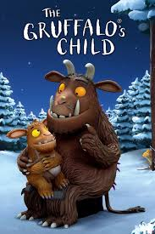
Week 4 |  | 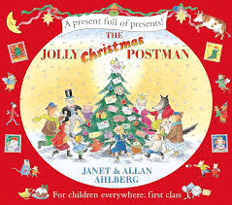 | 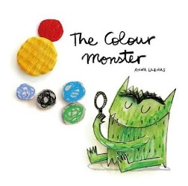 | Instructions – Easter themed | 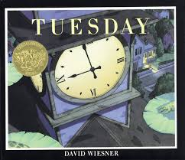 | Trip – Sandal Castle
Week 5 |  |  |  | Instructions – Easter themed |  | Trip – Sandal Castle
Week 6 | 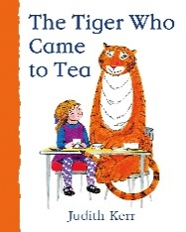 |  | 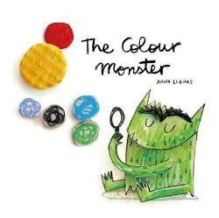 |  |  | Letter to new teacher
Week 7 |  | Recap Skills |  |  | Recap Skills
Week 8

The Gruffalos Child |  | Capital letters, full stops, completed sentences  -ed  -ing | The little mouse went into the dark woods.
The tiger who came for tea | A story about another unexpected visitor arriving for tea | Capital letters, full stops, question marks, exclamation marks | Who is at the door?  It is a Penguin!
Meerkat mail | Non-fiction report about meerkats | Expanded noun phrases, and, because, but | Meerkats are small, furry animals.  They live in dry places and sleep underground.  They watch for danger because eagles may be nearby
Letter to Santa | A letter to Santa explaining why they have been good this year and what they would like. | Because, and  -ed  -ing | I would love a bright red scooter because I enjoy playing outside.  I helped my brother with his work and to tidy up his toys.
The great race | A retelling from one of the animals viewpoints | Expanded noun phrases, when, or | When the race began, I jumped into the cold river.  I chose the ox because the water was deep.
The colour monster | My emotions is a colour - poem | Commas, expanded nouns | I see bright sunshines, golden stars and warm sand.  My happy feeling is a little light inside me.
The true story of the 3 little pigs | Viewpoint of the wolf explaining what really happened | Past progressive ( I was walking)  Contractions | I was walking past the first little pig’s house when I began to sneexe.  I didn’t want to blow it down.
Instructions | Easter instructions | If  Ly  Commas in a list | You will need paper, glue and coloured pencils  Carefully cut out the egg shape.  If the glue is wet, leave it to dry.
Jack and the beanstalk | Alternative version | That (There was a castle that stood above the clouds)  Singular possession (the giant’s castle) | Jack climbed the beanstalk and reached into the clouds.  In the giant’s bedroom, he found a golden harp.  He felt excited but then he heard the giant.
Tuesday | A live news report as the frog flies over town | Present tense  That  Singular possession (the frog’s umberella) | It is Tuesday night and frogs are flying above the town.  One frog lands on a man’s washing line.  A woman says that she can see hundreds of them.
Paddington | Caption writing | Was/were  Exclamation sentences – What a mess Paddington made!  Present progressive (is carrying) | Paddington is carrying our shopping bags.  He Is looking at a jar of marmalade.  What a mess Paddington made!
Sandal castle trip | Recount of the visit | Was/were  Are/our  Exclamation sentence | We went to Sandal Castle with our class.  The walls were old and the view was beautiful.  There was a steep hill!
A letter to our new teacher | Introducing themselves to their new year 3 teacher | Are/our  Questions  exclamation | Dear,  My name is Aisha and I enjoy drawing. Our class is excited about Year 3! What books will we read next year?

