Ordinary Time is a part of the Church year in the Christian faith.
It doesn’t mean “boring” - it means the weeks are counted in order (like Week 1, Week 2, Week 3, and so on).
Ordinary Time is part of the liturgical calendar which is like a church timetable for the whole year. It shows us when to get ready for and celebrate important parts of Jesus’ life, like:
- his birth (Advent and Christmas)
- his death and resurrection (Lent and Easter)
- and the times in between when we learn from him - Ordinary Time
- Ordinary Time happens: After Christmas and after Easter
Ordinary Time is the part of the year when we grow in our faith by learning how to live like Jesus in our everyday lives. During Ordinary Time, people learn about the life and teachings of Jesus Christ - like how he helped others, told stories, and showed love and kindness.
The colour for Ordinary Time is green, which reminds us of growth - growing in faith and becoming better people.
In Ordinary Time, we practise showing our values every day - resilience, creativity, understanding, inclusion and respect - just as Jesus did. This is the time when we think about:
- how Jesus taught people
- how he helped others
- how we can be kind, brave and loving too”

Our Collective Worship themes to include links, where appropriate, to British Values, Social Justice and Global Citizenship.
The British values that Ofsted expects schools to promote are: democracy, the rule of law, individual liberty, and mutual respect and tolerance for those with different faiths and beliefs. Schools have a legal duty to promote British values as part of the Prevent duty and as part of their overall responsibilities to prepare pupils for life in modern Britain.

Autumn Half Term 1  (Ordinary time - liturgical colour Green)  Spirituality - linked to the introduction of Spiritual Sparks in our curriculum there are weekly ‘Spiritual Reflective Moment’ ideas with each weekly theme to allow children time to ‘be still, question and wonder. |  |  |  |  | Focus School Value:  INCLUSION  Additional Links -  British Values Social Justice  Global Citizenship
Date | Theme | Bible Story/Videos | Big Question | Songs | Activity Ideas
Wk 1  w/c  1.9 | Building Strong Futures Together  Spiritual Reflective Moment  Close your eyes if you’d like. Imagine our school like a big building…”  Each of us is like a brick in that building.  Every brick matters. Without you, it wouldn’t be complete.”  “Think about one thing you can do this week to help someone feel they belong…”  Hold that thought quietly…”  Silence | A brand-new year – a fresh start – what is your vision for this year?  We have a vision in school, which is like a big, shared dream for our school and children. Share our school vision with the children (below).  Our vision is for everyone to work together to build strong futures. So, this year, we are building something special together. We are all valuable parts of our school community, and we can help each other grow into the people we are meant to be.  - We all belong – everyone is welcomed and valued  - We are better together – we help each other grow  - We each have something important to offer  - We build strong futures through our choices and actions  - In God’s love, we care for and support one another  We belong, we help each other, and together we can grow into our best selves – in this way we can flourish and live life in all its fullness just as God wanted.  Corinthians 12:12–27 – The Body of Christ: “We are all different, but we all belong together, like parts of one body. Every part is important. Think about your body. You have hands, feet, eyes, and ears. Each part is different, but all the parts work together—and they all belong to the same body! Your eyes help you see, your hands help you do things, your feet help you walk. Even though each part is different, every part is important.  The Bible teaches that people who follow Jesus are like one big body—the “Body of Christ.”  - Everyone has a special role (just like body parts do)  - Everyone is important  - We should help and care for each other  - When we share kindness, we are showing Jesus’ love  Just like the parts of your body work together, we can all work together as a school body to share love, kindness, and help—just like Jesus showed.  At Sandal Castle Primary School we build strong futures together. We celebrate and prepare our inclusive community by providing the education and experiences needed, as the building blocks for foundations for life. We empower everyone to be successful, resilient, and self-aware global citizens. Together, in God’s love, we nurture hearts, minds, and spirit, to equip everyone with wisdom, character and hope, in order to flourish. | How do our choices help build a strong future?  What is your vision for the future? | Feet on the Rock  Pop UK | Our Strong Future Wall  Each child writes and draws on a paper brick a way that they will help our school this year.  Scrapbook display – building our strong future together.  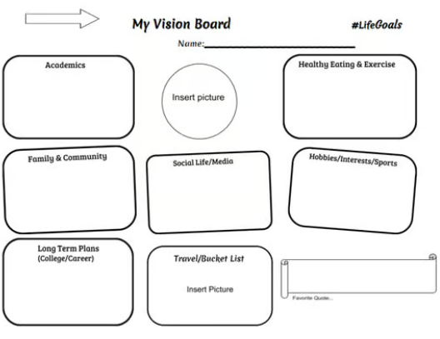  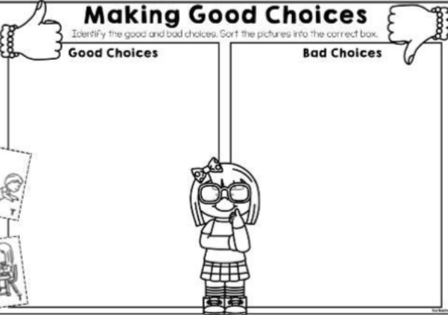
Date | Theme | Bible Story/Videos | Big Question | Song | Activity Ideas
Wk 2  w/c  7.9 | Our School: Where Everyone Belongs -  Inclusion then and now  Spiritual Reflective Moment  Let’s sit quietly…  Long ago, some children were not allowed to go to school. But kind people believed that every child mattered and deserved to learn.  That is why our school was started—a place where everyone could belong.  Pause…  Think about our school today and all the different people in it —different backgrounds, religions, ideas and talents.  Imagine opening a door…Behind it is our school.  Who could you welcome in?  Silence | Our school has an amazing history - it started with people wanting to do something to give opportunity to children who could not go to school at the time.  In 1838 many children from poorer families did not go to school regularly, and some didn’t go at all. Education existed, but it was not free, not compulsory, and not available everywhere. (Children can read the history in the old entrance corridor)  Many poor children worked instead. Poor families often needed their children to earn money or help at home. Some children worked long hours and never went to school.  There were some opportunities, but they were patchy and depended on charity or Church and charity schools like ours which was set up by the Church with money from wealthy local people to help teach poor children for free.  Our school, founded in 1838 was part of a growing movement led by the Church that helped fill a big gap in education and gave poor children a chance they might not otherwise have had.  This was a really important step towards the idea that:  ‘Every child deserves an education’ which only became seen as important after 1870.  Story - A Day at Sandal Castle School – 1838 (CW ambassadors to read)  It was a cold morning, and Thomas pulled his thin coat tightly around him. “Come along now,” his mum said gently. “You mustn’t be late for school.”  Thomas smiled. Not long ago, he hadn’t gone to school at all. He used to help his dad carry heavy bags and run errands. But now, something wonderful had happened. A new school had been set up by the church. Kind people had given money so that children like Thomas could go for free. As he walked through the door, he saw other children like him—some in worn shoes, some barefoot—but all ready to learn.  “Good morning, everyone,” said the teacher kindly. “Today we are learning to read.” Thomas held his book carefully. He was still learning, but each day he got better. At playtime, he turned to his friend Edward. “Imagine if we didn’t have this school,” he said. Edward nodded. “We might still be working instead.”  Thomas looked around the room. It wasn’t grand, but it was full of hope. “I’m glad we’re here,” he whispered, and for the first time, Thomas began to dream about the future—one where he could read, write, and be whatever he wanted to be.  Sandal Castle Primary School began because people believed that every child mattered, not just those who had money. At a time when many poor children could not go to school, kind people gave money so that all children could learn, grow, and have hope for the future. This shows a powerful example of inclusion and social justice—making sure everyone is welcomed, valued, and given the same opportunities. Today, we continue that mission by including everyone in our school community, just as those first founders did, recognising that every child is important and deserves to flourish. | Is it fair if some people get opportunities and others don’t? Why?  How would life be different if only some children were allowed to learn? | Be Kind | 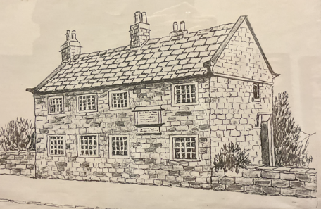  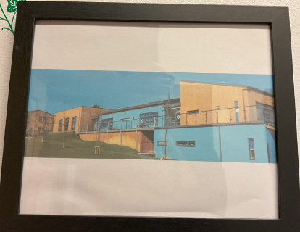    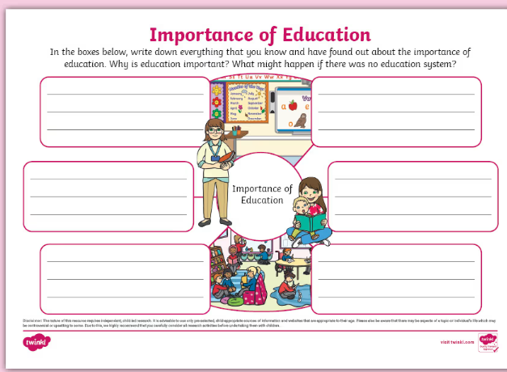
Date | Theme/  Value Links | Bible Stories/Videos | Big Question | Songs | Activity Ideas
Wk 3  w/c 14.9 | Autumn  Inclusion is about the “soil we create”  Spiritual Reflective Moment  Imagine holding a small seed.  Say slowly:  “This tiny seed looks very small… but inside it is something amazing. What small, good thing could you do this week?  A kind word? Helping someone? Saying thank you?  Imagine that small action growing into something big and beautiful.”  Soft music or silence.  How will you grow good things in your heart? | Sowing the Seeds  Key message:  Autumn is just around the corner when farmers will gather the harvest. It is a time when we get to see and enjoy the results of what has been planted. The Bible teaches us that what we plant (kindness, love, generosity) is what we grow.  Bible Link: The Parable of the Sower (Matthew 13:1–9)  Jesus told a story about a farmer who planted seeds.  - Some seeds fell on a hard path → they couldn’t grow  - Some fell on rocky ground → they started to grow but didn’t last  - Some fell among weeds → they got crowded out  - But some seeds fell on good soil → they grew into strong plants and produced lots of food!  Jesus explained that the seeds are like good things (love, compassion, honesty, God’s word), and our hearts are like the soil. If we look after the “seeds” we’re given, wonderful things can grow!  Parable of the Sower (Animation)  https://www.youtube.com/watch?v=guDeSYcwRYg  In Autumn, the crops the farmers collect will depend on the seeds they planted months before and how much care they gave them. In the same way, our lives are like a garden. When we plant seeds of kindness, hard work, and good choices, these grow into something positive over time. But if we don’t put in effort or care, very little will grow.  The phrase “you reap what you sow” reminds us that our actions and effort shape our results—we get back what we give. Just like a seed needs time, care, and patience to grow, the things we do each day—our learning, friendships, and choices—slowly grow into the person we become.  So, this autumn, let’s think carefully about the seeds we are planting. What are we choosing to grow? Are we planting seeds that will help us to build strong futures?  Autumn reminds us:  Things don’t grow overnight - You get out what you put in - small actions can grow into something big!  When we plant good seeds, something wonderful always grows!  In our school, we are all gardeners.  We help create the kind of inclusive, safe place where people can grow. | What seeds are you planting in your life?  (e.g. kindness, honesty, helping others)  How can we make sure our hearts are like good soil so good things can grow? | Harvest Songs | Seed to Tree” Drawing  Draw:  - A seed underground  - Roots growing  - A large tree above  Inside the tree write or draw good things you want to “grow”.  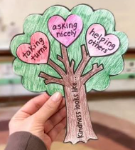  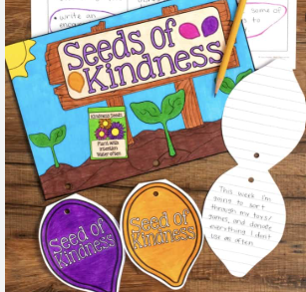
Date | Theme | Bible Story/Videos | Big Question | Songs | Activity Ideas
Wk 4  W/c 21.9 | Who am I becoming?  Developing Together  Spiritual Reflective Moment  Each day, we are growing into the person we are becoming.  Pause…  What kind of choices am I making?  Am I choosing kindness, honesty, and courage?  Pause…  Think about your character…  How do I treat others when no one is watching?  Am I the same kind person inside and out?  Pause…  Think quietly about how every choice you make helps shape the person you will become.  Silence | At the beginning of the year, we talked about ‘Our school vision’ (show vision from Week 1)  Let’s look at this line – Together, in God’s love, we nurture hearts, mind and spirit to equip everyone with Wisdom, Character and Hope, in order to flourish.  Why do we need wisdom, character and hope for a good life?  At Sandal Castle Primary we believe we need wisdom, character and hope because life is tricky and complicated, and flourishing is about more than doing well in your lessons - it’s about being equipped to live well, make good choices, and face challenges with confidence and purpose.  Developing Wisdom – allows us to make good choices  - Wisdom helps you understand right from wrong and act with understanding.  - It enables you to navigate relationships, challenges and responsibilities.  - Having wisdom allows you to use what you learn in a way that benefits yourself and others.  Without wisdom, knowledge alone isn’t enough – we all need to know how to use what we learn to live well.  Developing Character – to be who we are called to be  - Your character shapes how you treat others and respond to difficulties.  - It means having values like kindness, resilience, honesty and responsibility.  - To help develop good character at school we learn about the examples of Jesus, that help us learn to live with integrity and compassion.  What does integrity mean? Why is it an important characteristic to have?  Having a strong character helps us to build positive relationships, help make our communities and world better, and keep going when life is hard.  Hope – so we can face the future with confidence  - Hope lets us believe our lives have purpose and possibility.  - It helps us stay positive and resilient, even when times are hard or challenging.  - Christians believe, hope is not just optimism—it is knowing that through God’s love they are valued and never alone.  Without hope, we may struggle to see beyond difficulties. Hope enables us to persevere, dream, and flourish.  At school we believe children need wisdom, character and hope because these qualities equip you not just for school, but for life. Wisdom helps you make good decisions, character shapes who you are in relationships with others, and hope gives you the confidence to face the future. | What are you hopeful for in your life?  How do you know if something is the right choice? | A Hard Road to Travel |     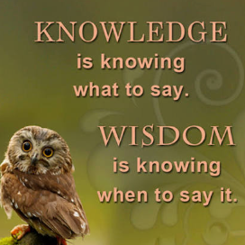
Date | Theme | Bible Story/Videos | Big Question | Songs | Activity Ideas
Wk 5  w/c  28.9 | Harvest Around the World  Spiritual Reflective Moment  Invite silence:  “Think about something you are thankful for…  It could be food, a person, or even nature.”  Silence  “Now think about someone else in the world.  Do they have enough food?  What could we do to help others share our ‘harvest’?”  Quiet music or silence  Inclusion and Social Justice  Everyone should have what they need | Harvest is celebrated all over the world in different ways – showing how people, cultures and religions are connected through the earth, food and community.  Harvest means gathering crops like fruit, vegetables or grains. People all around the world celebrate harvest when food is ready to gather in.  Christian Harvest  - Churches are decorated with food and people give thanks for bring donations.  - Food is often shared with those in need in the community  Christians celebrate Harvest Festival by saying a big "Thank you" to God for giving them the sun, rain, and soil needed to make food grow. Because God gives so many good gifts, Christians believe it is important to share with people who don't have enough. Many churches and schools collect tinned food and fresh groceries. These are used to make food parcels for people in the local community who are going through a tough time.  Hindu Harvest – Pongal (India) – They pay their respect for nature and all living things and give thanks.  - A special rice dish is cooked and shared.  - People thank the sun, earth and animals like cows for helping crops grow.  Sikh Harvest – Vaisakhi – People celebrate the food they have harvested and share food.  - Celebrates the wheat harvest.  - It is a joyful time with music, dancing and community mealss  Harvest Around the World  https://www.youtube.com/watch?v=n1DPPcBzG6M  Harvest celebrations look different, but they all show similar values:  - Community  - Joy  - Respect for the earth  - Sharing with others  - Hope for the future  Bible Link Galatians 6:9 “Let us not become tired of doing good… at the right time we will reap a harvest.”  This means - What we do grows, like seeds. Kindness, love and care can grow into something good,  Or as we learned a couple of weeks ago ‘you reap what you sow’. Even if harvest looks different around the world, people believe that what we give, we grow. | What do all harvest festivals have in common?  How are we connected to people around the world through food? | Harvest Songs for Church | .  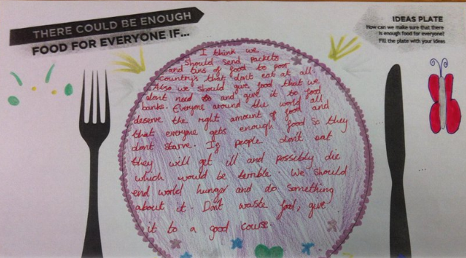  Seeds We Can Plant – Each child has a paper seed -  - Children write/draw:  - Kindness 🌼  - Sharing 🍎  - Helping others  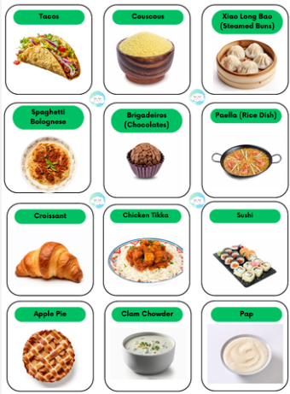  Label food from around the world we are thankful for on a world map
Date | Theme | Bible Story/Videos | Big Question | Songs | Activity Ideas
Week 6  W/c  5.10 | Harvest Church Visits  Growing like Jesus  Spiritual Reflective Moment  Let’s be still for a moment… you might like to close your eyes.”  Think about your heart… how can you show kindness this week?”  “Think about your mind… what will you try your best at?”  “Think about your spirit… when will you take a quiet moment to think or be thankful?”  Silence | What does our vision mean? - Nurturing heart, mind and spirit  What does nurture mean? - Nurture means looking after people, so they feel safe, loved and able to grow into their best selves.  In our school we nurture –  Minds – In our school, we help to nurture children’s minds so they can grow and flourish. We don’t just learn in classrooms—we learn in the pool when we swim, in the forest when we explore, and in quiet spiritual moments when we stop and think. We also grow through clubs like choir, sports, sewing and swim squad, where we discover new talents and work together. All of these experiences are like seeds that help our minds grow strong, curious and kind, so we can become the best version of ourselves.  Heart - In our school, we also nurture children’s hearts so they can grow into kind, caring and confident people. Through PSHE lessons, the One Life Programme and learning about relationships, we understand our feelings and how to treat others well. We take time for spiritual moments to pause and reflect, and we know there is always support through things like worry boxes and wellbeing ambassadors. All of these help our hearts grow strong, helping us to feel safe, valued and ready to care for ourselves and each other  Spirit - planned opportunities for: reflection in our lessons such as marvelling at a volcano erupting or the sound of a full orchestra. We stop and appreciate moments of spontaneous awe and wonder such as storms and rainbows. We ask and reflect on big questions and think about who we are in the world, our relationship with others and about God.  The Three Little Seeds  Once upon a time, three tiny seeds lay in the same garden. The first seed said, “I want to grow strong and clever,” and its roots stretched deep into the soil. It listened, learned, and its leaves grew wide and full. This seed grew into a plant with a strong mind.  The second seed said, “I want to be kind and help others,” and it opened its leaves to give shade to smaller plants nearby. It shared sunlight and space. This seed grew into a plant with a big, caring heart.  The third seed said, “I want to understand the world and find quiet and wonder,” so it reached up gently towards the sun and swayed in the breeze, noticing the sky, the rain and the seasons. This seed grew with a peaceful spirit.  As time passed, the three plants realised something special. The strongest plant wasn’t just the tallest…The happiest plant wasn’t just the kindest…The wisest plant wasn’t just the quietest…  The most beautiful plant was the one that grew all three: a strong mind, a kind heart, and a peaceful spirit. And together, their garden became a place where everything could grow and belong.  At Sandal Castle, we nurture hearts, minds and spirit so that together we can build strong futures and flourish in God’s love.” | How do we use our minds well?  What is our spirit, and how do we care for it? | Bring it All to Me | Heart, Mind, Spirit” circles  Give children three circles (or draw three areas):  - ❤️ Heart: write/draw how I will be kind  - 🧠 Mind: write/draw how I will learn or try hard  - 🌿 Spirit: write/draw how I will be calm, thankful, or reflective  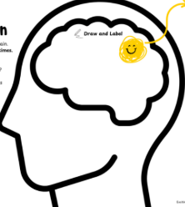  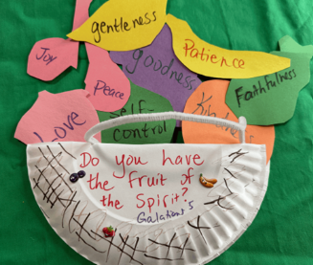  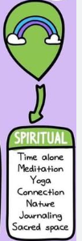

Date | Theme | Bible Story/Videos | Big Question | Songs | Activity Ideas
Week 7  W/c 12.10 | Courageous Advocacy: Making a Difference  Spiritual Reflective Moment  Let’s be still… you might like to close your eyes.”  “Think of a time when something felt unfair…”  “How did that feel?”  “Now think of one way you could help someone this week…”  “A kind word… a brave choice… a helping action…”  Silence | What is a courageous advocate?  - A courageous advocate is someone who stands up for what is right  - We can be agents of change by helping make the world better  - Even small actions can make a big difference  - We use our voices to help others who may not be heard  - In God’s love, we are called to act with justice, courage and compassion  We can be brave, speak up, and help make things better for others.  Bible Link Proverbs 31:8 - “Speak up for those who cannot speak for themselves.”  God wants us to be brave and speak up when something is unfair, especially for people who don’t have a voice or need help.  A courageous advocate is someone who is brave and speaks up when things are not fair.  They help others and try to make the world a fair place for everyone.  This is called social justice  A courageous advocate works to create social justice by  - standing up for fairness  - helping people who are treated unfairly  - trying to make the world a better and more equal place  The Story of Marcus Rashford  Marcus Rashford is a famous footballer in England. When he was younger, his family didn’t always have enough money for food. When he grew up, Marcus noticed something unfair: some children weren’t getting enough to eat, especially in the school holidays So he decided to do something brave. Even though it was a big challenge, Marcus: spoke up to the government, asked them to help children get free school meals and kept going, even when it was difficult  Because of his courage lots of children got food when they needed it.  Our school vision (our dream for everyone) explains we nurture hearts, minds and spirit so that we can grow into people with strength, character and hope—people who are brave enough to stand up for others and help build strong futures together.  Children interview Marcus Rashford  https://www.youtube.com/watch?v=XP1i967ImFc | What does it mean to stand up for what is right?  How can we be agents of change in our school? | Lift up Your Voice | Agents of Change  Give children a speech bubble  - Write/draw:  - “I will help by…”  - “I can make a difference by…”  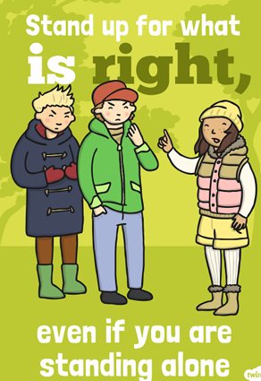  Create a Poster  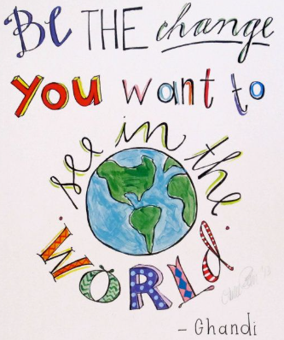

Date | Theme | Bible Story/Videos | Big Question | Songs | Activity Ideas
Week 8  W/c 19.10 | Be a Box Breaker -  breaking labels and including others.  Spiritual Reflective Moment  Close your eyes or sit quietly:  Think of a time when you felt left out or judged. How did it make you feel?  Pause  Now think of a time you included someone or were included.  Is there one small way you could help someone feel they belong?  Silence  British Value/  Mutual Respect  Tolerance of those with different faiths and beliefs. | Sometimes we put people into “boxes” or labels (e.g. “they’re different”, “they’re not like me”).  Jesus shows us that everyone matters, and we can choose to include others.  For example - “They’re not in my friendship group”, “They’re only into football”, “They like quiet things – they’re boring”, “They’re too slow”, “They’re naughty”, “They’re different to me”  A label is when we make a quick judgement about someone without really knowing them. We assume we know everything about someone when we don’t. People are more than just one behaviour or moment.  A label is when we make a quick decision about someone and put them in a ‘box’. But people are not boxes—everyone has lots of different parts to them, and we don’t always see them straight away. People are much bigger and more special than any label.  Hold a small box and say:  - ‘Can a whole person fit in here?’  - ‘No — people are too interesting, too unique!’  Labels can make people feel stuck, judged, left out and lonely.  Zacchaeus  https://www.youtube.com/watch?v=5BjtbJFz2ug  Bible Story: Zacchaeus the Tax Collector  - Zacchaeus was a tax collector – people didn’t like him and called him bad names.  - He felt left out and climbed a tree just to see Jesus.  - Jesus stopped, spoke to him kindly, and chose to spend time with him.  - This shocked others—but it showed that everyone is worth love and belonging.  Jesus didn’t see a label—he saw a person.  Diversity and Inclusion  https://www.youtube.com/watch?v=0vEl7xjWbxs  Social Justice  Social justice reminds us that every person is special to God and deserves to be treated with dignity and respect. We do not judge people by labels; we look for their gifts, potential and worth. | What “labels” do people sometimes use for others?  Do we ever make quick decisions about people without really knowing them? | This is Me |   Inside the body – what do people maybe not know about you.  Outside – what people do know about you.    Label  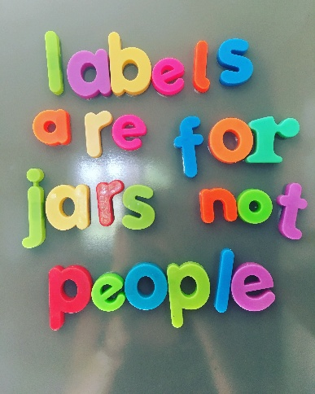  Label Jars not People – put the labels we shouldn’t give people in the jar.

