

Building Strong Futures Together
Spirituality Policy
At Sandal Castle Primary, we recognise that spirituality is hard to define. It is a deeply personal experience that is often felt rather than explained, and it can look different for each individual. Spirituality isn’t the same as religion - you can be spiritual even if you don’t follow a particular faith.
We understand and define spirituality as ‘the spark that connects us to ourselves, to others, to the world, and to God.’ It is expressed in curiosity, imagination, reflection, compassion, and the search for meaning. This quote summarises our belief in what spirituality means for our children -
Spirituality is delighting in all things, being absorbed into the present moment, not too attached to self, and eager to explore boundaries of ‘beyond’ and ‘other’, searching for meaning, discovering purpose, open to more. (Rebecca Nye).
We recognise that spirituality is not fixed. It can grow and change throughout a person’s life as they encounter new experiences and gain new perspectives. We believe that spirituality is at the heart of what it means to be fully human. Rooted in our Christian foundation, we enable curiosity and nurture an environment where every child can encounter awe and wonder, reflect on life’s big questions, and grow in their sense of identity, purpose, and belonging. In partnership with families, our parish and the wider community, we aim to cultivate a spirituality that sustains children throughout their lives, equipping them to live with faith, integrity, and love in a diverse world.

Other
People

Myself

ME

The World

‘God’

(Beyond)

(Beauty)

What do we aim to achieve for the children?
- The children become increasingly aware of the concept of self and reflect upon the relationship they have with themselves as a unique individual.
- The children become increasingly aware of the concept of others. They learn to think about other people’s feelings. They become more kind, caring, and thoughtful about how they treat others. They start to understand how their own values and choices can affect their friendships and relationships.
- Children notice and enjoy the world around them - like nature, animals, buildings, music, art, and how things are made. They begin to explore and understand both the real world and the creative things people imagine and create.
- The children become increasingly aware of the concept of the beyond - a growing relationship with the transcendental (something that goes beyond what we can see, touch, or fully understand). They explore really big ideas and experiences beyond the everyday - like love, beauty, or the feeling that there’s something greater than ourselves. The children search for meaning in their very existence and their place in the greater scheme of things.
- Children develop knowledge and understanding of the school’s core Christian values and the Biblical teaching that underpins them.
- They understand the value of difference and diversity through involvement with others.
- To encourage a love of curiosity, creativity and imagination and support the children to develop the ability to reflect upon experiences of awe, compassion and beauty.

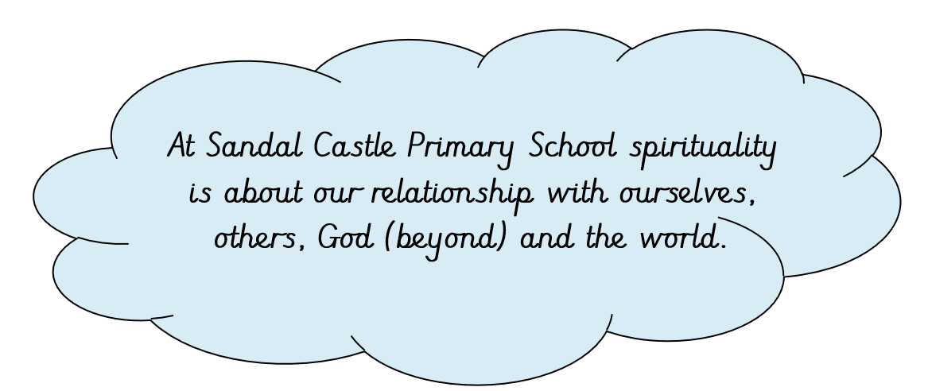

We give children the opportunities to:
- Experience a love of learning.
- Express personal beliefs and compare views with others, sharing feelings and opinions through discussions and stories.
- Read, explore and reflect on extracts from The Bible.
- Reflect upon the world around them and show a sense of awe and wonder towards aspects of the natural world.
- Ask and answer ‘big questions’ throughout the curriculum.
- Express mindfulness and develop their mental, physical and social fitness through our PSHE scheme ‘One Life’.
- Develop relationships with others, recognising them as developing a sense of community.
- Explore values and beliefs, including religious beliefs, and the way in which they affect people’s lives
- Participate in drama, singing and dance through collective worship, productions, after-school clubs and workshops.
- Learn from inspirational, expert visitors such as sportspeople, musicians and authors who enhance and extend curriculum learning.
- Engage in class visits in and around the local community and further afield.
- Celebrate and reward individual achievement regularly: Star of the Week, Star Reader, Star Mathematician, Star Linguist, Star Writer, Head Teacher and sports awards.
- Give service to others as School Councillors, Junior Leadership Team, Collective Worship Ambassadors, Eco Councillors and Courageous Advocates.
- Support charities, good causes and the local/school community by working together to raise money through PTA events, children’s summer fayre etc.
- Physically represent our School and Christian Values.

How do we embed spirituality throughout our curriculum?
Moments of awe and wonder are not always immediately recognised by adults or children, and they are often experienced fleetingly. Without time to pause and reflect, feelings and questions arising from these moments may be overlooked. Providing opportunities for reflection helps children notice how they feel, consider what has inspired them, and develop their spiritual awareness.
At our school, we recognise and value spontaneous moments of awe and wonder that occur naturally, such as changes in the weather or striking natural phenomena, and we give children time to pause and reflect on these experiences. In addition, we intentionally plan opportunities for spiritual reflection within our curriculum each half term, carefully embedding moments that inspire awe and curiosity, such as exploring the power of erupting volcanoes in Geography or experiencing the richness of a full orchestra in Music. These are known as our ‘Spiritual Sparks’. In addition, our children are encouraged to seek out around the school environment our regular ‘Spiritual Sparkler’ - questions that provoke wonder and allow children to reflect on their own personal responses.
Throughout our curriculum we continually recognise and exploit opportunities for spiritual reflection and response.
English
- Empathy with authors and the characters in stories and plays
- The appreciation of the beauty in language
- Emotions and sentiments in writing and speech
- Heroes and heroines in literature
- Imagining oneself as someone else
- Escaping into other worlds through literature
- The element of wonder in literature

Maths
- Infinity and nothing
- Pattern and order
- Appreciating the beauty of shape and space
- Perseverance and problem-solving which builds resilience and growth mindset
- Truth, certainty and likelihood
- The universality of mathematics over time and space
- The wonder of numbers and equations

Science
- Wonder as the basis of science
- Questions of beginning, creation and evolution
- Birth, life, death and renewal
- The universe and beyond
- Discovering the limits of experimentation
- Regularity and order in science
- Beliefs in science and the faith of scientists
- The impact of scientific achievements
- Nature and the world
- Focus on discovery and investigation during themed Science Week

Geography
- Wonder at the diversity of environments and people
- Land formation
- Questions about the care of the environment
- World (economic) development
- Understanding global issues
- Exploring diverse environments and cultures
- The beliefs behind particular causes and campaigns
- Fostering a sense of wonder and connection with the world

History
- Being part of history
- Handling artefacts and where do they come from
- Influential events and people
- The commitment and contribution of significant people in history
- The nature and importance of invention and exploration
- Empathy with people from other times in history
- Taking time to think about how people lived in the past and what they experienced

Creative Arts (Art and Design, Music, Drama and Dance)
- The work of creative artists from a variety of times and places
- Beauty, truth and goodness
- Expressing, interpreting and exploring deep feelings
- The effects of the arts on emotions and senses (How does the piece of art/music make you feel? What emotions do you feel when you see that image/hear that music?)
- Creating music as individuals, as a class and as a school - singing, recorders, percussion, strings, drums, guitar and piano
- Drama and self-expression - EYFS Nativity, KS2 performances, class assemblies and key stage worship
- Creation and display of art works throughout the school demonstrating different techniques and materials
- Exploring how people use music to connect to something bigger than themselves.
- Appreciating music as a bridge to meaning, reflection, and togetherness.
- Skill in creation and performance
- Personal response and preference

DT
- Discovering and looking deeper at how something works
- Appreciating genius
- Beauty in design
- Reflection of design choices
- Perseverance to solve problems
- Personal achievement and reflection on the product
- Appreciation of food
- Learning from others and sharing ideas
- Studying world creations and inventions

Computing
- The wonder of worldwide instant communication
- The speed of the growth of knowledge
- The accessibility of knowledge and contact with other people worldwide
- Reflection of technologies impact
- Exploring ethical considerations

PSHE
- Relationships with others, feelings and attitudes, keeping safe
- Ideas of honesty and sensitivity needed for gentle reflection
- Work out personal relationships in unusual and challenging situations
- Recognising moments of change and of personal development
- Engage in activities that promote courageous advocacy
- Understanding our own emotions and how to manage them

Collective Worship
- Consistent, weekly pattern of collective worship - music, values, social and global themes, British Values, clergy-led, sharing and class-led
- Prayer and Reflection in Key Stage collective worship and in the classroom
- Reflecting on our school Christian values
- Marking and exploring the key points of the church year participating in services at St Helen’s Church - Harvest, Christmas, Easter
- Recognising festivals with significance to our school community including Eid, Remembrance Day, World Book Day, leavers Week
- Prayer and reflection areas, peaceful indoor and outdoor spaces offering solitude and simplicity
- Spiritual environment - candles, music, prayer, silence, reflective spaces

Religious Education
- Learning about the beliefs, symbols and traditions of Christianity and other religions
- Visiting places of worship including St Helen’s Church and the local Mosque
- explore mystery, creation, and the universe
- explore experiences that can’t always be explained logically, encouraging curiosity and reverence
- By studying religious practices (festivals, rituals, prayers), children reflect on what gives people a sense of belonging
- Comparisons of their own families, communities, or traditions, fostering self-awareness and respect.
- Learning about diverse worldviews helping to develop tolerance, compassion, and appreciation for others.
- Hearing stories of faith, courage, or forgiveness enables children to reflect on virtues that can inspire their own lives.
Outdoor Learning
The children visit our natural environment in the school grounds and surrounding area to experience the wonders of nature during the changing seasons. This includes Forest School, the outdoor ‘Spiritual Reflection Garden’ and Gardening Club. Reflective Areas invite adults and children alike to reflect on the day and themes from collective worship. Our OPAL (Outdoor Play and Learning) approach supports children's spiritual development through child-led outdoor play - giving them greater freedom, time, and opportunity to explore, wonder, and connect with the world around them at break and lunchtime.

Organisation
The spiritual growth of pupils is not only dependent on learning in Collective Worship, Religious Education or our One Life lessons. We support the whole school community to share this responsibility and to develop the shared language of spirituality. We share with parents, whenever possible, the focus of our spiritual development through newsletters, social media, displays and our website inviting them to engage with the children in a ‘dinner debate - sparking spirituality’ with examples of life’s big questions. Opportunities are available for all to develop spiritually inspired by our vision and lived out through our Christian values.

Mrs Caroline Butterworth and Mrs Rachel Wolff are responsible for supporting and leading spiritual development in our school, including monitoring opportunities for spiritual growth in collective worship, the whole curriculum (including RE) and the general ethos throughout the daily life of the school.

