
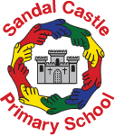
We are delighted to share our Outdoor Play and Learning (OPAL) program, which will be launched shortly after the Easter holidays! Please click onto this link for more information: https://outdoorplayandlearning.org.uk/
Building Strong Futures Together

Our OPAL launch!

(Outdoor Play and Learning)

Why change our current lunchtime provision?

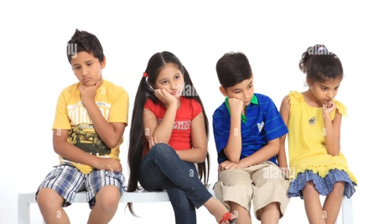
We have spoken to our School Council representatives and lots of our parents who feel that our current lunchtime model isn’t the best that it can be. In the wet months we struggle with 630 children on our small tarmacked area which causes accidents and poor behaviour choices through boredom and lack of space.

Introducing OPAL:

OPAL is a nationally recognized program of improving outdoor play- particularly over the most unstructured parts of the school playtimes and lunchtimes. Our children are encouraged to use all of the outdoor spaces (including the field in the winter), to be active, have fun and explore!

What kinds of things will our children be doing?
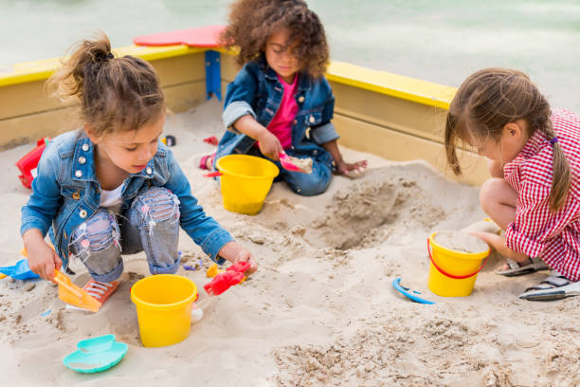
- Sandpit
- Stage for dancing/acting/performing
- Digging area
- Tree swings and rope slides
- Football pitch
- Scooter area
- Gymnastic bars
- Plus more coming (TBC)
Every week, our children will be nominated to receive certificates and the very prestigious award; The Golden Wellie!
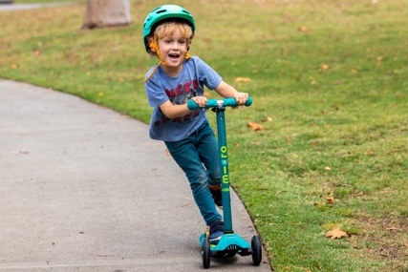
Scooters
We will be creating a rota for scooters, to encourage our children to bring theirs in to play on, on certain days. Watch this space…

How will our children learn about OPAL?
We will be holding regular OPAL assemblies to share information such as safe play, and to share child friendly risk assessments as necessary.

Is there any element of risk?
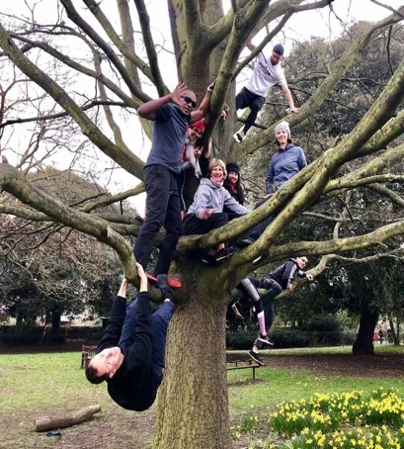
Our staff have all received training in the OPAL philosophy. During this training we have been trained in the risk/benefit model. Our children will receive regular assemblies to train them in how to enjoy safe risk.
As our children become more practiced at play, they will be carefully taught to undertake more riskier play (such as tree climbing). Risk assessments will be completed, and you will be informed, as we get to this point!

How will I be kept informed?

After the Easter holidays, we will be including an OPAL box as a standing item on our weekly newsletter. This will inform you of our weekly certificate winners, plus any OPAL updates or requests. We will often be needing some donations or support from local companies, so please keep an eye out for this!

What about clothing?

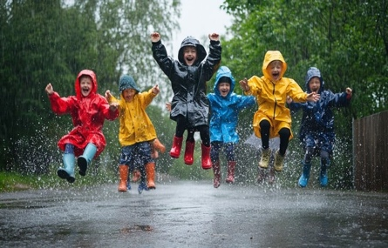
Our children will be encouraged to use our field- all year round. This does mean that during the winter months we will be encouraging or children to bring wellies to school and waterproof clothing. Our children will be encouraged to change their footwear and put on their waterproof clothing during the cold and wet months.

What about Children with Additional Needs?
Our staff will support children who have additional needs to be able to access our OPAL program. Reasonable adjustments will be made to support these children, including 1:1 adult support where appropriate.

