

Sandal Castle (V.A.) Community Primary School Handwriting Policy 2023

Sandal Castle (V.A.) Community Primary School

Handwriting Policy

Reviewed by Senior  Leadership Team | Reviewed by  Teaching and  Learning Committee | Ratified by  Governing Body | Planned date  of review

Print Name Signature Date

On behalf of
Headteacher
On behalf of the
Governing Body

Mrs C Butterworth [signed in meeting]

[signed in meeting]

Page 1 of 9

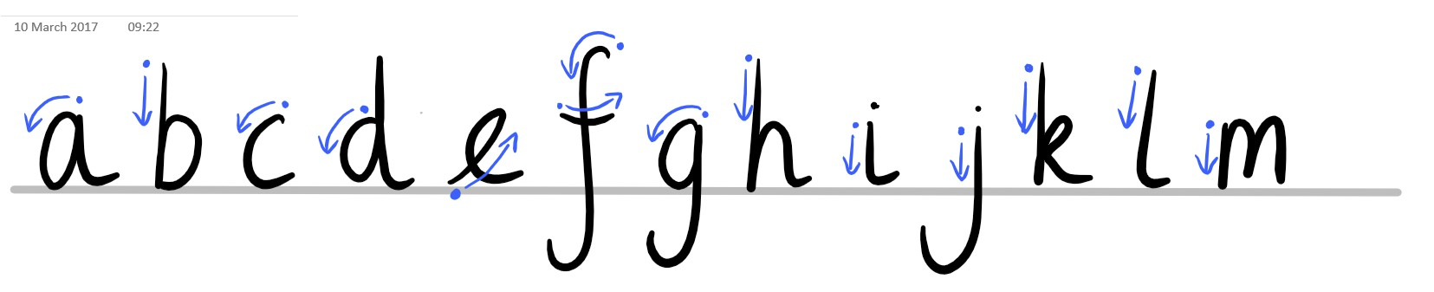
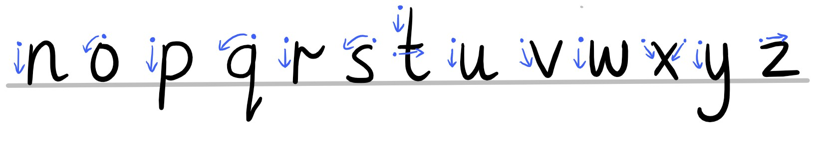
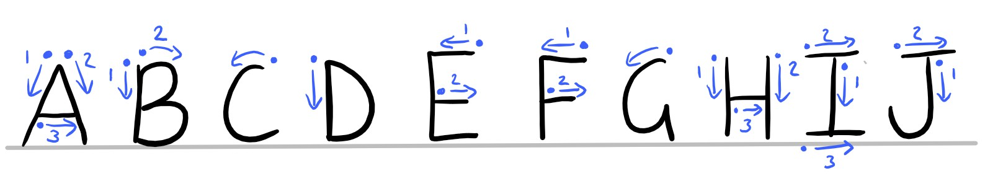
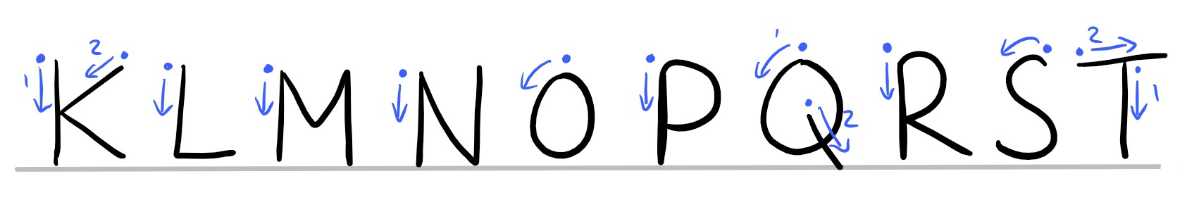
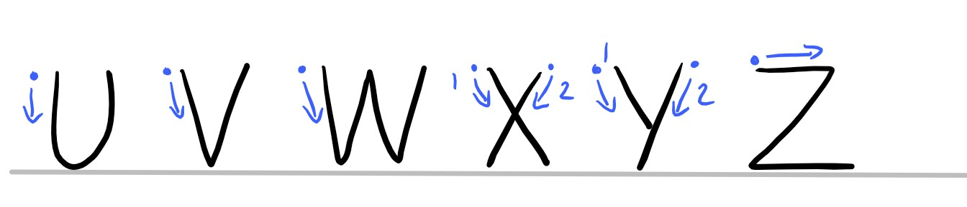
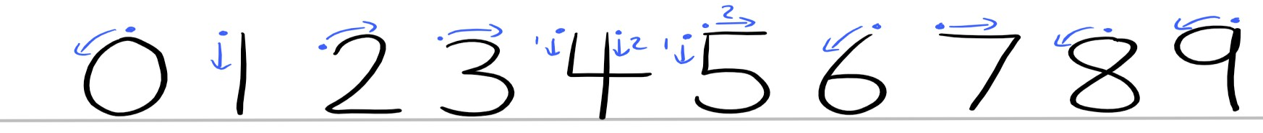
Sandal Castle (V.A.) Community Primary School Handwriting Policy 2023

1. Introduction
1.1 "It is our policy that joined handwriting be taught as a means of written communication as soon as children are able to form individual letters correctly. From this, children are encouraged to develop a legible, free-flowing script (handwriting style) of which they are suitably proud."

Our aim is to provide children with a fluent, neat, legible handwriting style for all their work.

2. Script

2.1 The script used at Sandal Castle is:

Page 2 of 9

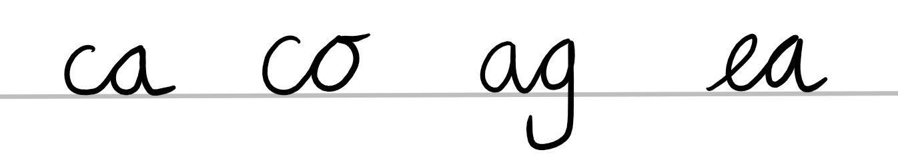
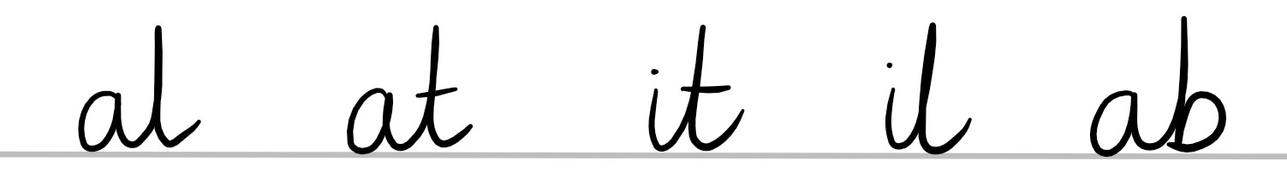
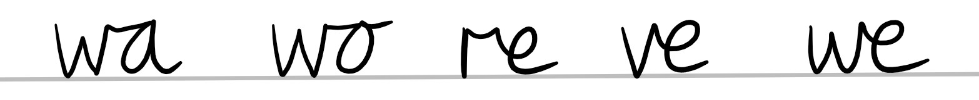
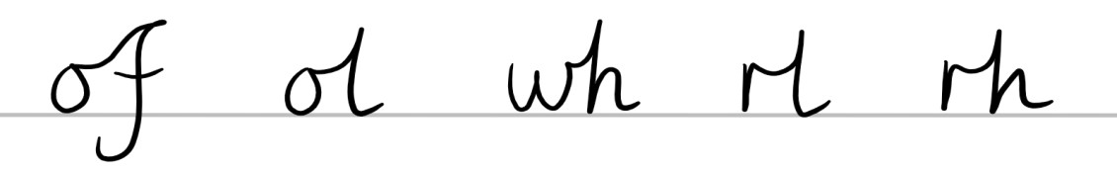
Sandal Castle (V.A.) Community Primary School Handwriting Policy 2023

2.2 Please note the following:

• Left-handed children generally cross the 'f', 't' and 'x' from right to left
• All small letters except 'd' and 'e' start at the top and not at the bottom
• All letters join except capital letters and the break letters b, p, g, j, q, x, y and z
• Once children can write in a fluent style, joining their letters correctly, they can be introduced
to loops and joins from all the letters and encouraged to begin to develop their own individual
but consistent style of writing.

3. Joining
3.1 Capital letters are not joined to other letters. The following letters do not have letters joined from them: b, p, g, j, q, y, x and z.
3.2 Children are taught to take their pencil to the top of the next letter as soon as they begin to
learn to join letters together. As all letters start at the top, except d and e, this helps to ensure all
letters are formed correctly, and helps the development of speed, fluency and legibility when writing.

3.3 In Year 2, once the child can form and write letters correctly, joined writing is introduced.

3.4 The four handwriting joins

• The first join is from the bottom of a small letter to the top of a small letter.

• The second join is from the bottom of a small letter to the top of an ascender.

• The third join is a horizontal join, from the top of a small letter to the top of the next small
letter.

• The fourth join is from the top of small letter to the top of the next letter.

Page 3 of 9

Sandal Castle (V.A.) Community Primary School Handwriting Policy 2023

4. Reception and Year 1

4.1 Correct pencil grip
As soon as children enter school, correct pencil grip is encouraged. Bad habits are easily formed and it is vital children are watched, at this early stage, as they write. Triangular shaped pencils and crayons are used to help children hold a pencil correctly.
4.2 The correct formation of each individual letter must be taught. This is linked to the teaching of phonics using Read Write Inc.

5. Year 2

5.1 At the start of Year 2, correct letter formation is revised and further embedded using letter families. Exit strokes are now added to prepare pupils to join their writing. Letter formation is taught in this order:
• c o a d g q e f s
• i l t u y j
• r n m h k b p
• x v w z
5.2 When a child enters Year 2, they will start to see joined writing in the Nelson script. Resources and displays are labelled in joined writing. Children will still see printed words e.g. in reading books and in their general environment.

Page 4 of 9

Sandal Castle (V.A.) Community Primary School Handwriting Policy 2023

6. Getting ready to write

6.1 Atmosphere

Try to create a relaxed atmosphere. Wrist-shaking exercises, scribbling and practising writing patterns all help to loosen up muscles ready for writing.

6.2 Seating and posture
The child’s chair and table should be at a comfortable height͘ The table should support the forearm so that it rests lightly on the surface and is parallel to the floor. Children should be encouraged to sit up straight and not to slouch. The height of the chair should be such that the thighs are horizontal and the feet flat on the floor. Tables should be free of clutter and there should be adequate light to allow children to see what they are doing. Ideally, left-handed pupils should sit on the left of their partners so that their movements are not restricted.

6.3 The 3 'P's

• Posture: the child must be shown how to sit correctly. Good posture helps the production of
good handwriting. During handwriting sessions, encourage children to place their feet firmly
on the floor. (Ideally, there should be tables and chairs of different heights.) Children should
be encouraged to sit up straight, with body slightly inclined towards the table.

• Position of paper: The position of the paper is also important. For right-handed writers the
paper should be inclined to the right of the centre of the body and should be angled slightly to
the left. For the left-handed child, the paper should be placed to the left of the centre of the
body and tilted slightly to the right.

• Position of pencil/pen: The pencil should be held (not gripped) between thumb and
forefinger, resting on the first knuckle on the middle finger. The writing tip should be approximately 2 centimetres from the fingers.

Page 5 of 9

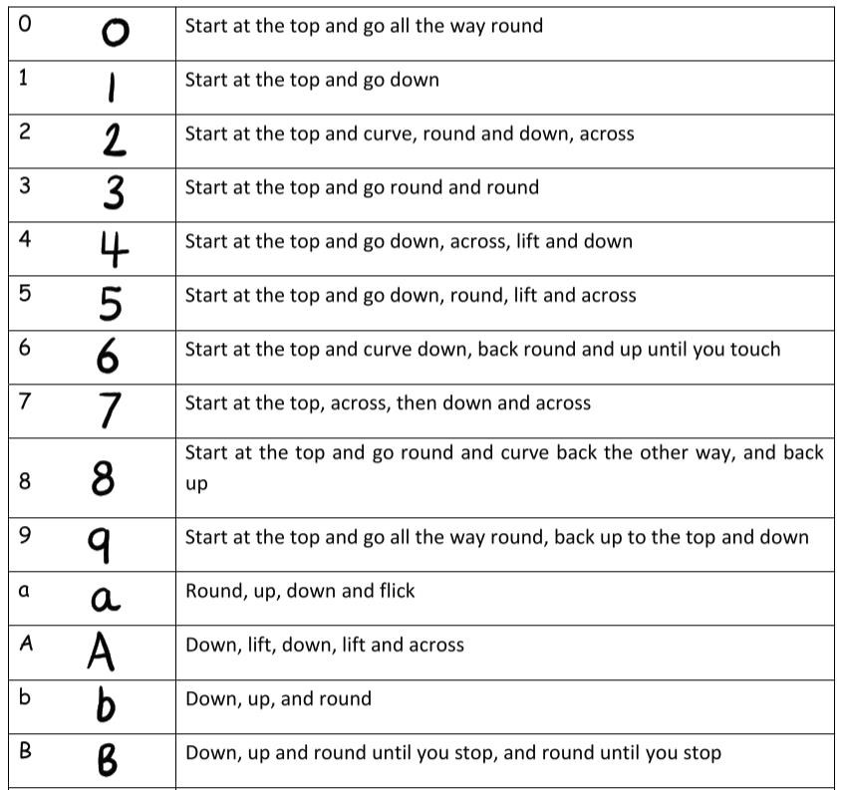
Sandal Castle (V.A.) Community Primary School
Handwriting Policy 2023

6.4 Left-handed children
Ensure left handed children sit to the left of right-handed children when sharing a table. This avoids knocking elbows. Furthermore, ensure hands are kept below the writing line in order that everything is visible. Paper can be moved slightly upwards to retain a comfortable position.

7. Size of letters
7.1 Opportunities to practise handwriting movement is more important than regulating the size
of letters in the early stages. Children need to see how letters are formed and not left to copy on
their own. It is vital throughout the early years that children work in small groups with a teacher or
support assistant to ensure correct letter formation when they are working on a specific handwriting
activity. The child must watch as the teacher writes. It helps to verbalise the direction of movement
i.e. start at the top, down to the bottom, up and over, down, flick etc. It is helpful if all staff and
parents use a clear, consistent set of instructions for describing the correct letter formation.

Letter/number Verbalise movement of the hand

Page 6 of 9

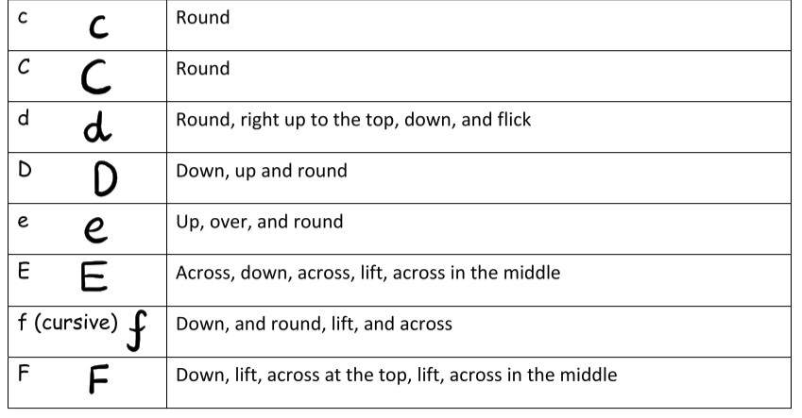
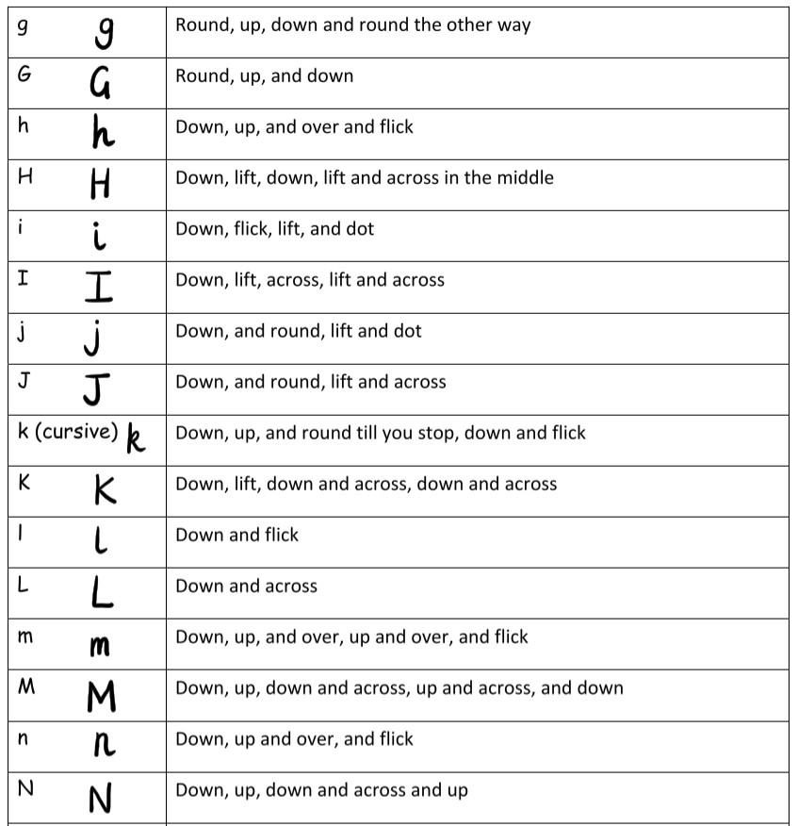

Sandal Castle (V.A.) Community Primary School Handwriting Policy 2023

Page 7 of 9

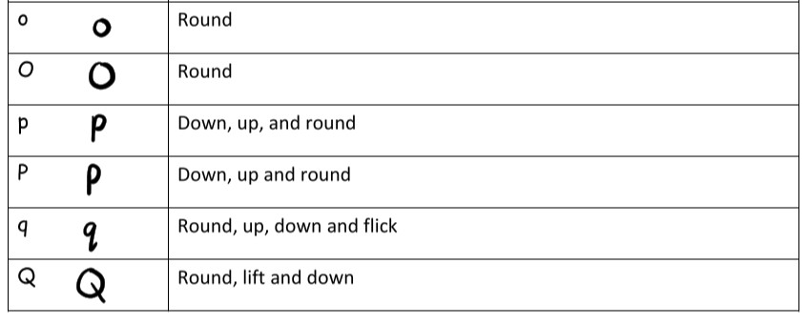
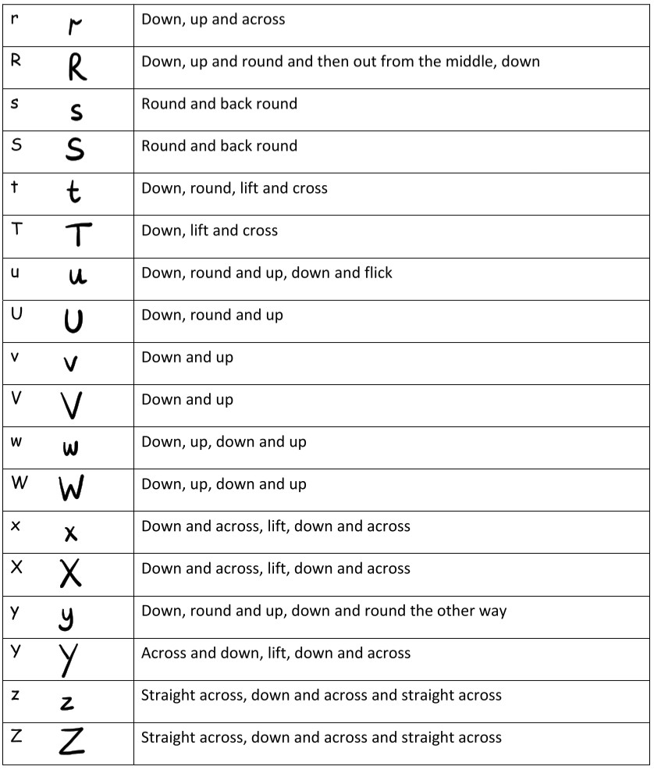
Sandal Castle (V.A.) Community Primary School Handwriting Policy 2023

Page 8 of 9

Sandal Castle (V.A.) Community Primary School Handwriting Policy 2023

8. Pen licences

A pen licence is awarded to any pupil who forms all their letters, with the correct size and height, and joins their writing using a consistent style.

Once a child receives a pen licence (awarded by the Headteacher), they may write using a pen in all their books, except Mathematics.

9. Nelson Handwriting scheme and font

9.1 The Nelson Handwriting scheme is available at Sandal Castle (V.A) Community Primary School

10. Children with SEND

10.1 Children who cannot access the Nelson handwriting scheme will attend interventions to support them to make progress based on individual needs.

Page 9 of 9

