Spring Half Term 2  (LENT - liturgical colour Purple - Easter Sunday falls within the Easter break - 5.4.26)  Our Collective Worship themes to include links, where appropriate, to British Values, Social Justice and Global Citizenship.  The British values that Ofsted expects schools to promote are: democracy, the rule of law, individual liberty, and mutual respect and tolerance for those with different faiths and beliefs. Schools have a legal duty to promote British values as part of the Prevent duty and as part of their overall responsibilities to prepare pupils for life in modern Britain. |  |  |  |  | Focus School Value:  RESILENCE  Additional Links -  British Values Social Justice  Global Citizenship
Date | Theme | Bible Story/Videos | Big Question | Songs | Activity Ideas
Wk 1  w/c  23.2 | LENT  Week 1  A journey of resilience  Social Justice / Global Citizenship  Many people face daily challenges without support  Resilience grows when communities help one another  We can help make the world fairer by noticing who needs support | Resilience means keeping going when things are hard, learning from mistakes, and not giving up — because we know we are not alone.  Christians believe God helps people grow stronger inside, even during difficult times — which is exactly what Lent is about.  WHAT IS LENT?  https://www.bbc.co.uk/bitesize/articles/z77jf4j#z6jgmbk  Resilience begins by pausing and preparing.  Jesus spent 40 days in a quiet, challenging place. He didn’t rush away -he stayed, reflected, and prepared. This shows resilience: taking time to grow stronger before facing challenges.  Jesus went out into the wilderness to prepare Himself. He was about to choose his disciples and travel all over preaching the good news of salvation. He knew just how important this was, so Jesus wanted to make sure there weren’t any distractions. Just Jesus and God talking to each other.  Lent is seen as a 40-day journey of resilience when people practise being strong on the inside. During Lent, we take time to think, make small sacrifices, and try to make good choices. It reminds us of the 40 days Jesus spent in the wilderness. Lent helps us learn how to keep going when things are hard, to try again when we make mistakes, and to face life with faith and hope.  We can follow Jesus’s example by getting ready for something tricky and preparing ourselves which will help us build resilience and cope better.  Part of being resilient means stopping, breathing, and thinking before reacting. Remember our One life sessions, where we learn how important it is to stop, breath and think so that we can ‘respond’ to something calmly rather than ‘react’ | How does being calm help me stay strong?  Who helps me when I find things hard? | Anchor in The Storm – POP UK | 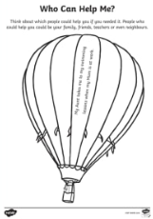  
Date | Theme | Bible Story/Videos | Big Question | Song | Activity Ideas
Wk 2  w/c  2.3 | LENT  Week 2  Resilient Choices – Staying strong when faced with temptation  Social Justice / Global Citizenship  Resilient people stand up to unfairness  Making ethical choices helps others around the world  Resilience supports justice and fairness | Bible Reference Matthew 4:1–11 – Jesus resists temptation  Linking Lent & Resilience  Lent is a special time for Christians before Easter. It lasts for 40 days.  The 40 days remind us of the time when Jesus spent 40 days in the wilderness. During that time, Jesus prayed, trusted God, and did not eat much food and became very hungry. Jesus was tempted by the Devil but showed resilience by not giving in, even when it was difficult. He stayed true to what was right.  First, the devil said, “Turn stones into bread.”  Jesus said no. He said that God’s words are more important than food.  Next, the devil told Jesus to jump from a high place to see if God would save him.  Jesus said no again. He said we should trust God, not test Him.  Then, the devil offered Jesus all the kingdoms of the world if Jesus would worship him.  Jesus said no. He said we should only worship God.  Jesus did not give in to the devil.  He showed that he trusted God and chose to do the right thing.  Jesus showed us how to listen to God and make good choices, even when things are hard.  The Temptation of Jesus  https://www.youtube.com/watch?v=mc-x4qKY6Wc  During Lent, people try to be more like Jesus. They might:  - pray more  - be kinder and more helpful  - give up something they enjoy  How can we be more resilient and make the right choices even when it is hard?  - Resisting peer pressure  - Choosing kindness instead of anger  - Keeping going when learning feels hard | How does resilience help me say “no” to poor choices?  Do you think Jesus felt like giving up? | Be Kind  Pop UK | 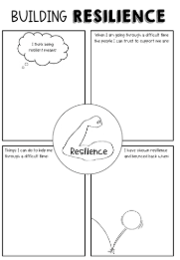  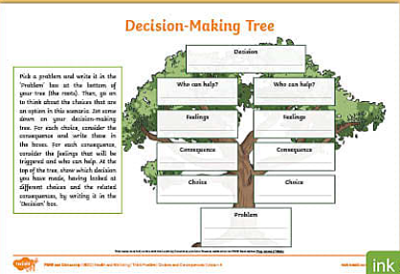  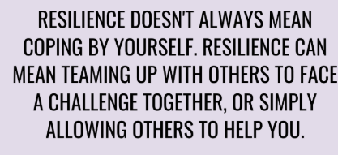  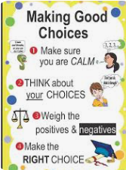
Date | Theme/  Value Links | Bible Stories/Videos | Big Question | Songs | Activity Ideas
Wk 3  w/c  9.3 | LENT  WEEK 3  Ramadan facts for Kids  https://www.youtube.com/watch?v=nI8qrKJ7OeU  Social Justice / Global Citizenship  Many families live with daily hardship  Resilience is strengthened through global support  Lent and Ramadan charities help people grow stronger and more hopeful | This year (2026), Lent and Ramadan overlap in time. They are two different religious seasons with different reasons and traditions.  - Lent is a Christian season of preparation for Easter and starts on 18 February 2026.  - Ramadan is a Muslim holy month of fasting and begins around 17 -19 February 2026 and goes into March.  They happen at almost the same time this year as they start in February and continue through March.  How are they linked?  - Lent is a time when many Christians think about God, pray more, and sometimes give up something they enjoy (like sweets or screen time) to grow closer to God.  - Ramadan is a time when many Muslims fast from sunrise to sunset every day for about a month, pray, and try to be kind and helpful.  Even though they come from different religions and have different reasons and ways of doing things, both Lent and Ramadan are times when people think more about their God, and try to be better, kinder, and more thoughtful. 😊  That’s why it’s meaningful that they’re happening at the same time this year — many people across different faiths are focusing on being their best selves at the same time.  How Lent and Ramadan Are the Same?  - Learning self-control:  During Lent and Ramadan, people practise saying “no” to some things they enjoy, like food or treats, to help them grow on the inside.  - Fasting:  Many people stop eating for a time.  - In Ramadan, Muslims do not eat or drink during the day.  - In Lent, Christians give up certain foods or treats.  - Praying and thinking:  People spend more time praying and thinking about how to be kind and make good choices.  - Helping others:  Giving to people who need help is very important. This shows kindness and caring.  - Saying sorry and starting fresh:  People ask God for forgiveness and try to be better and kinder.  - Being together:  Families and communities come together, share meals, and support each other. They also learn how it feels to be hungry, so they understand people in need | How does helping others build resilience?  What small sacrifice could I make this week? | A Hard Road to Travel | 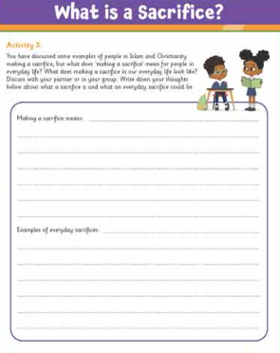  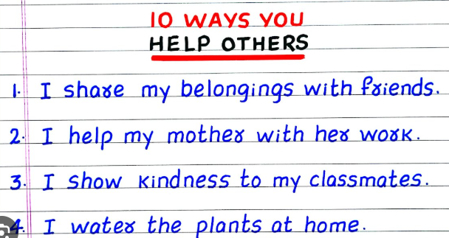  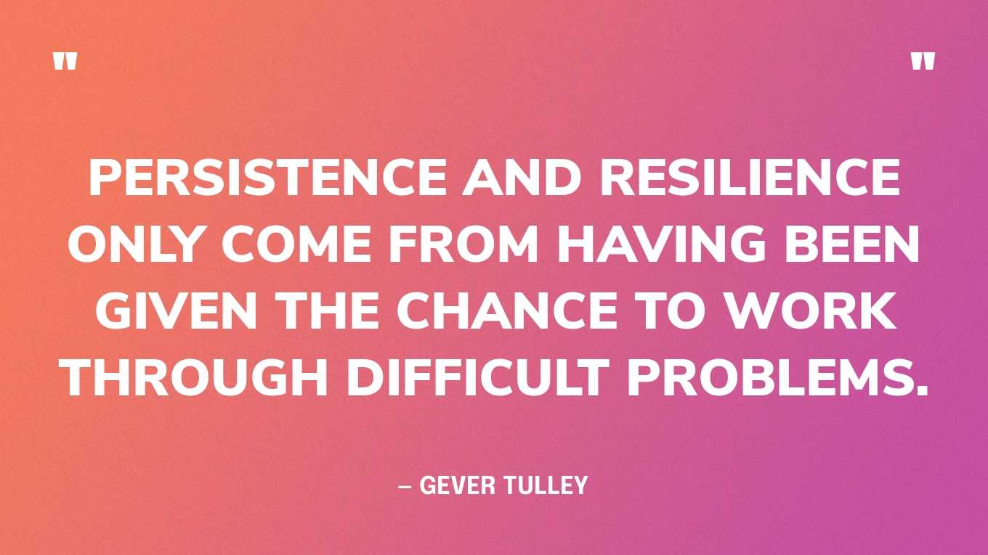
Date | Theme | Bible Story/Videos | Big Question | Songs | Activity Ideas
Wk 4  W/c 16.3 | LENT  WEEK 4  Easter: From Sadness to Hope – The Power of Resilience | Core Theme - The events of Holy Week and Good Friday  Core Message  Easter begins with difficulty and sadness, but even in the hardest moments, Christians believe God is still at work. Resilience means continuing to trust, hope and love even when things feel painful or confusing.  What is Holy Week?  https://www.youtube.com/watch?v=O___M05czhg  Good Friday -  - Jesus had friends who loved him and believed he was special  - He was arrested, hurt, and died on the cross  - His friends felt sad, frightened and confused  - Everything they hoped for seemed lost  “This was a moment when it looked like sadness had won.”  Christians believe Jesus chose love even when it was hard. He didn’t run away or give up. That takes huge resilience.  “Resilience doesn’t mean pretending things don’t hurt. It means not giving up, even when life is difficult.”  Jesus’ friends stayed together. They supported one another. That helped them cope.  Social Justice / Global Citizenship Link  Many people around the world experience sadness and hardship — war, poverty, illness or loss.  Christians believe Good Friday reminds us to:  - Stand with people who are suffering  - Be kind and supportive  - Not turn away from difficult situations  “How can we show resilience and kindness to people who are struggling?”  Bible Links: -  New Testament Gospels (Matthew 21–28, Mark 11–16, Luke 19–24, and John 12–20). Key events for KS2 include Palm Sunday (Matthew 21:1-11), Maundy Thursday (Luke 22), and Good Friday (Luke 23), leading to the Resurrection on Easter Sunday (Luke 24). | How do we feel when things go wrong?  Is it easy or hard to keep going when we’re sad? | Lift Up Your Voice  Pop UK | 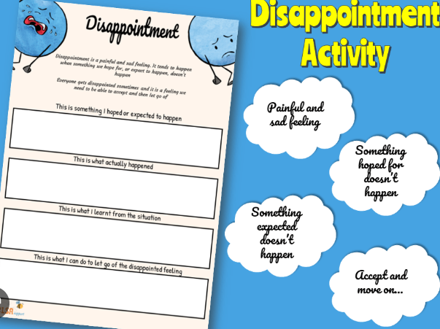  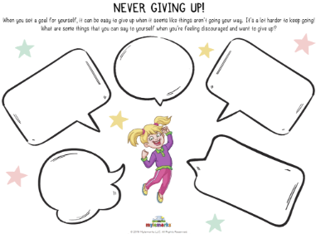  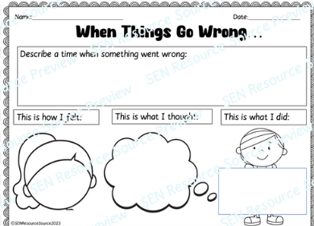
Date | Theme | Bible Story/Videos | Big Question | Songs | Activity Ideas
Wk 5  w/c  23.3 | EASTER  WEEK 5  Easter: New Life, New Hope – Resilience Through Belief  Social Justice / Global Citizenship Link  Many Christians around the world work for justice because Easter gives them hope:  Supporting food banks  Helping refugees  Standing up for fairness  Caring for the environment | Easter Sunday – Resurrection  Easter Sunday shows Christians that hope can come after the hardest times. Believing that new life is possible helps people be resilient and face challenges with courage.  Show a symbol of new life (flower bulb, seed, or image of spring).  Ask: - “What do you notice about spring after winter?”  Easter happens in spring because Christians believe it is about new beginnings.  Easter Sunday:  - Jesus’ friends went to the tomb feeling sad  - They found it empty  - An angel told them Jesus was alive  - Sadness turned into amazement and joy  “Christians believe that even death did not have the final word.”  The Story of Easter: The Resurrection of Jesus Christ  https://www.youtube.com/watch?v=YX6kfl9qBkA  How Christian Belief Helps People  Christians believe:  - God is always with them, even in hard times  - Bad times don’t last forever  - Love and hope are stronger than fear  This belief helps people:  - Keep going when life is difficult  - Forgive others  - Care for people who are hurting  - Believe they can start again after mistakes  Resilience is knowing that you can try again - just like Easter shows new life after sadness. | How does it feel to know tomorrow can be better?  What is one thing that helps keep you going when things are difficult? | Praise Ye the Lord Hallelujah  https://www.youtube.com/watch?v=WuODF9Kbgnw | Easter Reflection: Hope and Resilience  Sit quietly and take a slow, deep breath.  Today we are thinking about Easter — a story that begins with sadness but ends with hope.  On the first Easter morning, Jesus’ friends went to the tomb feeling worried and upset. They thought everything was over.  But the tomb was empty.  They were told,  “Jesus is not here. He is alive.”  For Christians, this means that love is stronger than sadness, and hope is stronger than fear.  Think about something you find hard. It might be a challenge at school, a worry, or a time when you feel disappointed.  Now think about resilience —the strength to keep going, to try again, and to believe things can get better.  Easter reminds us that even after the hardest times, there can be new beginnings.  Think of one thing that helps you keep going when things are difficult. For example, it might be a person, a place or a feeling of hope.    .
Date | Theme | Bible Story/Videos | Big Question | Songs | Activity Ideas

