Spring Half Term 1  (Ordinary time - liturgical colour Green)  Our Collective Worship themes to include links, where appropriate, to British Values, Social Justice and Global Citizenship.  The British values that Ofsted expects schools to promote are: democracy, the rule of law, individual liberty, and mutual respect and tolerance for those with different faiths and beliefs. Schools have a legal duty to promote British values as part of the Prevent duty and as part of their overall responsibilities to prepare pupils for life in modern Britain. |  |  |  |  | Focus School Value:  RESPECT  Additional Links -  British Values Social Justice  Global Citizenship
Date | Theme | Bible Story/Videos | Big Question | Songs | Activity Ideas
Wk 1  w/c  5.1 | A Fresh Start  Respecting Ourselves  Global Citizenship Link: Personal responsibility; self-respect leads to respect for others. | New Year/New Beginnings  Theme Focus: Recognising that God gives us new opportunities each day to grow and make wise choices.  Bible Links:  - Philippians 3:13–14 – “Forgetting what is behind and straining toward what is ahead.”  - Psalm 139:14 – “I praise you because I am fearfully and wonderfully made.”  Christian Message:  God respects and values each of us as His creation. We show respect to ourselves by making good choices, learning from mistakes, and using our gifts well.  STORY  Every morning, when the sun rose over Maple Street, the world outside Emma’s window seemed to take a deep, bright breath. She loved that moment—when the first light touched the rooftops, gently reminding her that yesterday’s worries belonged to yesterday alone.  One morning, after a particularly difficult day before, Emma hesitated before getting out of bed. She wondered if the mistakes she’d made would follow her forever. But as she stepped outside, she noticed something small and surprising: the neighbourhood bakery had put out a new sign that read, “Fresh Batch Today!” The smell of warm bread drifted through the air.  “It’s a brand-new batch every morning,” the baker said when she stepped inside. “Doesn’t matter how the last one turned out.” Emma smiled. She walked to school with a lighter step, carrying the scent of fresh bread and fresh beginnings with her.  Throughout the day, she realized something: the world was constantly resetting. Clouds shifted, breezes changed direction, people laughed again after frowning. Every moment was quietly offering her another chance.  And that night, as she set her alarm, Emma finally understood—tomorrow would rise just as brightly, giving her all the room she needed to start again. Every day, like a fresh loaf of bread, warm and new. | What does it mean to respect ourselves as people made by God?  How can I show respect for myself in the way I learn, live and grow? | This is the Day that The Lord has Made  https://www.youtube.com/watch?v=cccJhMVFrLs |   Create a “Respect Pledge Tree” — each leaf is a way pupils will show respect for themselves this term.  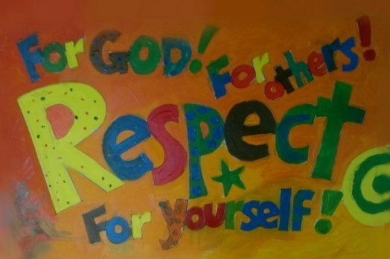  
Date | Theme | Bible Story/Videos | Big Question | Song | Activity Ideas
Wk 2  w/c  12.1 | Respect for the Importance of Honesty  British Values  Individual Liberty  Tolerance of those with different faiths and beliefs | At our school we place honesty at the core of all interactions. This builds trust and positive relationships. We encourage children to be honest with themselves, admit when they are wrong and to know when they should ask for help.  Honesty for Kids – The Benefit of Telling the Truth  https://www.youtube.com/watch?v=DdPZGW-ODH8  The Bible often highlights the importance of honesty -  It is better to be honest and poor than dishonest and rich” - Proverbs 16:8  John 8:31-32 “Then you will know the truth and the truth will set you free”  Jesus teaches that truth leads to freedom. Being truthful brings inner peace and trust.  Proverbs 12:22 “The Lord detests lying lips, but he delights in people who are trustworthy”  GOD VALUES INTEGRITY - What does integrity mean?  Integrity means being honest and doing the right thing, even when no one is watching. It's about being fair, trustworthy, and having strong morals that guide your choices. For example, it means returning a lost wallet or telling the truth even when it's hard.  Luke 19:1-10 Zacchaeus the Tax Collector (Read from Class Bibles)  https://www.youtube.com/watch?v=5BjtbJFz2ug  Zacchaeus faces the truth about himself. When we are honest about our mistakes we can change and be forgiven.  Honesty in British values  - Fairness and trust: Honesty is seen as a foundation for fairness and trust, ensuring people are treated as they would expect to be treated.  - Integrity and responsibility: Honesty is linked to having integrity and being truthful, even when it is hard.  - Building relationships: Honesty is essential for building strong, dependable relationships, as it fosters cooperation and mutual respect within a community. | What does it mean to be an honest person?  Why is it sometimes hard to tell the truth? | Life is Always Better  POP UK | 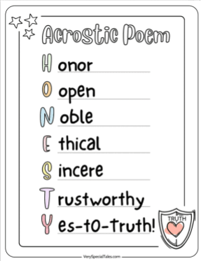  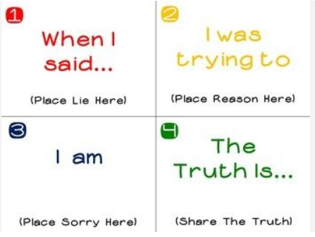  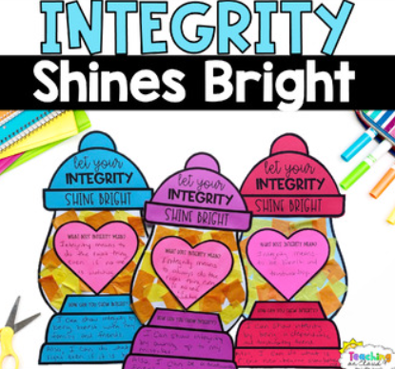
Date | Theme/  Value Links | Bible Stories/Videos | Big Question | Songs | Activity Ideas
Wk 3  w/c  19.1 | Respect for the Global Church  British Values  Individual Liberty Everyone has the freedom to worship in their own way and language | 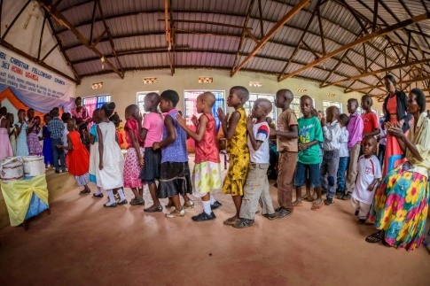  A children’s choir in Uganda marches their way to the front of the Church to sing worship songs during services.  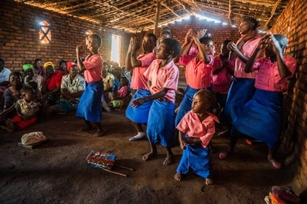  Worship in Malawi  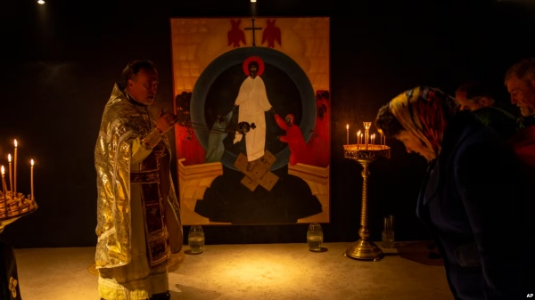  There have been numerous reports and images of Ukrainian Christians worshipping in basements and bomb shelters since the Russian invasion began in February 2022. This has become a poignant symbol of resilience and faith amidst the ongoing conflict.  “Christians are Everywhere: One Family Around the World”  What do you think a Christian looks like? Where do you think Christians live?”  Show images of Christians worshipping in different countries — a church in Kenya, a house church in China, a beach service in Brazil, an underground church in Ukraine, a cathedral in France, etc.  Explanation:  - Christianity is the world’s largest faith.  - Christians speak many languages, worship in different ways, and live out their faith in their own cultures.  - But they all believe in Jesus and try to follow his teaching of love, peace, and forgiveness.  Acts 2:1–12 – Pentecost – “The Holy Spirit helped people from many nations understand each other. God’s love is for everyone, not just one language or country”  Reflection - Christians believe that no matter where you live — a big city, a tiny village, or even a refugee camp — God knows you and loves you. The Church is like one huge family, full of different voices, songs, and ways of praying, but all united in love. | What do I think of when I hear the word “Christian?  Where could I find a Christian? | He’s Got the Whole World in His Hands  https://www.youtube.com/watch?v=kDBJNQiugnM | 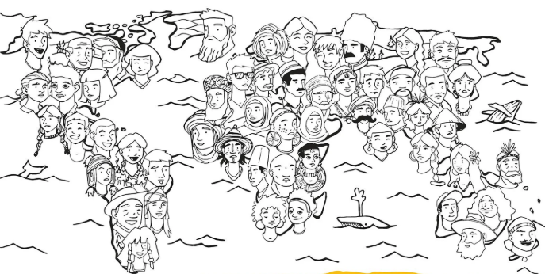  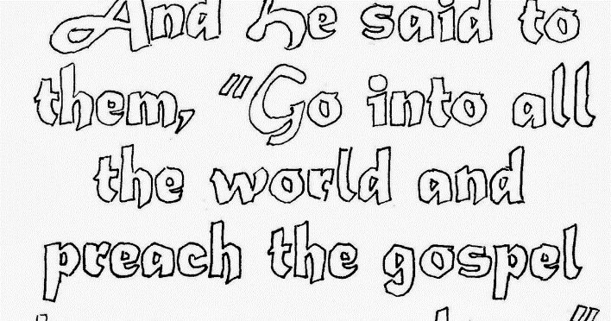  A Christian is…….  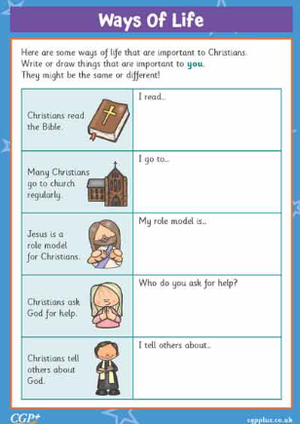
  Mutual Respect
  & Tolerance
  We respect that
  Christians – and
  people of all faiths
  – come from
  every culture.
Date | Theme | Bible Story/Videos | Big Question | Songs | Activity Ideas
Wk 4  W/c 26.1 | Theme  Building on Respect –  Foundations for a Strong Future | 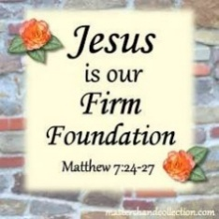  Our Motto  BUILDING STRONG FUTURES TOGETHER  Our belief at Sandal Castle is that we prepare children for their futures by enabling them to build strong foundations – specifically in the way that children interact with opportunities for learning.  Jesus’ parable about the wise and foolish builders (Matthew 7:24-27) ends his most famous teaching, the sermon on the mount (Matthew 5-7). He uses the story to illustrate the importance of putting into practice our learnings in life – being doers not just hearers of good teaching. (Vision by Rev Hannah – see website)  The Wise Man and The Foolish Man - Animation  https://www.youtube.com/watch?v=CXWHLB1f6_U  Building your life on Jesus is like building a house on a big, strong rock. When storms come—like hard days or problems—your house won’t fall because it has a strong foundation.  But building your life on things that don’t last—like trying to be popular or only caring about stuff—is like building a house on soft sand. When the storms come, the house falls down.  So, the strong foundation is trusting Jesus, loving others, and doing what He teaches. That’s what helps us stay strong no matter what happens.  At Sandal Castle Primary School, we build strong futures together. We celebrate and prepare our inclusive community by providing the education and experiences needed as the building blocks or foundations for life. We empower everyone to be successful, resilient, and self-aware global citizens. Together, in God’s love, we nurture hearts, minds, and spirit to equip everyone with wisdom, character and hope, in order to flourish.  Our School is a Building With strong foundations, Four Walls and Tomorrow Inside  Message: Respect is a strong foundation - when we all live it out, we build something amazing together.  Respect is what connects social justice and being a good global citizen. When we respect others, we treat everyone fairly, no matter where they come from or what they look like. A global citizen shows respect by valuing different cultures, standing up for what is right, and trying to make the world a fair and kind place for everyone. So, respect is a foundation we can all build on to help us work together to make the world better for all people and the planet. | What kind of foundation are you building your life on?  How does showing respect help us build strong futures together? | Feet on the Rock  POP UK | 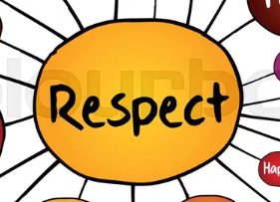  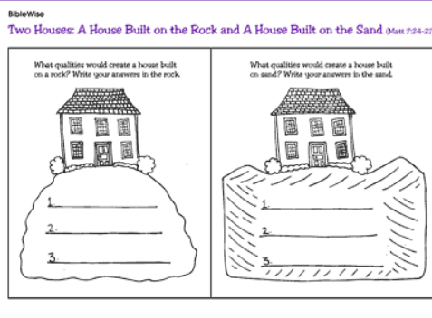  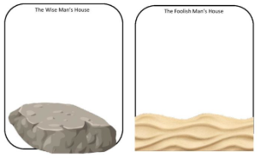  My Firm Foundations are…..
Date | Theme | Bible Story/Videos | Big Question | Songs | Activity Ideas
Wk 5  w/c  2.2 | Respect for Justice and Fairness | What does ‘justice’ mean?  Some people think it is about giving people who do wrong a punishment they deserve. However, this is just one side of justice.  Justice also means giving all people – particularly those who are vulnerable – what is right and fair for them to have – like life, health, education, freedom and dignity.  It is about acting out of concern for what is right and making sure what is right wins.  We talk about ‘social justice’ and this is people working together to get what is right and deserved for those who suffer most and are least able to help or protect themselves.  The Bible emphasises how hugely important ‘justice’ is to God. It is a key part of God’s character.  ‘For the LORD is righteous, he loves justice; upright men will see his face’ (Psalm 11:7)  So, JUSTICE is not about everyone insisting on their own rights at the expense of others. It is about acting out of concern for what is right and making sure right wins.  Bible verse: Let justice and fairness roll on like a river that never runs dry - Amos 5:24  Micah 6:8: The Lord God has told us what is right and what he demands: "See that justice is done; let mercy be your first concern, and humbly obey your God."'  Esther – Bible Story – Esther 2:7  https://www.youtube.com/watch?v=D3lsMSEEuG4  It took courage for Esther to tell the King who she really was. She was literally risking her life. We, too, may have to take risks when we speak up for what is right. But, like Esther, we can be sure that the results of our efforts are in God's hands - even if it costs us to do the right thing. | Do I always act fairly?  What does God think is unfair in this world? | Lift Up Your Voice  POP UK | 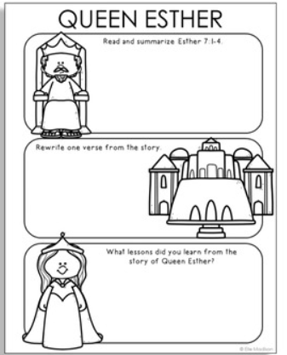  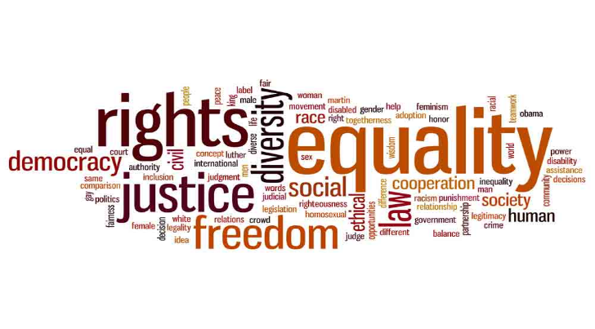  . 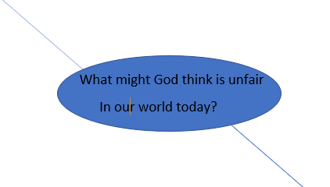
Date | Theme | Bible Story/Videos | Big Question | Songs | Activity Ideas
Week 6  W/c  9.2 | VALENTINES  DAY  Love and Respect | Today we are thinking about Valentine’s Day. Lots of people think it is just about cards, chocolates, and hearts - but it actually began because of love that was kind, brave, and caring - just like the love God shows us.  Valentine’s Day is named after a man called Saint Valentine, who lived a long time ago. He was a Christian who believed that showing love and kindness was very important.  He helped people in secret and wanted everyone to know that God loves them.  People remembered him for his kindness, so a special day was named after him—Valentine’s Day.”  The History of Valentine’s Day for children  https://www.youtube.com/watch?v=ZC5T2wvzKc0  Valentine’s Day reminds us to show love in caring and kind ways, just like Jesus taught.  Bible Link: God’s Love (1 John 4:7–8)  “Dear friends, let us love one another, because love comes from God.”  The Bible teaches that God is the one who shows us perfect love. When we love others—by helping, sharing, or being kind—we are sharing God’s love with the world. Love is not just a feeling—it is something we do. We show love when we help, care, and include others.  Reflection  Valentine’s Day is not just about hearts and cards.  It is a reminder that God loves us, and because of that, we should show love to everyone—our friends, our family, and even people we might not know very well.  In the Bible, Jesus teaches that the most important commandments are:  - Love God  - Love your neighbour as yourself — meaning be kind, caring and helpful to others.  “Today, let’s remember that love is something we share, not just something we feel.  Let’s go out and spread kindness, because that’s how we pass on God’s love.” | How does it feel to know that God loves me?  What small act of love could make someone smile today? | All You Need is LOVE  https://www.youtube.com/watch?v=afC2Kox_seU | 

