SANDAL CASTLE BEHAVIOUR POLICY
“Building Strong Futures Together”


We believe every child at Sandal Castle Primary School has a right to learn, teachers have a right to teach and this will only happen if there is an ethos of positive behaviour. Our pupils should enjoy learning...
By building their confidence, feeding self-worth and lighting their ambition they will be well placed to take advantage of opportunities to become creative and effective learners, prepared for the world of work, active and enterprising citizens, secure in self-knowledge and ready for the changing world we live in demonstrating good behaviour and self-discipline.
The Governors, Head Teacher and Senior Leadership Team work with all teaching and support staff, to develop and implement behaviour support strategies to promote positive behaviours throughout school providing excellent continuity of care. By involving all our staff, this ensures a consistent approach throughout, which they can take ownership of and have the confidence in our behaviour policy by being a great role model to our pupils.

This policy has been written through careful consultation with our School Council, all Staff, our Governing Body and through evaluating surveys and informal conversations with our parent community.
We have high expectations of our children’s behaviour. We believe that every child can make the right choice about their own behaviour and learn to take responsibility for their own actions.
We believe that good relationships are the key through which to influence, shape and build wellbeing. Young people need nurture and empathetic relationships alongside containment and structure in order to feel safe. We believe that all our children wish to, and have the right to, belong, achieve and contribute to their school community. Over time, secure relationships enable our children to develop the skills to regulate their feelings and behaviour, develop an understanding of social situations, and develop healthy and positive feelings about themselves and their abilities.

What you expect to see in classrooms and around school

Adults working in school are committed to modelling appropriate behaviours and delivering a consistent set of expectations around behaviour.
- All classrooms will have a Golden Star and a traffic light
- We use a class chart to record our house points.
- We walk on the left through school and pause at the doors.
- We have a signal to stop and listen outside - an adult will use a whistle and then raise their hand.
- We have designated places to line up at the end of playtime and lunch time.
- At lunch time, we have a one-way system to come in and out of the building.

In School, rewards are given for demonstrating our four School rules:
- Be Safe
- Be Ready
- Be Responsible
- Be Respectful

Our school rules are based on our rights and responsibilities. They aim to help our children develop and grow into young adults who can make appropriate choices about their behaviour, reach their full potential and go on to make a positive contribution to their community. We believe our Christian Ethos promotes our rights and the consistent approach to behaviour management.
All members of our school community are aware of their rights and the responsibilities that our rules come with. Our rules are few in number, simple, positively phased, clearly communicated and modelled by all adults in school.
Our children know that processes are in place to repair harm, restore a sense of safety and learn from the experience when agreements are broken.

We believe that these rules look like:
- Be Safe; keeping ourself and others safe from harm
- Be Ready; ready to learn
- Be Responsible; for ourselves and our actions
- Be Respectful; to all our Sandal Castle Community

Our One Life Mission:


As part of our One Life mission, we are supporting our children to be the best version of themselves; just because it is who they are. Within assemblies and PSHE lessons our children will learn how to listen to their moral compass and also how to catch themselves before making wrong choices.

House points
We have recently changed our reward system in order to give more recognition to our pupils that show positive behaviours, high effort levels and produce excellent work.
Every pupil is allocated a house place upon entry to our school which they will belong to until they leave Sandal Castle School. Our Houses are named after the four historical leaders of Sandal Castle; Clifford, Rutland, Warren and York. We hope that this will generate lots of excitement and that these houses can be used for a variety of events across the year. By following and promoting our School rules throughout school, house points can be earned throughout the school day.
The points gained by the children will be tracked throughout the year and the children will aim to receive the following certificates to recognise their achievements:

Bronze: 30 House points
Silver: 60 House points
Gold: 100 House points
Platinum: 200 House points
Diamond: 300 House points

Each academic year the house points will reset, so the children will personally aim to beat their previous year’s total. The house captains (Children in Year 6 who have applied for the role) from each house will be responsible for collating the totals for each house in every class across school so that the trophy can be awarded at the end of the year to the winning house. House point totals will also be celebrated in or weekly Collective Worships.
Once 30, 60, 100, 200 or 300 points have been received, the children can choose an appropriate level prize from our Prize Store as they reach each level. The higher the points, the bigger the prize!

This is a great way of demonstrating team work and working collaboratively throughout the school.

Playtimes and Lunchtimes
Lunchtime and playtime positive behaviours are rewarded using the same system of house points by staff on duty. They will inform the class teacher where house points have been awarded during this time.

Celebration Collective Worships
Celebration Collective Worship is held every Friday afternoon for children in Years 1-6. These community gatherings are a celebration of the talent and qualities of all and include Christian themes and messages. During the year every child will be chosen for Star of the Week award. They will also receive a maths and a reading star recognition.
A brick will be presented to the child with their name on and giving the reason of their achievement to go on display on our Sandal Castle, upon the wall of the hall to celebrate their success. These are placed on the Castle by the child during the assembly taking pride in the recognition of their efforts. This is because their achievements are helping them build strong futures; just like or castle!
When your child has been chosen to be ‘Star of the Week’, you will receive an invitation in advance inviting you to join our special Celebration Collective Worship. This is a lovely opportunity to be part of or family. Parents will also be invited (This will be received a week in advance to support work commitments) for celebratory refreshments with your child; either before or after the Collective Worship.
Each half term children will be chosen to display excellent examples of work on the Head Teacher’s ‘Achievement’ display board.
As part of our continued good practice - stickers, awards, certificates, Head teacher’s awards, notes home, post cards, reward charts, home-school diaries and verbal/non-verbal praise and feedback are given continually throughout the school day.

Home/School Agreement
A strong partnership between home and school is of real benefit to our children. We aim to share good news and achievements as well as any concerns or details of any incidents. This may be through a quick chat at drop off/collection times, meetings, a telephone call or by post.
(See home/school agreement- separate document)

Sanctions:
Traffic Light System

All children start each half term on the Golden Star. Traffic Lights will be displayed at the front of the class with all pupils’ names on the Golden Star at the start of the half term.
If low level negative behaviour is witnessed a child will receive a warning (statement of reality, followed by statement of choice- see below). If the behaviour continues, a second warning will be given before moving to amber on the traffic lights. If behaviour continues to escalate or a serious incident has occurred, a red may be given. Any red/amber given means they come off the golden star for the rest of the half term and their name will sit on the green traffic light. Every new half term sees all children starting again on the Golden Star.
Those children remaining on Golden Star at the end of each half term, with a perfect behaviour record, are invited to a star treat session. These sessions can include a visit to the museum, trip to the cinema, art workshops, DVDs, circus skills workshop plus many more chosen and decided by our School Council for our Gold Star treats. Children whose name is on the green traffic light will undertake normal curriculum lessons during this time.
If a child is not following the school rules, we implement the ‘Steps to better behaviour’:
• First ‘Statement of reality – describe the behaviour’
• Next ‘Language of choice’ - If you continue, you will go on amber.
• Continued behaviour -children move their name on to red and have an inclusion at their next available play time with a member of SLT. This is a time to discuss and reflect on their actions and implement restorative practice to help avoid similar situations in the future. The child will remain on red for the remainder of the day.
Every red a child receives – a message will be sent home to advise parents of the incident on the same day. If the incident is more severe, a phone call will be made home prior to the child going home on that day. If negative behaviour continues, the Head Teacher will arrange a meeting with parents to discuss ways of helping.
Sometimes a child may just require a calmer, quieter area to think about their actions and this is a safe space within their classroom to have time out.
All incidents are recorded on our Arbour (School Management and Information System) to help staff identify any triggers to enable us to put strategies in place to help the child succeed at certain times/areas/lessons of the day. An inclusion slip will be completed by staff and given to the member of SLT on arrival by the child.
During the inclusion, children will undergo restorative practice conversations and alternative self-reflection activities, promoting positive behaviour will be available too. If they refuse, they will repeat inclusion at the next available playtime or the following day or pre-discussed with parents to stay after school for a short period of time.

Children will place their name straight on to red if they:
  - Physically assault a child or adult including deliberate pushing – may also be fixed term suspension depending on the severity of the assault
  - Lie
  - Swear
  - Hurt /spit or intimidate another individual
  - Call someone an offensive name including racism, homophobia (gay word used inappropriately)
  - Steal
  - Damage property
  - Behave dangerously including leaving a room without permission – this also incurs an after-school detention
Bullying/Homophobic/Racist incidents must be clearly marked on the incident form with detail to record on Arbour including victims/by standers names etc. Parents will be immediately informed. Senior Staff will meet parents/carers to discuss next steps.

If a child receives a red, the following escalation will be followed:

EYFS:
1st red –Miss 15 mins of play in class.
2nd red –Miss 15 mins of play in class. Parents meet with class teacher.
3rd red – 30 minutes dinnertime inclusion. Child to sit with Mrs Jayne.
4th red –30 minutes dinner time inclusion. Child to sit with Mrs Payne. Parents meet with Phase Leader
5th red –Behaviour home /school book issued. 30 minutes at lunchtime. Child to sit with Mrs Payne. Parents meet with HT.
6th red – 5x lunchtime inclusions with Mrs Payne.
7th red –10x lunchtime inclusions with Mrs Payne.
8th red – Parents, Teacher and Senior leadership to meet, discuss and implement IBP. Possible Fixed term exclusion and referral to Inclusion Panel (See below)

KS1 and 2:
1st red – Miss 15 mins of next playtime/lunchtime.
2nd red – Miss 15 mins of next playtime/lunchtime and Parents meet with class teacher. Year 6- short term loss of ‘Hoodie of Responsibility’ and short-term loss of JLT position where appropriate
3rd red – 30 mins after school inclusion and parents meet with Class Teacher on collection.
4th red – 30 mins after school inclusion and parents meet with Phase Leader on collection.
5th red – 30 mins after school inclusion and parents meet with Head or Deputy Head Teacher on collection – Behaviour home /school book issued.
6th red – Half day internal inclusion.
7th red – Full day internal inclusion.
8th red – Parents, Teacher and Senior leadership to meet, discuss and implement IBP. Possible Fixed term exclusion and referral to Inclusion Panel (See below)
If your child continues to receive further reds, they may be referred to the Local Authority Inclusion Panel, where their behaviour will be discussed amongst experts and a plan put in place to support this. Dual registration or a managed move to a different Wakefield School may be required
Reasonable adjustment will be made for children who are on the SEND register.- see below

Children with Additional Needs

We are all in the same ocean,
but not in the same boat.


As an inclusive school, we are aware that the behaviour policy may not suit all children. For these individuals, personalised plans have been made.

In accordance with Section 91 of the Education and Inspection Act 2006, some children with additional needs or who are in circumstances that are known to make them vulnerable may need a significantly differentiated approach to behaviour management. This may include individual targets and rewards, an individual Behaviour Management Plan or a Wellness Recovery Action Plan (WRAP). For these children we adopt ‘rubber boundaries’ - boundaries that bend and flex but never break.
All behaviours are understood to be communication of an individual’s needs. A curious approach to understanding behaviour is essential. Needs must be understood and met in a compassionate and informed way, rather than seeking to manage and contain behaviours alone.
Trauma induced behaviours require emphasis placed upon the importance of secure and trusting relationships in school and the sense of safety that these provide. Our Nurture team work closely with these pupils, ensuring that they are available to support when required, but also provide timetabled evidence-based programs to develop strategies for coping and managing de-regulated emotions.

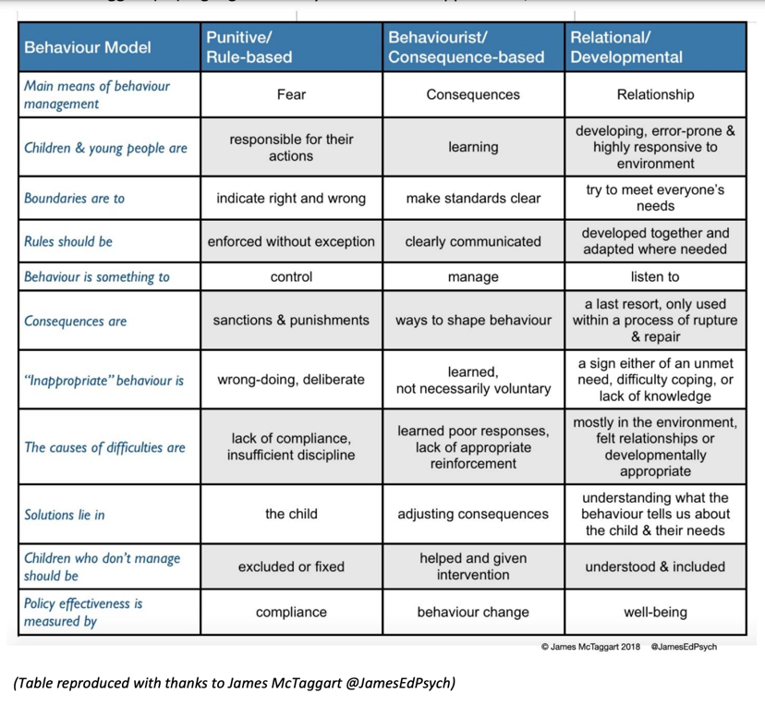

Responding to and Calming a Child who may be De-Regulated

All staff at Sandal Castle have received Emotion Coaching training from the Education Psychology service, to ensure that we are delivering a consistent approach across our school. Emotion Coaching helps children and young people have an understanding of different emotions they experience, why these occur and how to manage them.
It is a universal approach which focuses on the promotion of emotional wellbeing through a relational approach, centred around attunement and coregulation. Our staff use Emotion Coaching to support the regulation, resilience and development of our children’s emotions. At Sandal Castle we understand that all behaviour is a form of communication and Emotion Coaching helps us to recognise this.
There are 4 key steps to Emotion Coaching, which include:
1) Recognising the child’s feelings and empathising with them.
This does not involve agreeing with the behaviour, but acknowledging why the child may be reacting a certain way. The key is not to act or react straight away. Adults supporting are to think about what is going on for the child right now, what is the root cause of their behaviour? Attune yourself and put yourself in the child's shoes. Reflect, what might be a similar situation you've found yourself in before?
2) Validating their feelings and labelling them.
Emotion Coaching Scripts:
'I can see that you are frowning and looking really frustrated. It's ok to feel the way that you do'.
'I'm wondering if you are feeling angry? I think I would feel angry if that happened to me, I get it'.
'I've noticed that you don't want to join the others. I'm thinking that you might be feeling a bit worried at the moment'.
3) Setting expectations of behaviour if needed.
- This is an opportunity to remind the child about appropriate behaviours (policy) and that certain behaviours cannot be accepted.
- Retain the child's self-dignity and avoid asking 'why'. Use language of choice 'would you like to do this or this' (2 choices only).
- Make suggestions 'Maybe you could do this or this'. Be indirect rather than direct 'The books need picking up' vs 'pick up the books’.
- Re-direct the child's focus only when the child is calmer.
4) Problem solving with the child.
Time to find a solution together. Only when the child is ready, staff are to provide a narrative of what happened. Scaffold alternative ideas and actions leading to more appropriate outcomes. Staff aim to empower the child to believe they can overcome difficulties and manage their behaviour in the future.
- 'What does your body feel like now?'
- 'Let's think together of what we could have done instead'
- 'Shall we think of a different way to deal with these feelings and sort things out'
- 'Can you remember what we said before?'
- 'Let's sort this out together'
- 'Let's decide what to do next time you feel like this'
- 'This is what you can do instead'

Hoodie of Responsibility
The Year 6 ‘Hoodie of Responsibility’ is a privilege and this will be withdrawn for a period of time at the Head Teacher’s discretion if a child gets more than 2 reds within the academic year, or if a serious incident occurs - Reasonable adjustment will be made for children who are on the SEND register.

Suspension
If a child reaches 8 reds or is involved in a very serious incident, the Head Teacher may choose to exclude your child for a fixed period of time, following the Local Authority guidelines. For exclusions that are over one day, the child may be visited by our Safeguarding and Family Support Teacher and PCSO. The Parent will be required to attend a re-integration meeting with the Head Teacher to discuss how to avoid future exclusions and support their child in their return to school.

If a child receives repeated reds over the lunchtime period, the Head Teacher may choose to excluded the pupil over this time frame. You will be required to collect your child at 12pm and return them for 1pm/1:15pm to gain their afternoon register mark.

Searches for Prohibited Items
Searching without consent can be carried out for prohibited items within the parameters of the guidelines. ‘Prohibited items’ are defined in the Education Act 1996 and the Schools Regulations 2012 as:
1. Knives or weapons, alcohol, illegal drugs and stolen items
2. Tobacco and cigarette papers, vapes, fireworks and pornographic images
3. Any article that the member of staff reasonably suspects has been, or is likely to be, used to commit an offence, or to cause personal injury to, or damage to property
4. Items banned by the school which may be searched for:
• Mobile phones and devices or any internet ready device
• Sweets and drinks not including drinks in packed lunches
• General search of lockers, trays, bags and coats to prevent stolen goods leaving premises
• Money not for payment of school trips etc.
• Toys

Social Media – Allegations – Slander and Libel – Threatening Behaviour
Where children or parents/carers make malicious allegations, insult, slander or label the school or staff at the school (once clear evidence is available) the Local Authority Legal Team will be consulted to determine further action. This includes malicious and upsetting Facebook/Social Media posts. Where the child or parent refuses to remove/withdraw comments the school will pursue the matter legally and consider if the relationship is broken and whether they can continue to provide an education for the child/children in question. Amendment - see Ofsted advice behaviour.

Data
Data is stored securely on Arbour – school management system.

Prepared by (member of staff):  Caroline Butterworth | Date: January 2026
Approved by Governing Body: | Date: January 2026
Ratified by Full Governing Body: | Date: February 2026
Signed off by Chair of Governing Body: | R. White

