

Sandal Castle VA Community Primary School

Inclusion and SEND Policy

Approved By: | Governors
Updated: | October 2025
Next review due: | October 2026

Contents
- Aims and objectives
- Visions and values
- Legislation and guidance
- Inclusion and Equal opportunities
- Definitions
- Roles and responsibilities
- SEN Information Report
- Our approach to SEND support
- Evaluating the effectiveness of SEN Provision
- Expertise and training of staff
- Links with external professional agencies
- Admission and accessibility arrangements
- SEND Complaints Procedure
- Monitoring and evaluation arrangements
- Monitoring the policy
- Links with other policies and documents

Aims and Objectives

We aim to match the quality and quantity of our provision to the changing needs of all our children:

- To ensure the SEN and Disability Act and relevant Codes of Practice and guidance are implemented effectively across the school.
- To ensure equality of opportunity for, and to eliminate prejudice and discrimination against, children with special educational needs and /or other temporary or ongoing barriers to learning.
- To monitor the progress of all children, to identify needs as they arise and to provide appropriate levels of support as early as possible.
- To provide full access to the curriculum through planning provided by class teachers through quality first teaching.
- To provide specific input, matched to individual needs, in addition to classroom provision, for those children where it is deemed necessary.
- To involve parents/careers throughout the process of meeting their child’s additional needs.
- To involve the children themselves, where appropriate, to support their additional needs.

- Vision and Values

Building Strong Futures Together
As a Church of England School, we believe in the importance of strong foundations. Jesus is described as the cornerstone of our faith (Ephesians 2:20-22) and we are encouraged as Christians to build wisely in our lives (1 Corinthians 3:11-17).

At Sandal Castle, our logo is of our local landmark, a ruined castle, which has stood on a rock for hundreds of years. The castle’s continued strength throughout storms and battles speaks to us of the resilience and solidity we can have when we have strong foundations.

Our belief at Sandal Castle is that we prepare children for their futures by enabling them to build strong foundations – specifically in the way that children interact with opportunities for learning.

Jesus’ parable is an illustration that is relevant in two specific ways to our school community.
Our aim is to give each child opportunities to excel by learning and by putting into practice what they have learnt in the curriculum. Alongside this our aim is to give each child an opportunity to flourish by learning and by putting into practice that which grows their character and spirituality. We believe that nourishing understanding works on these two levels – understanding intellectually and understanding emotionally and that both areas require investment.

As part of our Christian ethos, we echo the Bible’s teaching that each of us are made in the image of God (Genesis 1:26-27) and each person is precious and worthy of respect. As we treat others as we wish to be treated, we seek to demonstrate understanding and inclusivity of people in their diversity. We build strong futures not in isolation but by working together for the good of all.

We recognise the importance of caring for God’s creation (Genesis 1 and 2) as part of building for the future of our children and seek to cultivate respect for our planet. We reflect God’s creativity in creation by cultivating creativity in each of us through music, art and play.

- Legislation and Guidance

Sandal Castle VA Community Primary School has due regard to the following guidance documents:

- SEN Code of Practice (2015)
- Equality Act (2010).
- Children and Families Act (2014)
- Schools SEN Information Report Regulations (2014)
- Statutory Guidance on Supporting pupils at schools with medical conditions (2014)
- The National Curriculum in England Key Stage 1 and 2 framework document Sep 2013
- Sandal Castle VA Community Primary School Safeguarding Policy
- Sandal Castle VA Community Primary School Accessibility Plan
- Intimate Care Plan Policy
- National Curriculum Teachers Standards (2012)

- Inclusion and Equal Opportunities

We are committed to providing equal opportunities to all groups of learners regardless of their age, gender, ethnicity, impairment, attainment or background. We are aware that we may need to adapt our provision for different groups of learners, for example:

- Children with Special Educational Needs (SEN) and /or those who have a disability
- Children learning English as an additional language (EAL)
- Children with Behavioural, Emotional and Social difficulties
- Children looked after by the local authority
- Children who are more able, gifted and talented

- Definitions

Children have Special Educational Needs if they have a barrier to their learning, which calls for additional provision to be made above and beyond first quality teaching. Whether their personal barriers are deemed to be of a temporary or continuous nature.

Children have a learning difficulty if they: a) have a significant greater difficulty accessing learning in comparison to the majority of children of the same age; or b) have a disability, which prevents or hinders them from making use of educational facilities. Facilities which are generally provided for children of the same age in schools, within the area of the local education authority.

Categories of Need
Special Educational Needs may fall into four broad categories. In practice, children may have needs across more than one of these categories.

Communication and Interaction:
Children with speech, language and communication needs (SLCN) have difficulty communicating with others. This may be because they have difficulty saying what they want to, understanding what is said to them or in following the social rules of communication. Children with Autistic Spectrum Disorder are likely to have particular difficulties with social interaction.

Cognition and Learning:
Support may be required when pupils learn at a slower pace than their peers, despite provision being put in place to support them. Learning difficulties cover a wide range of need including MLD (moderate learning difficulty), SLD (severe learning difficulty) and PMLD (profound and multiple learning difficulty). Specific learning difficulties (SpLD) affect one particular aspect of the curriculum and include dyslexia, dyscalculia and dyspraxia.

Social, Emotional and Mental Health:
Children and young people may experience a range of social and emotional difficulties, which present themselves in different ways. Pupils may be withdrawn or isolated as well as displaying challenging and disruptive behaviour. These behaviours may reflect underlying mental health difficulties such as: anxiety or depression, self-harming, substance abuse or eating disorders. Other children may have disorders such as attention deficit hyperactive disorder (ADHD) or an attachment disorder.

Sensory and/or Physical needs:
Some children require special education provision, because they have a disability which affects their access to education. This may be visual impairment (VI), hearing impairment (HI) or multi-sensory impairment (MSI). Some children with a physical disability require additional support and equipment to access education.

- Roles and Responsibilities

Provision for children with SEND is a whole school approach. Some responsibilities are defined in accordance with the code of practice.

Head Teacher – Mrs Caroline Butterworth will:
Have overall responsibility for all aspects of SEND provision, whilst allocating roles to ensure special needs are met. The head teacher will keep governors informed on the needs and progress of the children with SEN and will work closely with the SENCo’s to ensure that the needs of SEN children are met within the school.

SENCo’s will:
EYFS – Jayne Payne
KS1 and KS2 – Rebecca Smethurst

Oversee the day-to-day operation of the school’s SEN policy, by co-ordinating provision for children with SEND. They will liaise with teachers and manage other relevant staff including learning support assistants. They will maintain the records of all children with SEN, meet with parents, external agencies including the Local Authority support and Educational Psychology services, health and social services and voluntary bodies. They will contribute to the in-service training of staff.

Governing body will:
Be fully involved in developing and monitoring the SEN Policy, have up to date knowledge about the school’s SEN provision through termly meetings with the SENCo’s to discuss: how funding, equipment and resources are deployed. They will liaise with the Head Teacher, to ensure that financial resources are available to carry out the SEN policy and ensure the quality of SEN provision is continually monitored.

Class Teachers will:
Identify the initial SEN of individual children and provide learning experiences, which are appropriate to the needs of the child through first quality teaching practice. Teachers will plan for and resource learning to be provided by themselves or a Teaching Assistant, in order to provide evidence of assessment, tracking and/or monitoring of progress against specific or individual targets.

Teaching Assistants will:
Have appropriate training to support children with SEN. Specifically when supporting children through first quality teaching in the classroom under the direction of the class teacher or through specific intervention/physical adaptations. Teaching Assistant’s must liaise with class teachers to feedback on children’s progress against specific or individual targets.

Parents and Careers will:
Inform the school if they have any concerns about their child’s progress or development. Parents or careers of a pupil on the SEND register will be given the opportunity to provide information and express their views about the pupil’s SEND and the support provided. They will be invited to participate in discussions and decisions about this support. They will be:
- Invited to termly parents/careers meetings to review the IEP provision that is in place for their child.
- Asked to provide information about the impact of SEN support outside school and any changes in the pupil’s needs.
- Given the opportunity to share their concerns with school staff through: contact year group emails; scheduled parent consultations and termly SMTLP reviews with class teachers.
- Given an annual school report to highlight pupil progress, which will be provided for all children by the class teacher at the end of the academic year.

The Pupil will:
Always be given the opportunity to provide information and express their views about their SEND and the support provided. They will be invited to participate in discussions and decisions about this support through pupil voice with the SENDCo’s throughout the year. This might involve the pupil:

- Explaining what their strengths and difficulties are
- Contributing to setting targets or outcomes
- Attending EHCP review meetings in KS2
- Giving feedback on the effectiveness of interventions

The pupil’s views will be taken into account in making decisions that affect them, whenever possible.

The Local Offer will:
Local Authorities must publish a local offer, setting out in one place, information about provision they expect to be available across education, health and social care for children and young people in their area who have SEN or are disabled. This can be found at www.wakefield.mylocaloffer.org. Similarly, Sandal Castle VA Community Primary School produces a Local Offer including a School Information table, and accessibility plan. These may be found on the school website, although a paper copy can be supplied on request.

- SEN Information Report

The school publishes a SEN information report on its website, which sets out how this policy is implemented in the school. The information report will be updated annually by the SENCo’s and as soon as possible after any changes to the information it contains.

8. Our approach to SEND Support

Pupils with SEND will have their needs met according to the Wakefield Graduated Approach as follows. Pupils will be identified and supported using the ‘Assess, Plan, Do, Review’ approach.

Assess:
Some children come to Sandal Castle VA Community Primary School, either through early years or later, with specific needs already assessed. For others, we need to ensure early identification of children with barriers to learning, which may impact on their progress, attainment or ability to access a full curriculum. Concerns that a child may have learning or other difficulties can be initiated by the child’s parents or class teacher. These concerns will be discussed with the child’s parents or careers and any other relevant background information is considered to help make an initial assessment of the difficulties. It may be decided at this point to introduce a One Page Profile (OPP) Supporting Me to Learn Plan (SMTLP) for the child, which will be put in place by the class teacher.

Plan:
Following an initial assessment of a child’s needs the class teacher will review the OPP or SMTLP and meet with the SENCo, if appropriate, to decide how best to provide support. We have a range of strategies in place to meet a child’s needs. Teachers and support staff carefully plan classroom provision, teaching materials and teaching styles to decide how these can be developed, so that a child is able to access learning effectively. During termly Pupil Progress meetings teachers are required to raise concerns about children who are not achieving their potential with the Phase Leader and SENCo, to then record this on the ‘SEND At Risk Register’. Class teachers are provided with the opportunity to attend drop in consultations with Wakefield Inclusion and Special Educational Needs/Disabilities Support Service (WISENDSS), to discuss initial concerns with professionals anonymously to help with the identification of needs.

Do:
It may be decided at this point by the SENCo, to refer a child for further assessment from one of the outside agencies provided by the Local Offer such as WISENDSS Advisory Teachers and Kingsland Outreach. These professionals then provide class teachers and SENCos with recommendations on how they can offer extra support for our children to overcome barriers to their learning and how these contribute towards the SMTLP targets, My Support Plans (MSP) or Education Health Care Plan (EHCP) annual reviews.

Review:
All children with identified SEN will have their progress carefully tracked and monitored. Many children will only need additional support for a short or specified period of time. Some children may require different forms of support throughout their time at Sandal Castle and the success of each type of support will be monitored and measured for its impact on progress. It may then be necessary to change the provision.

If, despite receiving differentiated learning opportunities and support, expected progress is not made, further school-based action is sometimes necessary. The teacher will discuss the progress made and any identified barriers with the SENCo and with the child’s parents through the SMTLP review process. Further programmes of support or intervention may be decided and put in place specific to SMTLP, MSP or EHCP targets to track progress. The SENCo and teacher will continue to review the child’s progress and adjust the support as needed, as highlight in the Wakefield Graduated response:

file:///C:/Users/rsmethurst/Downloads/Local%20Partnership%20Graduated%20Approach%20(A4)%20-%20Online%20(Accessible).pdf

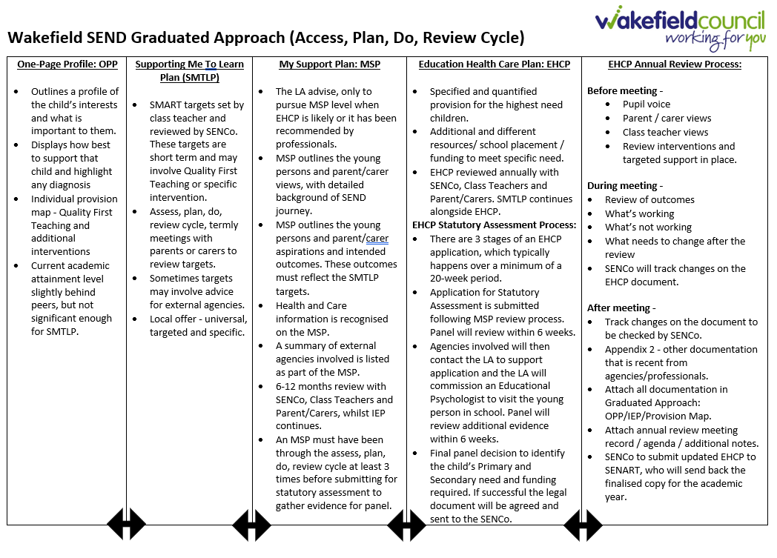

If a child’s needs are identified prior to entry, provision is put in place to ensure a smooth transfer from the onset. The admission of children with disabilities is discussed at a transfer meeting that is held prior to the child starting school. SEND children with Education Health Care Plans are admitted to school through Fair Access. Liaison is made with the Local Authority for support to ensure the facilities are in place for easy access arrangements. If there is a medical need a care plan is written and shared with parents. The school has toilet facilities and a lift for wheelchair users or children with reduced mobility. In order to support children who, have SEN we will continue to use a graduated response. We recognise that there is a continuum of SEN and where necessary will seek specialist expertise for support with barriers that a child may be experiencing.

Pupils receiving SEN provision will be placed on the school’s SEND register. These pupils have needs that can be met by the school through the Graduated Approach.
One-Page Profile (OPP)
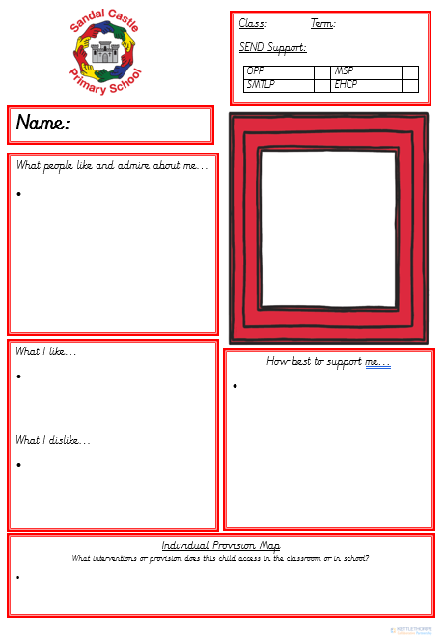
A One-page profile captures all the important information about a person on a single sheet of paper. Information is recorded as follows:

- Name and picture of the child
- Determined category of SEN support
- What people like and admire about me
- What I like and dislike
- How best to support me
- Individual Provision Map

Supporting Me to Learn Plan (SMTLP)

An SMTLP is a planning, teaching and reviewing tool for children and young people who require additional SEN support in the classroom. These targets have been set by the class teacher to support children in school and track their progress across the academic year. The targets are specific to the four areas of need, which will be identified by the class teacher as well as the support the child will receive to achieve these targets. These targets are reviewed termly by parents/careers, the class teacher and the pupil themselves across the school year. Parents and careers will receive updates on the child’s learning and progress following reviews.

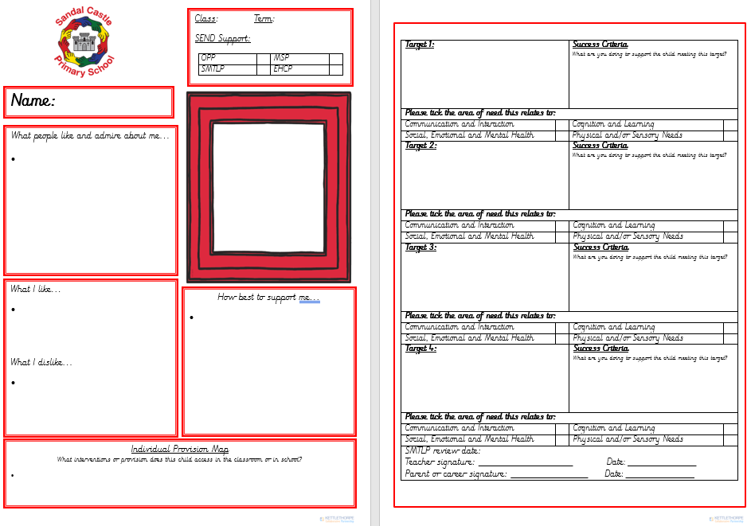

My Support Plan
A ‘My Support Plan’ will be considered when a pupil is working with a number of external agencies or when it is thought that a request for an Education, Health and Care needs assessment is needed. It is important to understand that an MSP is only started when an EHCP is likely to be achieved. The ‘My Support Plan’ documents the child’s strengths and needs in relation to the four areas of need and is reviewed when appropriate with the SENCo, class teacher, parents/careers and the child.

Request for an Education, Health and Care needs assessment
The majority of children with SEN or disabilities will have their needs met within a mainstream setting. Some children may need an EHC statutory assessment in order for the local authority to decide whether it is necessary to make provision in accordance with an EHC plan. A request will be made for an EHC needs assessment, when the outcomes set out in the ‘My Support Plan’ are not met, despite the best efforts of school and the involved external professionals. In some cases, this assessment will result in an EHC plan if all professionals are in agreement. It should be noted that an EHC needs statutory assessment will not always result in an EHC plan, but may indicate ways in which school can meet the child’s needs without an EHC plan.

A request can be made by:
- the child’s parent;
- a young person over the age of 16 but under the age of 25 and
- a person acting on behalf of a school or post-16 institution.

At Sandal Castle VA Community Primary, this person would be the SENCo and would always be with the knowledge and agreement of the parent/career. The assessment process is lengthy and, from the date of request submission, can take up to 20 weeks. An EHC plan is a forward-looking document that helps to raise aspirations and outlines the provision required to meet the assessed needs to support the child in achieving their ambitions. ECHPs are reviewed at least annually, where parents/careers and child will always be invited to these reviews, but there is no requirement to attend.

- Evaluating the effectiveness of SEN Provision

We evaluate the effectiveness of provision for pupils with SEN by:

- Tracking pupils’ progress, including by using provision maps
- Half termly monitoring, evaluation, review and analysis of individual progress on iTrack.
- Carrying out termly monitoring, evaluation, and analysis of IEPs
- Drop in consultations for class teachers with WISENDSS to receive anonymous advice and support.
- SENCo planning meetings termly with WISENDSS Advisory Teachers to discuss current/potential new cases and key transition points.
- SENCo Liaising with external professionals.
- Carrying out the review stage of the Wakefield Graduated Approach.
- SENCo’s holding annual reviews for pupils with EHC plans.
- Expertise and Training of Staff

Training will regularly be provided to teaching and support staff. The headteacher and the SENCo’s will continuously monitor to identify any staff who require specific training needs and will incorporate this into the school’s development plan for continuous professional development.
We will continue to raise the skills, knowledge and understanding of all staff as well as enabling individuals to develop higher levels of expertise in specific areas of need. Training for all staff will be delivered in a variety of ways reflecting the needs of the school community. Training requested by individuals as part of the performance management and pupil progress, will be considered by SLT and where appropriate be made available. External specialists will be brought in to offer advice to individual teachers about particular SEN children in their class.

- Links with external Professional Agencies

The school recognises that it won’t be able to meet all the needs of every pupil. Whenever necessary the school will work with external support services such as:
- Early Years SEND Team
- Speech and language therapists
- Specialist teachers or support services; HI and VI (WISENDSS)
- Learning Support Advisory Teachers / Transition Support Practitioners (WISENDSS)
- Educational Psychologists
- Occupational therapists or Physiotherapists
- General practitioners or pediatricians
- School nurses / Specialist nurses (Epilepsy, Epi-Pen, Asthma, Diabetes, Respiratory)
- Child and adolescent mental health services (CAMHS)
- Education welfare officers
- Social services
- Teams around school (TAS/ EYAS)

- Admission and Accessibility Arrangements
Admission arrangements
- Under normal admissions circumstances, all children will be offered a place, regardless of disability, if there is a place available within the year group, following our School’s Admission policy.
- Children who have an EHCP will be prioritised by SENART. This process will go through Consultation by our SENCOs who will provide a positive or negative response in line with the SEN Code of Practice.
- When a year group is oversubscribed, admission process will continue through Fair Access Panel (FAP).
Accessibility arrangements
- Please read our Accessibility Plan on the School website.
- Reasonable adjustments would be made, to meet the needs of the child

SEND Complaints Procedure

Where parents have concerns about our school’s SEND provision, they should first raise their concerns informally with the SENCo’s. We will try to resolve the complaint informally in the first instance. If this does not resolve their concerns, parents are welcome to submit their complaint formally. Formal complaints about SEND provision in our school should be made to the headteacher in the first instance. They will be handled in line with the school’s complaints policy, which can be found on the school website. If the parent or carer is not satisfied with the school’s response, they can escalate the complaint. In some circumstances, this right also applies to the pupil themselves.

To see a full explanation of suitable avenues for complaint, see pages 246 and 247 of the SEN Code of Practice.

To find out about disagreement resolution and mediation services in our local area please click on the following link: https://wakefield.mylocaloffer.org/education-health-and-care-plan-ehcp-information/appeals-and-disagreements/disagreement-resolution/

You can request mediation and tribunal information by clicking on the following link: https://wakefield.mylocaloffer.org/education-health-and-care-plan-ehcp-information/appeals-and-disagreements/mediation/
- Monitoring and Evaluation Arrangements

We are constantly looking for ways to improve our SEND policy. Therefore, we will evaluate how effective our SEND provision is with regards to:
- How early pupils are identified as having SEND
- Pupils’ progress and attainment once they have been identified as having SEND
- Whether pupils with SEND feel safe, valued and included in the school community
- Class teachers to attend transition meetings in July, for in house transition handover. This will ensure staff awareness of pupils with SEND from the start of the autumn term.
- SENCo’s may visit additional settings to support transition.
- Comments and feedback from pupils and their parents

- Monitoring the policy
This policy will be reviewed by the SENCO’s, Kelly Wiles and Rebecca Smethurst annually. It will also be updated when any new legislation, requirements or changes in procedure occur during the year. The policy will be approved by the full governing board.

- Links with other Policies and Documents

This policy links to the following documents:

- SEN information report
- The local offer
- Accessibility plan
- Behaviour policy
- Equality information and objectives
- Supporting pupils with medical conditions policy
- Attendance policy
- Safeguarding / child protection policy
- Complaint’s policy

