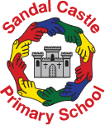

Sandal Castle Primary School Writing Policy

This policy outlines the purpose, nature and management of writing at Sandal Castle Primary School. The school policy for writing reflects the consensus of opinion of the whole teaching staff. The implementation of this policy is the responsibility of all the staff.

Vision
Developing writing skills is one of the core purposes of primary education. At Sandal Castle Primary School, we place the utmost importance on the development of writing skills across the curriculum. We want the children to feel enthusiastic and passionate about writing.

Aims
We strive for the children at Sandal Castle to be able to communicate confidently and effectively, not just in writing lessons but in every area of the curriculum. We believe that both boys and girls should have equal opportunities; they should be encouraged and supported to write to the best of their ability and succeed in English.

Objectives:
- To write with confidence, clarity, imagination and creativity.
- To understand the spelling system and apply these skills to write confidently and with increasing accuracy.
- To write with grammatical understanding and accuracy and become increasingly aware of the conventions of writing, including grammar, punctuation and spelling.
- To write in different contexts and for different purposes and audiences, including
themselves.
- To understand how to write in a range of genres in fiction and poetry using some of the structures of narrative in relation to setting, character and plot.
- To write non-fiction texts, using the features of different forms.
- To plan, draft, revise and edit, and sometimes publish own writing.
- To learn to appraise the writing of others critically and constructively.
- To develop a technical vocabulary through which to understand and discus writing.
- To form letters correctly, leading to a fluent, cursive and legible style of handwriting.
- To become familiar with and competently use reference books such as dictionaries and thesauruses.

Entitlement
Children in both key stages will be taught an increasing range of key skills. The school will create and maintain a stimulating environment for children to experience and explore writing with confidence and enjoyment. All children’s work will be celebrated and displayed to show the wide range of skills that are being taught, each key stage will have a hall of fame for writing. We will maintain writing as a valued, high-profile activity which accesses the whole curriculum. Writing will be celebrated during our celebration collective worship on a Friday.

Teaching and Learning
Children work in mixed ability groups within their class. Work is differentiated by task, by adult support where appropriate, and by expected outcome. We recognise the importance of challenging and extending more able children as well as supporting those with specific learning difficulties who are following an IEP.

The Writing Process at Sandal Castle

Early Years Foundation Stage (EYFS): Communication, Language and Literacy provision
- Early Years at Sandal Castle provides a supportive and nurturing environment in which the children can develop their early skills as a communicator, reader and writer.
- Skilled adults in EYFS support children with developing their language through child initiated and adult led learning.
- EYFS is an enabling environment where all children can learn.
- There is a well organised writing area that includes a variety of different resources for mark making and writing such as different types of paper, writing tools, fasteners, envelopes, notepads, post it notes, magnetic letters, RWInc handwriting phrases and words for children to use in their writing.
- In addition to the writing area, writing resources and mark making materials are available for children to use in each area of learning in the EYFS to support and encourage the children to mark make in every opportunity e.g- large rolls of paper and labels in the construction area, clipboards in the small world area.
- A listening station provides opportunity for the children to listen to stories and rhymes
- Puppets, props and small world resources are available for role-play.
- The outdoor environment provides opportunities for developing language, reading, mark-making, writing and role-play.
- Activities to develop children’s fine and gross motor skills are provided e.g. building, practising writing patterns with big brushes and water, making dens, mud kitchen etc.
- Children are able to access ICT, including torches, recording devices, camera's, torches, remote control bugs, computers and ipads - which have suitable software in use.
- The interactive whiteboards are accessible to the children.
- Inviting book corners are well organised with quality books - books created by our children, TFW story maps, fiction, non-fiction and rhyme books.
- Displays celebrate children’s achievements and support children’s future learning, being interactive where appropriate. They also include handwritten text, speech and captions from adults and children.
- In the EYFS daily Read Write Inc sessions take place that are differentiated in to different groups and regular literacy opportunities are available through the week.
- These are supported by linked independent and adult directed activities.
- These are to be clearly described on planning with the use of learning intentions and key questions, along with details of differentiation.
- Core texts are used to develop children's love of books

EYFS and Year 1

The ‘Talk for Writing’ programme will be used to teach writing in the EYFS and Year 1.
Talk for Writing strategies will be used frequently both within literacy lessons and across the curriculum. The ‘Talk for Writing’ approach involves making explicit the processes and thinking involved in the writing process, so that ultimately, they can be internalised and applied by children in their own writing. Talk for Writing will be embedded in every phase of the ‘Writing Sequence’.

The main principles of Talk for Writing are;

Imitation – talk that helps children to think and behave like a writer, it gives them the confidence to be able to write by learning and repeating oral stories and texts continuously until the children know the text off by heart, building their confidence of new vocabulary and sentence structure.

Innovation – taking the story or text that the children have learned during the imitation stage, adapting the text using their own ideas, adding new vocabulary or new ideas and then becoming familiar with the new version - preparation and rehearsal for writing through shared and guided writing.

Invention – children eventually creating and writing their own version after having their confidence built up and having being taught the skills in order to do so.

In the EYFS and Year 1 the children will also use the Read Write INC programme to develop their understanding of sentence structure and basic grammar skills.

Year 2
In year 2 the ‘Talk for Writing Programme’ will continue to be used for writing narrative, although there will be a much stronger focus on the ‘invent’ stage of the process. This will allow the pupils to be more creative and develop more independence as the progress to the juniors. For non-fiction pieces the ‘Text Based Approach’ will be used. (See below)

The Text based approach to writing- Year 2 and KS2

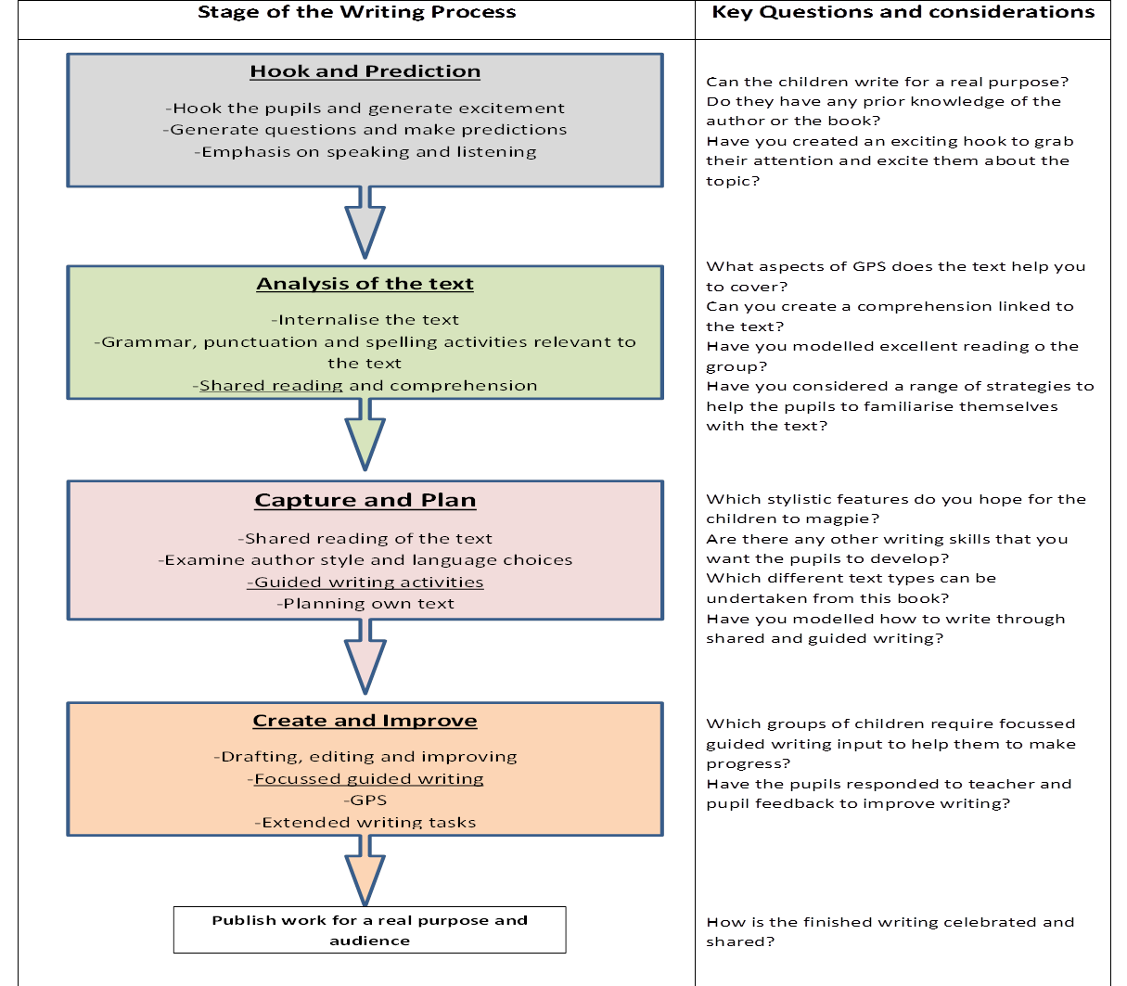

KS2
Across KS2 the ‘Text Based Approach’ for writing is used to teach both fiction and non-fiction.

Long term planning in Key Stage 2 should include:
- Three classic texts a year- 1 each term that are linked to a year group topic where possible.
- Two poetry units.
- A unit linked to ‘current affairs’ or a school focus area. (Olympics, election, healthy school week, Primary Futures.)
- A unit linked to an educational visit/external visitor.
- An extended author study (studying several texts from an author)

The Text Based Approach essentially allows for one inspiring, exciting text to be the stimulus for the pupils to write in a range of genres and for different audiences and purposes. We aim for the majority of the chosen texts to reflect other areas of the curriculum so that cross curricular writing can take place. The pupils will work systematically throughout the following stages:
- Hook and Predict
- Analysis of the Text
- Capture and Plan
- Create and Improve
Wherever possible we endeavour for the children to write for a real purpose and for a real audience to provide extra motivation.
As a school we ensure that the following strategies are employed in English lessons to ensure that lesson time is being maximised to promote good writing progress for our pupils:

- Shared Writing
Shared writing takes place within the English lesson; the teacher models the writing process to the whole class as an expert writer, articulating the process. Teaching objectives are pre-planned and sessions are characterised by explicit teaching of specific writing strategies, oral response and high levels of collaboration and discussion with the children. The children join in individually or through group work, where appropriate.

- Guided Writing
Guided writing takes place as part of a guided session at least once within a unit of work. During guided writing, the responsibility for writing shifts to the learner. Guided writing takes place with a group of children with similar writing targets/needs. During a guided writing session the children will write with a teacher or ESA supporting. It is intended that guided writing provides a forum for children to demonstrate what they have learned about writing and to further develop and extend their writing skills.

- Role-Play and Drama
We recognise the importance of developing the speech and language skills of our pupils by providing them with regular opportunities to undertake a range of drama and role-play tasks. Traditional favourite techniques are used to develop ideas and skills such as; hot seating, conscience alley, freeze-framing etc.

- Proof-reading and Editing
Opportunities for proof-reading are built into English lesson time. Following guidance from the teacher, the children are responsible for proof-reading their own work in order to identify and correct their own mistakes. The children are also taught how to edit their own work to make improvements. Pupil edits are completed in purple pen to clearly show how the writing has been up-levelled by the pupil.

- Independent Writing
All children are given opportunities to apply their understanding of the text type in their own writing. This is vitally important if children are to develop their skills as writers within different genres. The children will constantly proof-read and edit their own writing following feedback from their peers and from the teacher and ESA.

Writing Inspiration Events
Gifted and Talented events and days are planned in the school year to excite learners and provide a meaningful context to writing. Writing Inspiration Days provide an opportunity for all children to access and write about, e.g. a crime investigation situation, a satellite landing, time machine etc… During these events, writing will be centred on children’s experience to enhance their motivation to write.

Moderation of Writing
Moderation takes place in house 3 times a year. All teachers bring a sample of writing to the meeting and they have professional dialogue to discuss the level at which the child is working. This takes place across the key stages to ensure consistency across school.
Within individual teams across school, moderation also takes place to ensure consistency across Key Stage One, Lower Key Stage Two and Upper Key Stage Two.

Furthermore, moderation also takes place three times a year within the local authority pyramid to ensure good practice and secure levels with other teachers of the same year group. We believe as a school that this is important to secure our judgements and it benefits the teachers as professionals, as they gain in confidence and knowledge on levelling and moderating a child’s writing.

A child's progress will be reported to the parents through parents’ evenings twice a year and progress will be formally reported to parents at the end of the academic year.

End of Key Stage assessments and test results will be reported in line with statutory requirements to the local authority.

Teaching English to Children with Special Needs and Inclusion
English forms a major part of the school curriculum policy to provide a broad and balanced education for all children. Teachers draw up Individual Education Plans (IEPs) and provide learning opportunities to match the needs of children with learning and/or behavioural issues. These are then made available to the SEND Co-ordinator. Targets take into account the individual needs of the child and are set down in child-friendly terms. They are reviewed regularly. We seek to include the child and parents/carers in the monitoring process of these targets. Teachers, TAs and Higher Level Teaching Assistants provide support to those children with individual difficulties in accessing the curriculum.

Gifted and Talented Children who are working well above the overall level of their class or group will engage with a range of experiences designed to broaden or deepen their learning, whilst working on the same learning objectives as their peers. Occasionally they may also be accelerating the pace of their learning by working towards objectives chosen from a later year.

English as an Additional Language Pupils (EAL)
Children learning English as an additional language will be assessed as soon as possible after joining the school, and children who are new to the country or have very little English will have timetabled additional support with our EAL Support Worker.

