Year 5 Writing Spine 2025 - 2026
 | Autumn 1 | Autumn 2 | Spring 1 | Spring 2 | Summer 1 | Summer 2
Week 1 | Baseline | 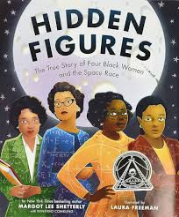 | 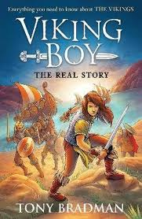 | 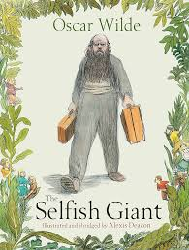 | 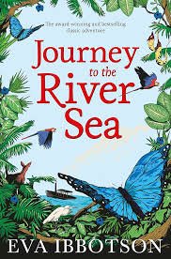 | 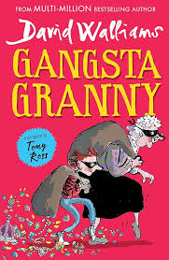
Week 2 | Baseline
Week 3 |  |  |  | 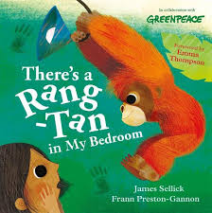
Week 4 |  |  | 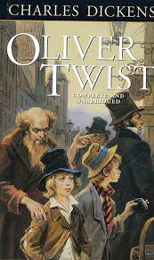 |  | 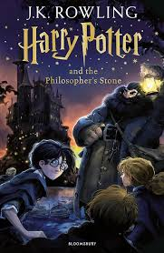 | Discussion  Crime and punishment
Week 5 |  |  |  |  |  | Discussion  Crime and punishment
Week 6 | 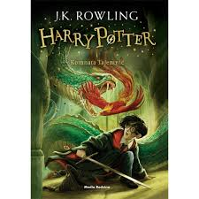 |  |  |  |  | Discussion  Crime and punishment
Week 7
Week 8

