Year 4 Writing Spine 2025 - 2026
 | Autumn 1 | Autumn 2 | Spring 1 | Spring 2 | Summer 1 | Summer 2
Week 1 | Baseline |   Diary entry | Instruction texts - How to look after a dragon | 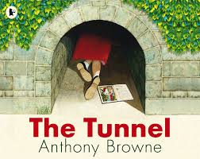  Narrative | 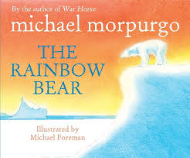  Newspaper report | 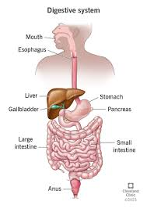  Explanation
Week 2 | Recap | Diary entry | Instruction texts - How to look after a dragon | Narrative | Newspaper report | Explanation
Week 3 | Narrative  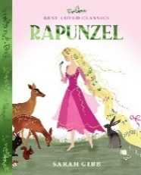 | Diary entry | Instruction texts - How to look after a dragon | Narrative | Newspaper report | Explanation
Week 4 | Narrative  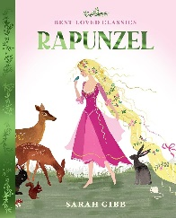 | 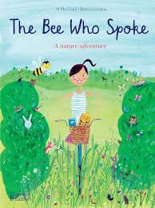  Non cron | 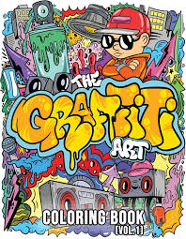  Persuasive letter | Description  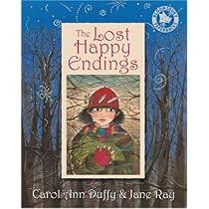 | Trip | 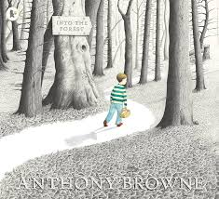  Narrative
Week 5 | Narrative | Non cron |  | Description | Trip | Narrative
Week 6 | Description  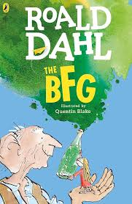 | Non cron |  |  | Trip | Narrative
Week 7 | Description | Christmas poems
Week 8 | Description

