Year 3 Writing Spine 2025 - 2026
 | Autumn 1 | Autumn 2 | Spring 1 | Spring 2 | Summer 1 | Summer 2
Week 1 | Baseline | 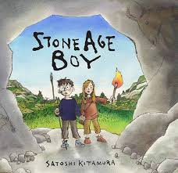 | David Attenborough | 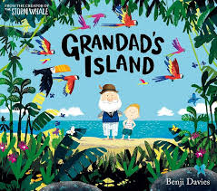 |  | 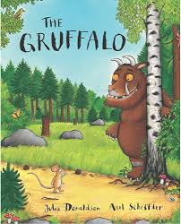
Week 2 | Baseline |  | David Attenborough
Week 3 | 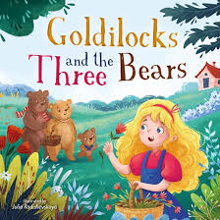 |  | David Attenborough |  | 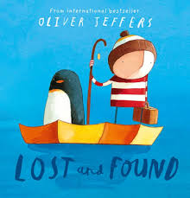
Week 4 |  | Assessment week | Trip | 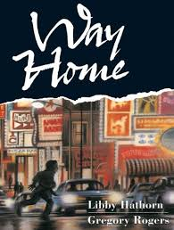 |  | 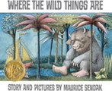
Week 5 |  | Letter to Santa/Christmas | Trip |  | 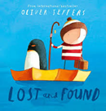
Week 6 |  | Letter to Santa/Christmas | Trip | 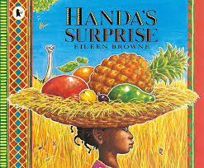
Week 7 |  | Letter to Santa/Christmas |  |  |  | Letter to new teacher
Week 8

