Year 2 Writing Spine 2025 - 2026
 | Autumn 1 | Autumn 2 | Spring 1 | Spring 2 | Summer 1 | Summer 2
Week 1 | Baseline | 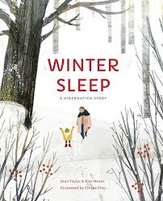 | 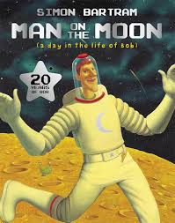 | 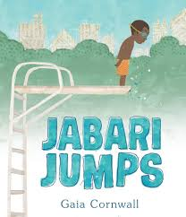 | 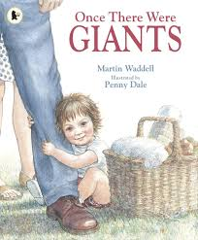 | 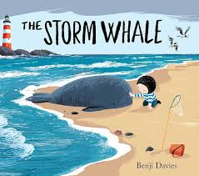
Week 2 | Recap Yr. 1
Week 3 | 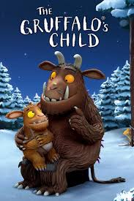 |  |  |  |  | Trip
Week 4 |  | 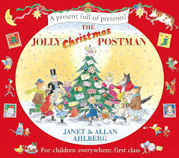 | 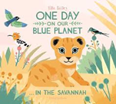  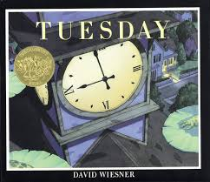 | Poetry |  | Trip
Week 5 | 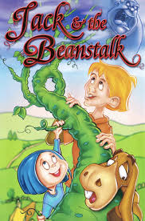 |  | 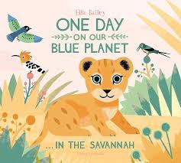 | Poetry |  | Letter to new teacher
Week 6 |  |  |  | Poetry |  | Letter to new teacher
Week 7 | Trip | Christmas Activities
Week 8 | Trip

