Year 4 Newsletter: Autumn 2

Dear Parents/Carers,

It’s the end of a long half term and we would like to provide you with some information as to what your children will be focusing during the upcoming half-term.
Next half term in Year 4, the children will be completing works on Science, History and R.E. We will be looking at states of matter in Science. This will include: focussing on grouping materials into the different states and looking at the concept of evaporation and condensation. In History, we will be focussing on Ancient Greece. In R.E we will be studying, ’What does it mean to be a Sikh in Britain?’.
Maths
This half term in Year 4, the focus in our maths lessons will be mainly on multiplication and division. Multiplication tables will be a key focus ready for the multiplication tables check in May.
English
This half term in Year 4, we will be writing a recount in the form of a diary and a fact file.
Collective Worship
This half term is ‘Ordinary Time’ moving to Advent in the church calendar. In our Collective Worship we will be looking at Remembrance and visiting Church to celebrate Christmas. This half term we will be focussing on our school value of understanding.
Book Bags/Reading Book Changing
Children will bring their school reading book into school EVERY DAY, as they will be reading on a daily basis. Their books will then be changed and returned as and when required.

Homework
Homework will be handed out on a Friday and needs to be returned the following Wednesday. Please ensure children complete their homework as this will support learning that has taken place in class.
Maths homework is set online using White Rose Infinity. Children will also receive a spelling task to be completed in their green homework books. If you have any difficulties in accessing the maths homework, please let your child’s teacher know.

Other Important Information
 | Day | What will I need to bring/come to school in?
P.E. | Monday – 4RH(outdoor)  Wednesday- 4AD and 4RQ(indoor)  Thursday-4AD and 4RQ(outdoor) | Wear PE uniform including suitable outdoor clothing and footwear.
Swimming | Tuesday - This will be on a rota basis and will change half-termly.  Autumn term 2: 4RH | Swimming kit, towel.
Forest School | Monday - This will be on a rota basis and will change half-termly.  Autumn 2-4AD | Appropriate coat and footwear.
If you need to contact your child’s year group or teacher for any reason, the email address is: contactyear4@sandal.wakefield.sch.uk
This will be checked regularly, and will be replied to during school working hours.
Thank you and here’s to a wonderful half term!

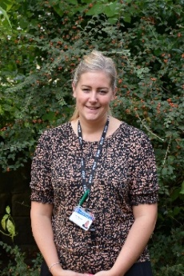
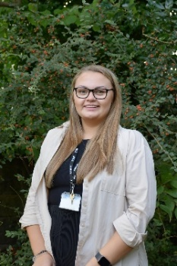
Miss Quayle, Miss Dickinson and Mr Holt

