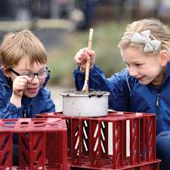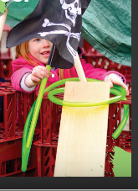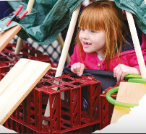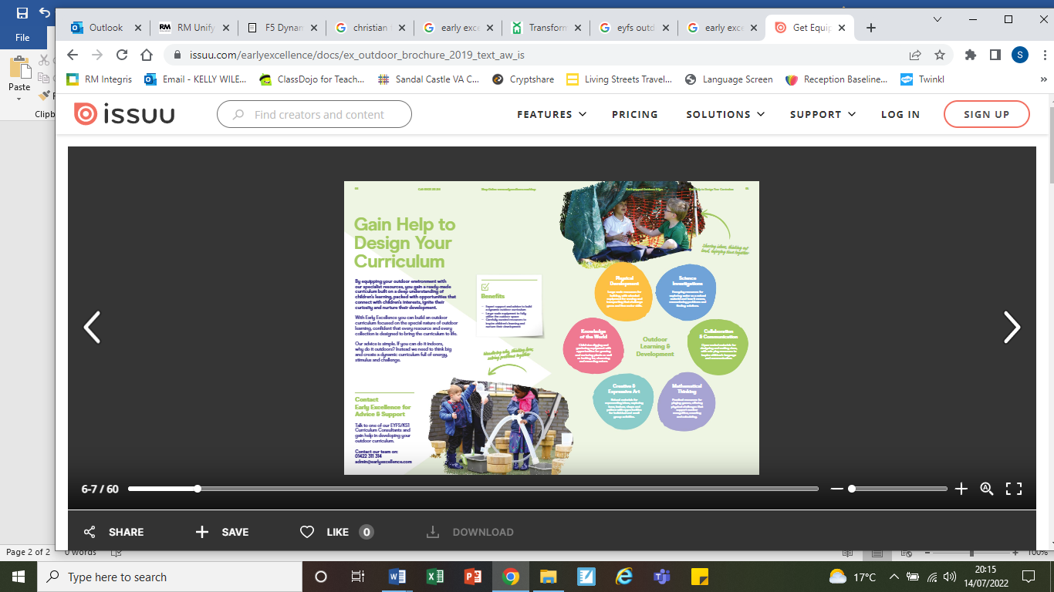

Welcome to the Early Years Foundation Stage (EYFS)
If you have any questions please don't hesitate to contact us, you can email our class email – contactfoundation@sandal.wakefield.sch.uk
Mrs Wiles, Mrs Woodcock and Mrs Payne

Enabling Environments
At Sandal Castle Primary we acknowledge that the environment plays a vital role in supporting and extending the children’s development. We aim to create an attractive, welcoming and stimulating learning environment, which will encourage children to explore, investigate and learn through first-hand experience. We also aim to make it a place where children feel secure and confident and are challenged to develop their independence. Activities are planned for both the inside and outside environment. Children have the freedom to move between the indoor and outdoor classroom during child-initiated learning time.
Children have access to a wide range of equipment including construction materials, role play equipment, small world, sand and water equipment, art materials, musical instruments, ICT equipment, mark making materials, counting equipment, books, larger outdoor equipment and specialist PE equipment. All areas are carefully planned to reflect learning needs, the theme and children’s interests.
All children and adults are expected to take responsibility for the care of and use of resources and the environment and we believe that supporting the children and helping them to look after and respect their environment is a very important part of a child’s development. We encourage children to tidy up as they go through the day and we also have ‘Tidy Up Time’ before lunch and at the end of the day as this offers a valuable opportunity for talking, reading, problem solving, reasoning, counting and sorting activities.
How the environment supports the curriculum
We believe that developing a learning environment that allows the children to select their own resources is a crucial part of creating independent and curious learners. Adults support the children to select the things they need to follow their interest. Often when a new interest develops the adults will then adapt the environment and resources to support this thread of learning.
Our long-term plan sets out our intent for the year and we acknowledge that there will be always flexibility within this in order to react to interests and development. Our team produce a weekly plan which outlines the learning intentions to be focused on in each area of learning and show how those activities and experiences will be delivered through ‘Adult Led’ and ‘Child Initiated’ learning opportunities. Planning is therefore constantly developed, adapted and evaluated through ongoing observations of child initiated or spontaneous activity and planned opportunities (indoors and outdoors). Assessment for learning is crucial in response to children’s developmental needs and interests. The learning intentions are also informed by a thorough knowledge of child development enhanced by reference to the ‘Development Matters’ document.

Key information:
- PE will take place on a Tuesday. Please make sure your child comes to school in their PE kit on those days
- All children should wear uniform which is clearly named.
- Drop-off time is 8:45am. Pick-up time is 3.15pm. Please drop off and collect your child from the classroom doors in the EYFS outdoor area
- Please ensure your child has a spare set of clothes in school every day.

Curriculum Information
Throughout the Reception Year your child will partake in an ambitious curriculum which is designed in a sequential way to ensure progress towards our end of year curricular goals. See below

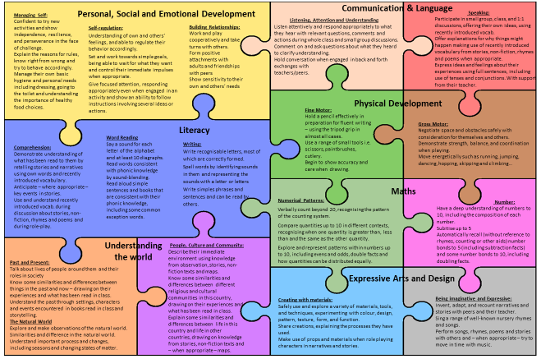

An overview of the Reception Year
Learning in EYFS often takes us to wonderful places but please see below for a general overview of themes for the year.

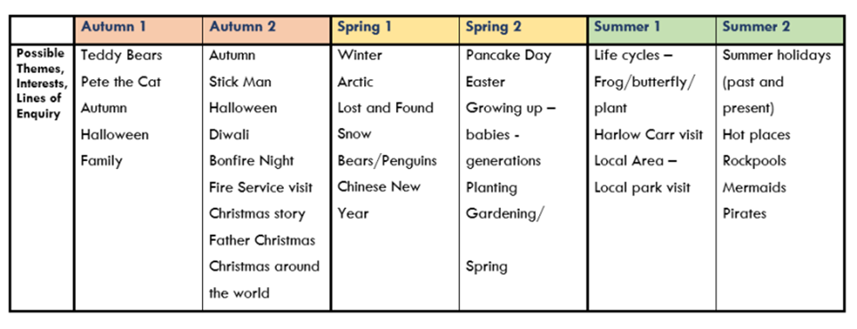

RWI Phonics

Read Write Inc (RWI) is a complete phonics and literacy programme which helps all children learn to read fluently so they can focus on developing their skills in comprehension and vocabulary. The programme is designed for children aged 4-7. However, we will continue teaching RWI to children as an intervention beyond the age of 7 if they still require support in their reading. RWI was developed by Ruth Miskin and more information on this can be found at https://ruthmiskin.com/en/find-out-more/parents/.

Five key principles underpin the teaching in all Read Write Inc. sessions:
Purpose: know the purpose of every activity and share it with the children, so they know the one thing they should be thinking about
Participation: ensure every child participates throughout the lesson. Partnership work is fundamental to learning
Praise: ensure children are praised for effort and learning, not ability
Pace: teach at an effective pace and devote every moment to teaching and learning
Passion: be passionate about teaching so children can be engaged emotionally.

How will RWI be taught?
All children are assessed regularly by our RWI lead teacher so they are grouped with children at the same level. This allows lessons to be pitched at the correct level and ensures full participation.

​
Reception
In Reception children will learn how to ‘read’ the sounds in words and how those sounds can be written down. They then access short age appropriate texts daily. In Year 1 children follow the same format as Reception but will work on complex/alternative sounds and read longer books appropriate to their reading level.

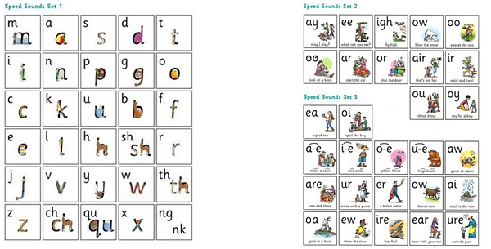

Reading
The children:
- Learn letter sounds and the corresponding letters using simple picture prompts
- Learn to read words using Fred talk and sound blending
- Read from a range of storybooks and non-fictions books matched to their phonic knowledge
- Develop comprehension skills in stories by answering 'Find It' and 'Prove It' discussion questions

Writing
The children:
- Learn to write and form the letters/letter groups which represent the 44 sounds with the help of fun phrases
- Learn to write words by using Fred Talk and Fred Fingers
- Learn to build sentences by practising sentences out loud before they write

Talking
The children:
- Answer every question
- Practise every activity with their partner
- Take turns in talking and reading to each other
- Develop ambitious vocabulary

Read, Write Inc Terminology
At school we use a puppet called Fred who is an expert on sounding out words!

The following video is an example of blending sounds with Fred. https://www.youtube.com/watch?v=dEzfpod5w_Q
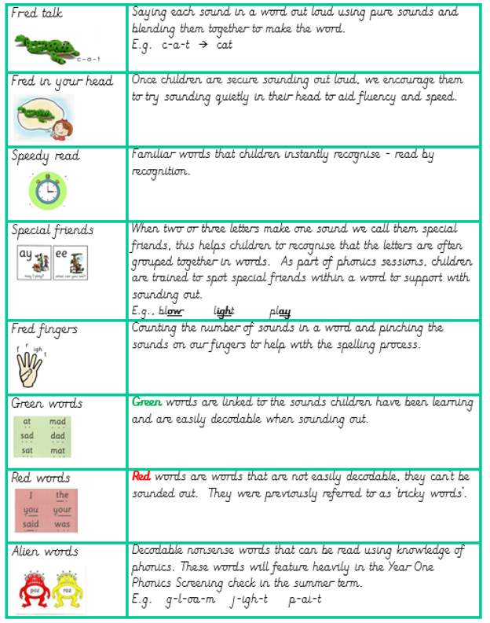

RWI Expectations of Progress

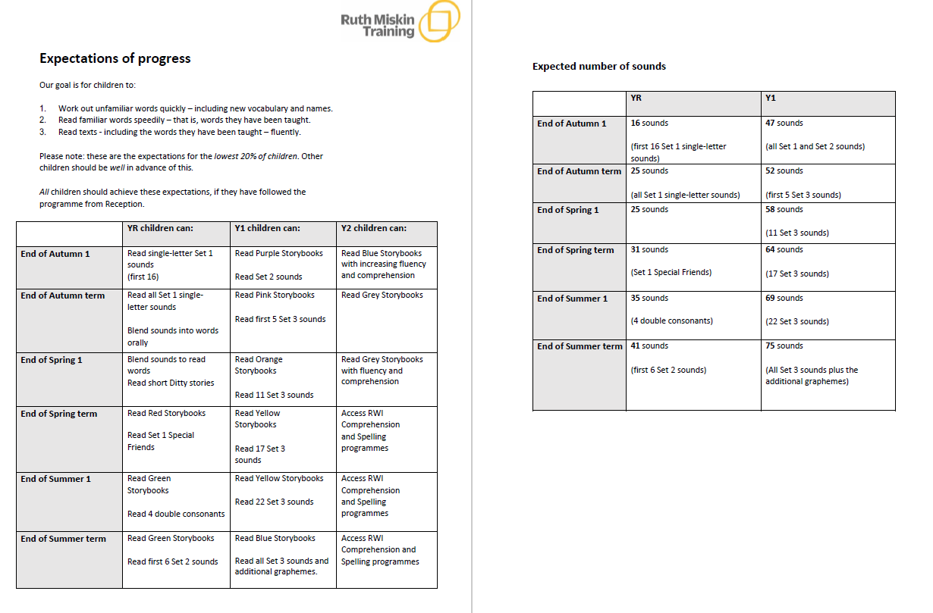

Mathematics

Across Reception and KS1, we have implemented a new and exciting Mastering Number maths project. This project aims to secure firm foundations in the development of good number sense for all children from Reception through to Year 1 and Year 2. The aim over time is that children will leave KS1 with fluency in calculation and a confidence and flexibility with number. Attention will be given to key knowledge and understanding needed in Reception classes, and progression through KS1 to support success in the future.

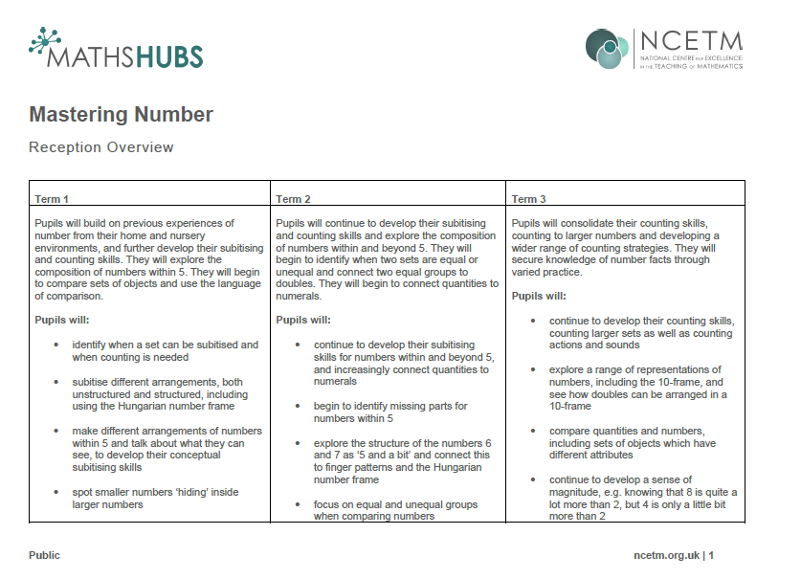

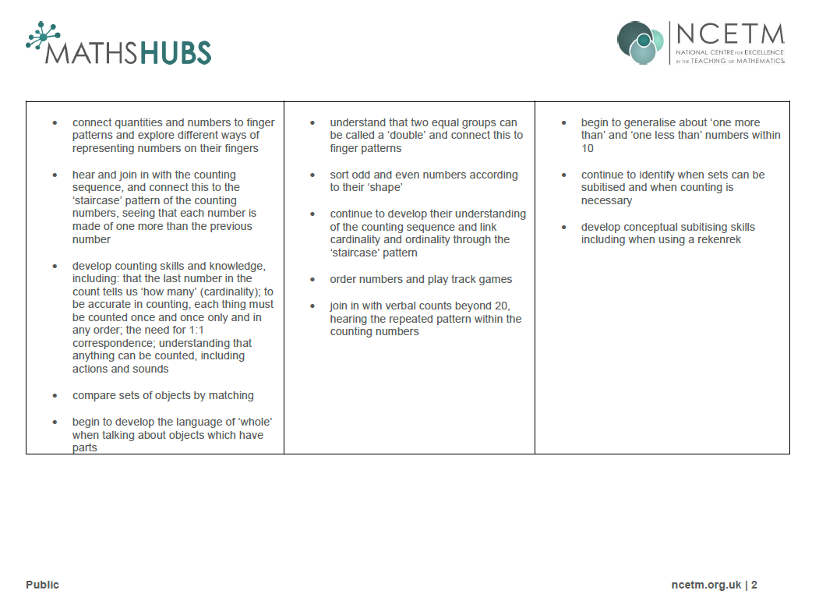

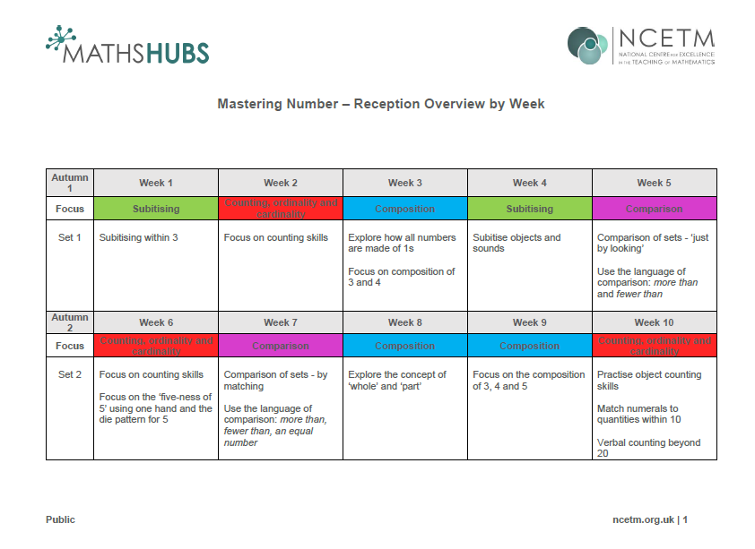

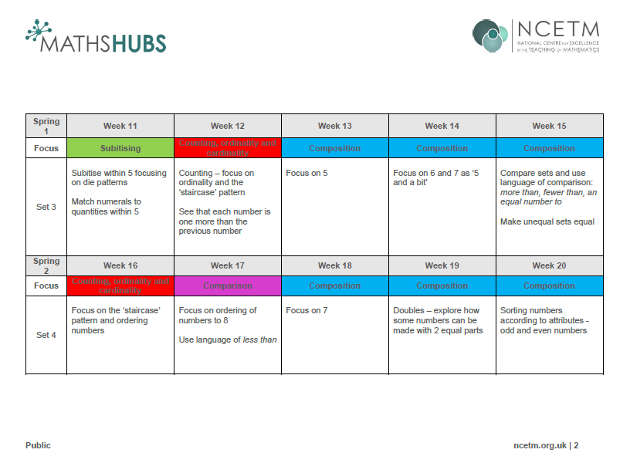

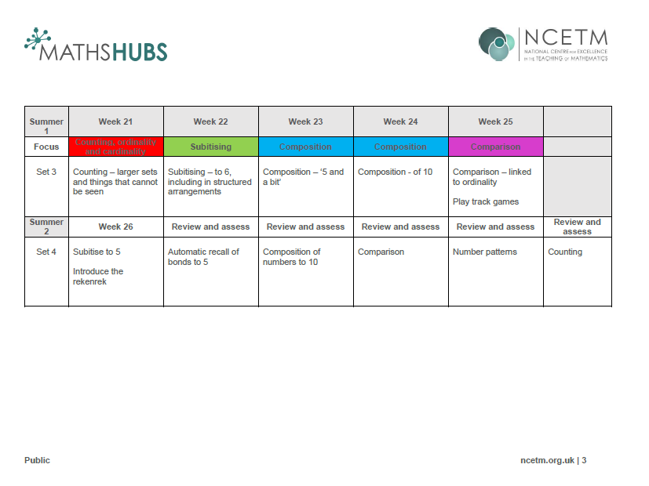

We Use White Rose Maths to plan and teach Shape, Space and Measures.

How to support your child at home
Your child will start to bring books home when they are confident at reading the sounds they know. Please find time to listen to them read, have patience and give lots of praise!

Mathematics Support
There are six key areas of early mathematics learning, which collectively provide a platform for everything children will encounter as they progress through their maths learning at primary school, and beyond:
- Cardinality and Counting
- Comparison
- Composition
- Pattern
- Shape and Space
- Measures

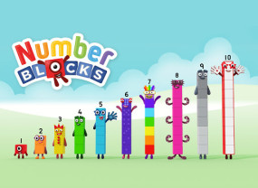
These areas form the fundamental mathematical basis of a CBeebies series of five-minute animated programmes called Numberblocks.

You may also like to check out the EYFS websites below:
- White Rose Math White Rose Maths Team has prepared a series of five maths lessons for each year group from Year 1-8. Every lesson comes with a short video showing you clearly and simply how to help your child to complete the activity successfully.
- Active Learn: Read online Bug Club Books and visit the Math Factor.
- Numberblocks: Sing along and learn all about numbers with the Numberblocks!
- Alphablocks: Watch as the letters of the alphabet tell stories and make words using phonics. Play the learning game, watch clips and print colouring pages.
- Epic Phonics: One month free membership.
- Phonics Play: You will find lots of games and ideas to explore with children at home. Free membership.
- Stay at Home Story Time: Oliver Jeffers will be reading one of his books every weekday and talking about some of the things that went into making it.
- Time To Come In, Bear written by Kim St. Lawrence - A story explaining social distancing to young children

Photos



