Sandal Castle VA Community Primary School
Reading GEMS Progression Document
As a whole school, we have worked together to create a document which reflects the progression of skills in our reading lessons. We felt that the enjoyment of reading is a key part of our whole school ethos, and not limited to reading lessons, so we have chosen to have this as a starting point for our document.
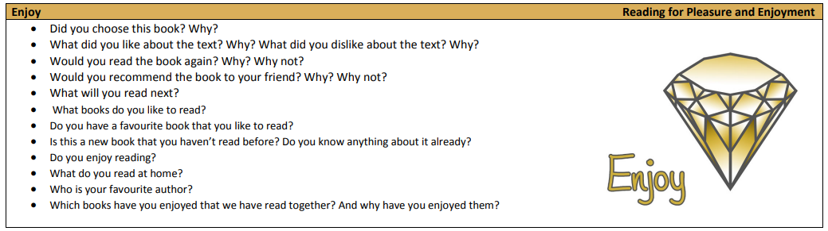

EYFS
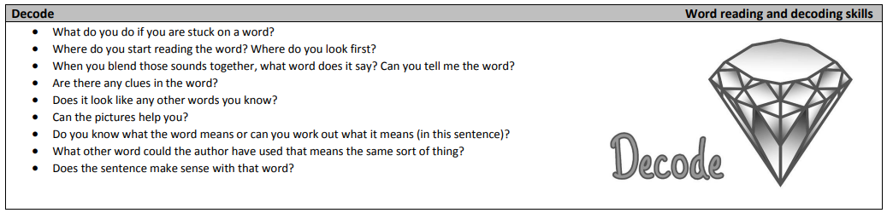

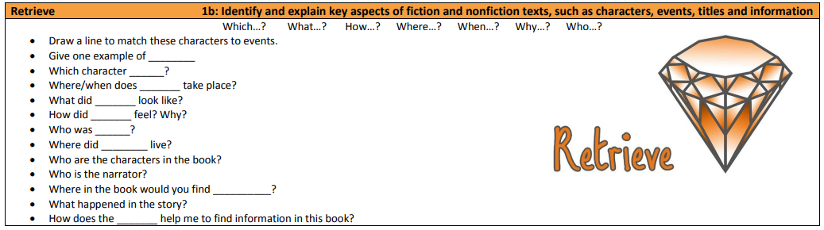

Key Stage 1
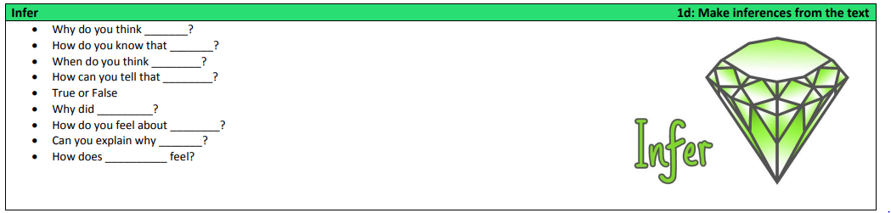

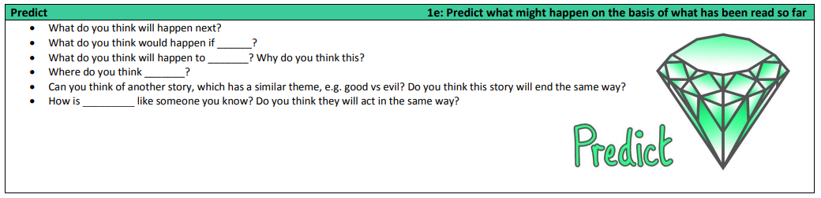

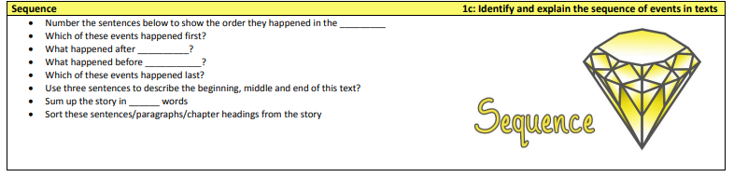

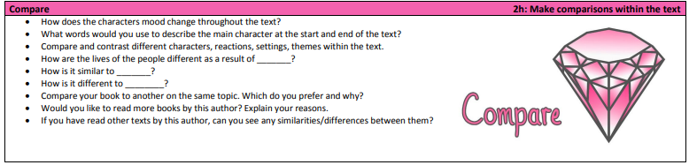

Lower Key Stage 2
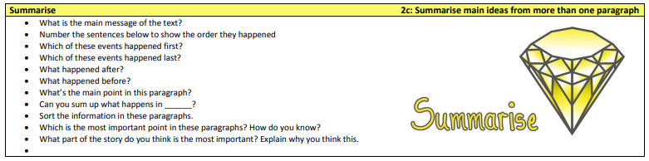

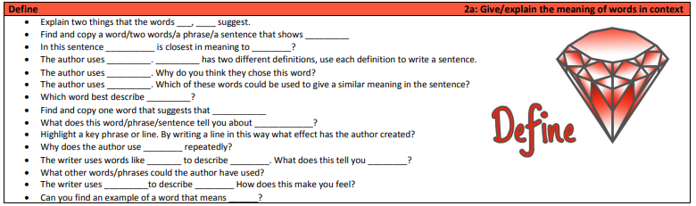

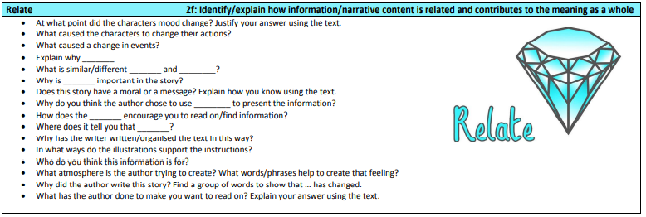
Upper Key Stage 2



