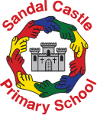
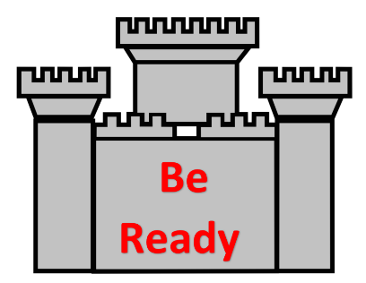
We are delighted to share our new behaviour plans with you, which will be launched after the Easter holidays!
Building Strong Futures Together

Our new Behaviour Policy

Why change the current policy?

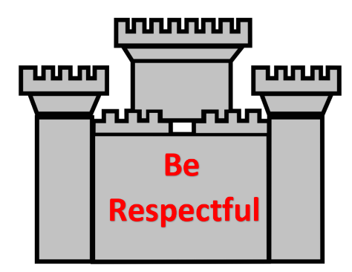
We have spoken to our School Council representatives and lots of our parents who feel that our current model is old fashioned and has lost its impact. We also feel strongly that our well-behaved children don’t gain enough kudos for their good behaviour choices!

Introducing our four new School Rules:

What do these mean in practice?
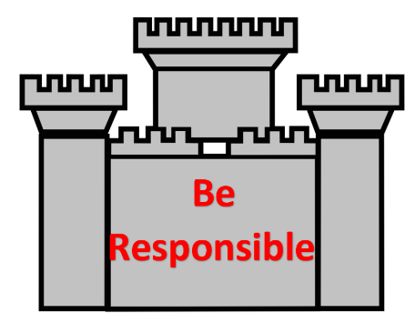
- Being Safe is : keeping yourself and others away from harm
- Being Responsible is : taking care of yourself and your environment
- Being respectful is : being kind to others and your environment
- Being Ready is : ready to learn and be a good Sandal Castle Ambassador!

How will our children be rewarded?
Every child (and adult) in School will be placed in a House team. Our House names have been chosen by our School Council. Our Houses are:
- Warren (blue team)
- York (green team)
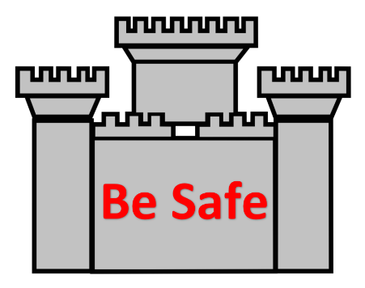
- Rutland (red team)
- Clifford (yellow team)
When our children follow our School rules, they will be rewarded by House points. Every week, the house points will be collected by our House Captains and celebrated in our Friday afternoon Collective Worships.
Every half term, our children will receive certificates and prizes to take home and enjoy!

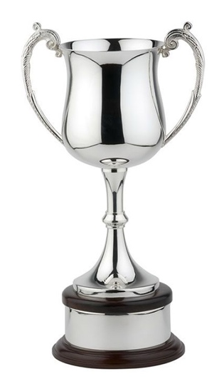
How will behaviour be rewarded?
In every learning space, there will be a golden star and a traffic light. At the beginning of every half term (approximately six weeks) every child’s name will be on the golden star. The aim is to remain on the golden star to receive the star treat at the end of the half term. The Star treats will be exciting events, chosen by the School Council such as glow in the dark discos, picnics, circus skills, water fights etc. Parents will also be invited every year to one of our Friday Celebration Collective Worships to share their child’s success!
If unfortunately, a child displays ‘low level’ poor choices, they will be given three opportunities (using a green, amber and red- traffic light system) to address their behaviour. If the child continues to present poor choices, they will gain a ‘red’ and be expected to attend a same day inclusion with a member of our Senior Leadership Team. During the inclusion, they will undergo some restorative practice conversations. Some inclusions may be after School and require parents to attend.

Once off the golden star for that half term, they will remain on the green traffic light and will not receive the star treat. They will go back onto the golden star at the beginning of the new half term.

How will I be kept informed?

After every red given, the child’s parent will be sent a message through our ParentPay communication system. This will explain the reason for the red and the consequence given.
At certain points, parents will invited into School to discuss behaviour concerns and ways in which we will work together to support their child going forwards.
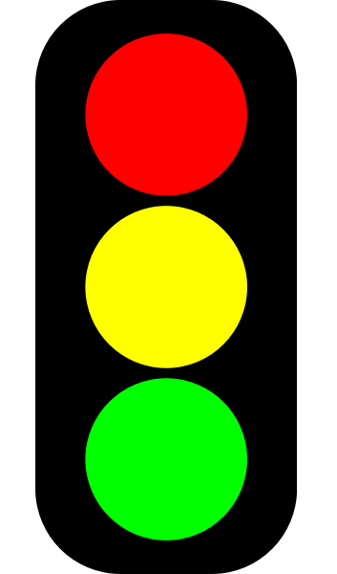
Year 6 Hoodies of Responsibility
Our Year 6 pupils will receive ‘hoodies of responsibility’ which will be purchased by us. These are to be worn with pride! However, if a child receives two reds in a half term, sadly the hoodie will be removed and the child will be expected to return to their normal school jumper. The child will be given a time frame to earn their hoodie back, through improved attitude and responsibility.

What about Children with Additional Needs?
Our staff will support children who have additional needs to be able to access our new behaviour policy. Reasonable adjustments will be made for this and this will be shared with the child and parents through their Individual Education Plan (IEP).

