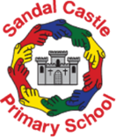 | Sandal Castle VA Community Primary School  Knowledge, Skills and Vocabulary Progression (KSV)  Art
Knowledge and Skill Progression
What should an age-related pupil know and be able to do in each year group? (expectations)
Highlight-Cross curricular link

 | EYFS | Year 1 | Year 2 | Year 3 | Year 4 | Year 5 | Year 6
Drawing | Enjoys making marks, signs and symbols on a variety of types of paper.  Begin to show accuracy and care when drawing.  Showing confidence in controlling the pencil and its movement.  Self portraits  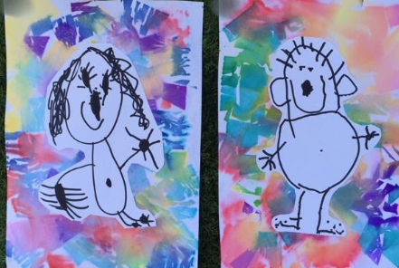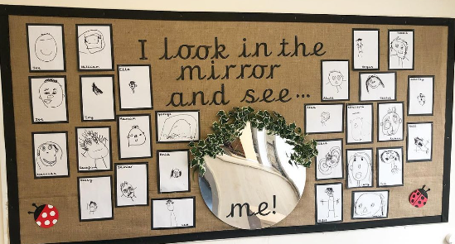 | To use drawing to develop and share their ideas, experiences and imagination.  To hold a pencil correctly showing control.  To draw lines of different length using the terms longer and shorter.  To create lines of different types (horizontal, vertical, diagonal, wavy, zig-zag, loop, parallel).  To draw lines of different thickness using the terms thicker and thinner.  To follow a continuous line.  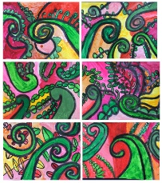  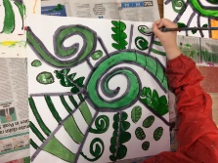  (Y1 artwork inspired by Raewyn Harris)  https://primaryschoolart.com/category/year-1-2/ | To use drawing to develop and share their ideas, experiences and imagination.  To apply different pressure when colouring.  To add dots to a drawing with precision.  To add lines on to a drawing effectively.  To create a contrast with light and dark tones whilst using dots to show depth.  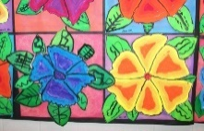  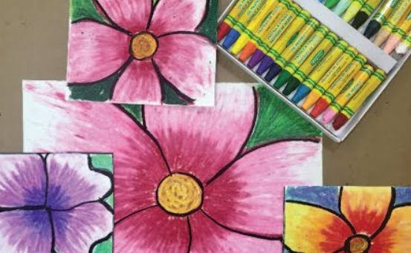 | To improve their mastery of art and design techniques including drawing with a range of materials.  To understand the term hardness.  To select the correct hardness to show shadow.  To select the correct hardness to show light.  To sketch lightly without rubbings.  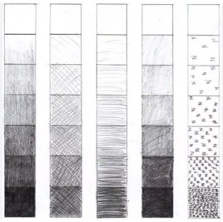  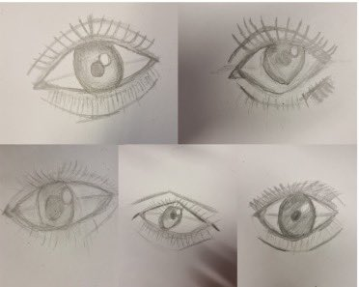 | To improve their mastery of art and design techniques including drawing with a range of materials.  To explain the term texture.  To practise the hatching technique.  To practise the crosshatching technique.  To develop their own unique ways of creating texture.  Useful links:  https://www.bbc.co.uk/bitesize/guides/zpb7qty/revision/5#:~:text=Van%20Gogh's%20The%20Starry%20Night,suggest%20that%20they%20are%20twinkling.  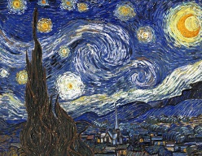  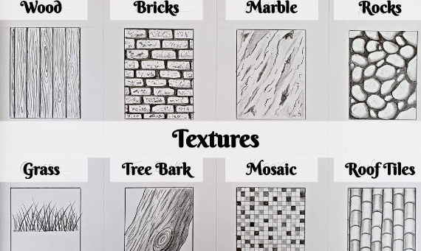 | To improve their mastery of art and design techniques including drawing with a range of materials.  The children should be taught further drawing techniques (feathering, circlism, vertical hatching, horizontal hatching, radical hatching, loops, interwoven textures) depending on purpose) and apply these to create texture and tone (tonal shading) within a drawing. They can add interesting effects using techniques and show reflection, shadows, and direction of sunlight.  To practise a variety of sketching techniques.  To use different hardness of pencil to create reflection, shadows and direction of light.  To use the seven elements in art to become an effective drawing artist.  Useful links:  https://arteza.com/blogs/articles/16-pencil-drawing-techniques  Self portrait  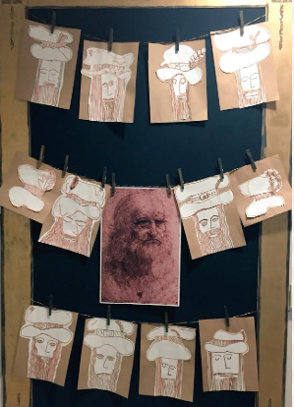 | To improve their mastery of art and design techniques including drawing with a range of materials.  To develop control of a variety of materials.  To master a variety of techniques within a drawing.  To shade showing light and shadow.  To apply a basic perspective.  Children should use a choice of techniques to depict movement, perspective, shadows and reflection. Choose a style of drawing suitable for the artwork impressionistic or realistic.  Media: sketching pencils,  Charcoal, chalk pastel, oil pastel  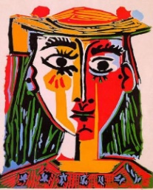  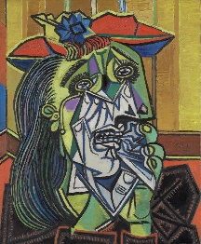
Artist knowledge linked to drawing and key vocabulary | Line | Artist: Raewyn Harris  To understand the artistic background of Raewyn Harris.  To know when and where she lived.  To be able to talk about the artwork she created.  Spiral  Line  Shape  Movement | Artist: Georgia O’keeffe  To understand the artistic background of Georgia O’Keeffe.  To know when and where she lived.  To be able to talk about the artwork she created.  Artist: Georges Seurat  To understand the artistic background of Georges Seurat.  To know when and where he lived.  To be able to talk about the artwork he created.  Line  Shape  Movement  Shade  Tone  Texture  Depth | Artist: Hector Gonzalez  To understand the artistic background of Hector Gonzales.  To know when and where he lived.  To be able to talk about the artwork he created.  Line  Shape  Movement  Shade  Tone  Texture  Depth | Artist: Vincent Van Gogh - Starry Night  To discuss how Van Gogh creates texture in his artwork.  To understand the artistic background of Vincent Van Gogh.  To know when and where he lived.  To be able to talk about the artwork he created.  Line  Shape  Movement  Shade  Tone  Texture  Depth | Artist: Leonardo da Vinci  https://drawpaintacademy.com/how-to-develop-your-own-unique-artistic-style/  To understand Leonardo Da Vinci as an artist.  To know when and where he lived.  To be able to talk about the artwork he created. .  Line  Shape  Movement  Shade  Tone  Texture  Depth  Cross hatching | Artist: Pablo Picasso  Children should research their chosen artist, find out about their life, their artistic history and discuss the artwork they have created.  Line  Shape  Movement  Shade  Tone  Texture  Depth  Cross hatching  Illusion
Painting | Explores making marks on a variety of papers.  Uses a variety of tools to spread paint such as, straws and matchsticks.  Explores mark-making using a range of brush sizes, foam and sponges.  Experiments with and enjoys colour and exploring colour changes.  Colour mixes with powder paint from primary colours.  Uses the correct painting sequence (water-sponge/brush-paint-palette).  Creates patterns using different tools and colours.  Uses colour and marks to express feelings.  Share their creations, explaining the process they have used.  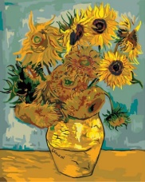  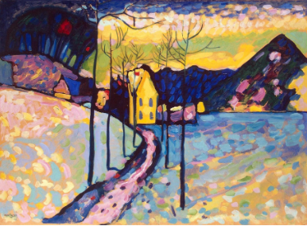 | To use painting to develop and share their ideas, experiences and imagination. To develop a wide range of art and design techniques in using colour, pattern, texture, line, shape and space.  To select a thick or thin brush for purpose.  To hold a brush correctly.  To practise a light stroke.  To understand the ratio of water to paint.  To mix two colours carefully.  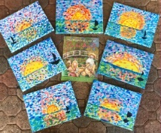  To explore different paint types such as water colour and ready mixed paint.  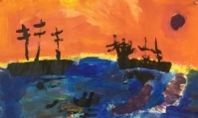 | Combine topics of printing and painting.  To use painting to develop and share their ideas, experiences and imagination. To develop a wide range of art and design techniques in using colour, pattern, texture, line, shape and space.  To select the correct amount of paint to mix.  To create a tint.  To create a tone.  To create a shade.  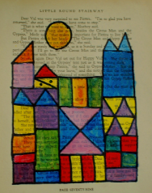  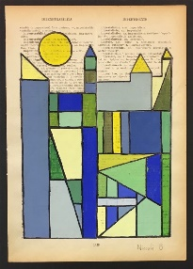 | To use painting to develop and share their ideas, experiences and imagination. To develop a wide range of art and design techniques in using colour, pattern, texture, line, shape and space.  To select brushes for specific use.  To understand the effects of warm and cool tones.  To mix proficiently with water and paint.  To use paintbrush in the same direction.  To create a background wash.  Useful links:  https://www.jacksonsart.com/blog/2014/09/23/simon-fletcher-watercolour-artist-interview/  https://www.bbc.co.uk/bitesize/guides/z3bqycw/revision/5  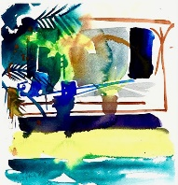  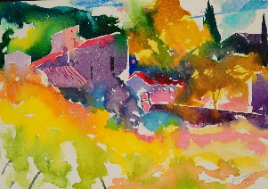 | To use painting to develop and share their ideas, experiences and imagination. To develop a wide range of art and design techniques in using colour, pattern, texture, line, shape and space.  Link back to drawing and starry night texture in artwork.  To identify texture within a painting.  To select tools to create texture.  To select the correct amount of paint.  Useful links:  https://www.tate.org.uk/kids/make/paint-draw/have-fun-textures  https://www.tate.org.uk/art/artworks/kandinsky-cossacks-n04948/how-paint-kandinsky  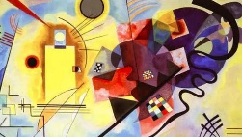  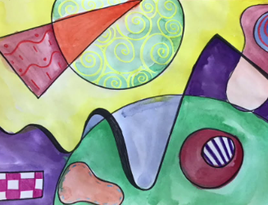 | To use painting to develop and share their ideas, experiences and imagination. To develop a wide range of art and design techniques in using colour, pattern, texture, line, shape and space.  The children should be taught why we need to use sketching before we begin painting. The children should view a range of artists and discuss them in depth. They should then practise painting in a number of styles of choose their favourite and explain why they prefer this.  To use sketching to form an outline.  To practise a variety of painting techniques.  Main piece idea:  Reverse Acetate Portraits  https://primaryschoolart.com/2022/01/17/reverse-acetate-portraits-year-5-6-art-lesson/  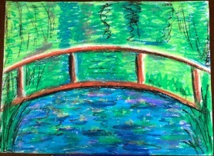  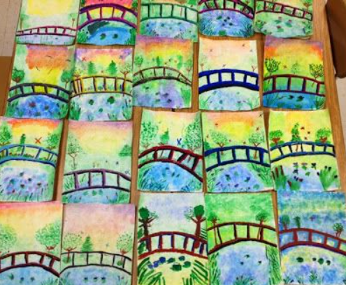 | Combine topics of printing and painting.  To use painting to develop and share their ideas, experiences and imagination. To develop a wide range of art and design techniques in using colour, pattern, texture, line, shape and space.  To uses different methods, techniques, tools and colour to express mood.  To uses with control primary and secondary colours with the addition of black and white and other hues.  To uses techniques, colours, tools and effects to represent something observed, remembered or imagined.  To explores the effect of light and colour, texture and tone on natural and made objects.  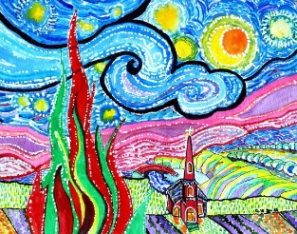  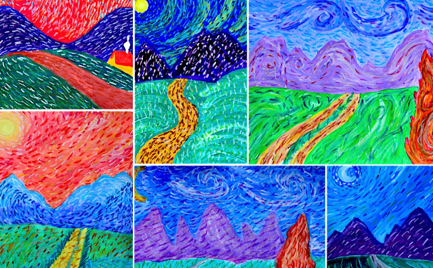
Artist knowledge linked to painting and key vocabulary | Artist: Kandinski (Winter trees)  Artist: Van Gogh (sunflowers)  Artist: Mattise (spring flowers)  Colour  Primary colours  Secondary colours  Thick  Thin  Mix  Feelings | Artist: Claude Monet (Sunrise)  To understand Claude Monet as an artist.  To know when and where he lived.  To be able to talk about the artwork he created.  Colour  Primary colours  Secondary colours  Thick  Thin  Mix | Artist: Paul Klee - colour theory  To understand Paul Klee as an artist.  To know when and where he lived.  To be able to talk about the artwork he created.  Colour  Primary colours  Secondary colours  Mix  Thick  Thin  Tints  Tones  Shades | Artist: Simon Fletcher  To understand Simon Fletcher as an artist.  To know when and where he lived.  To be able to talk about the artwork he created.  Colour  Primary colours  Secondary colours  Mix  Thick  Thin  Tints  Tones  Shades  Mood | Artist: Kandinsky  To understand Kandinsky as an artist.  To know when and where he lived.  To be able to talk about the artwork he created.  Colour  Primary colours  Secondary colours  Mix  Thick  Thin  Tints  Tones  Shades  Texture  Mood | Artist: Claude Monet(water lilies)  To discuss how Claude Monet creates texture in his artwork.  To understand the artistic background of Claude Monet.  To know when and where he lived.  To be able to talk about the artwork he created.  Colour  Primary colours  Secondary colours  Mix  Thick  Thin  Tints  Tones  Shades  Texture  Mood  Perspective | Artist: Vincent Van Gogh  To understand Vincent Van Gogh as an artist.  To know when and where he lived.  To be able to talk about the landscape artwork that he has created.  To discuss the mood that Van Gough portrays through the colours that he uses.  Colour  Primary colours  Secondary colours  Mix  Thick  Thin  Tints  Tones  Shades  Texture  Mood  Perspective  Hues
Printing | Random experimental printing using body parts, veg and materials.  Are exposed to a variety of prints and methods within the classroom.  Share their creations, explaining the process they have used. | Combine topics of Printing and Collage.  To develop a wide range of art and design techniques in using colour, pattern, texture, line, shape and space.  To understand the term printing.  To select a tool for printing  To hold the tool so it allows an image to be printed.  To understand that pressure needs to be applied.  To understand that moving the object when it is on the paper will cause the print/image to look differently.  To practise the rubbing, pressing, rolling and stamping movements. | Combine topics of printing and painting.  To develop a wide range of art and design techniques in using colour, pattern, texture, line, shape and space.  To select a tool for printing.  To apply the correct amount of paint to print - what happens when there is too much/less.  To apply the correct amount pressure.  To carefully lift and reapply paint to create an overlapping print.  To explore different printing techniques.  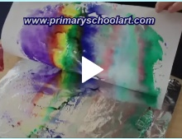  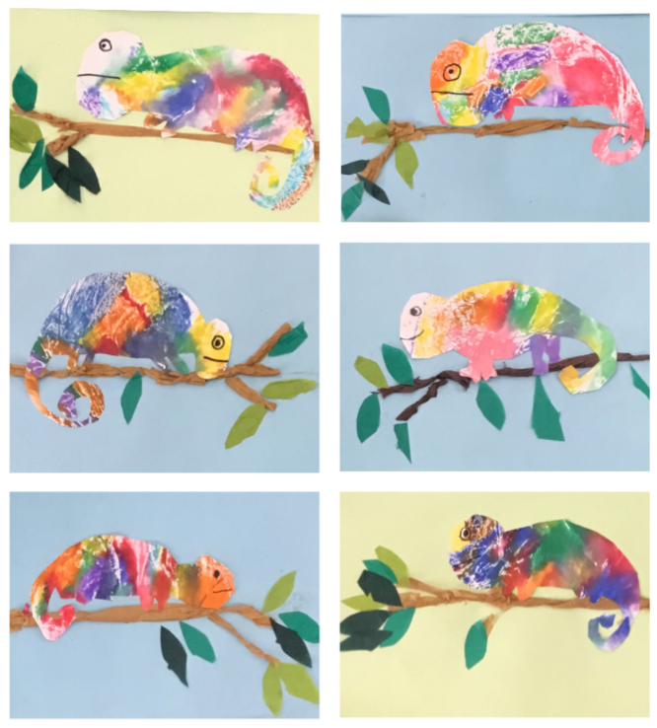  https://primaryschoolart.com/category/printing/ |  | To improve their mastery of art and design techniques.  To choose and explore tools for carving.  To carve out a pattern carefully.  To apply the correct amount of paint and pressure for printing.  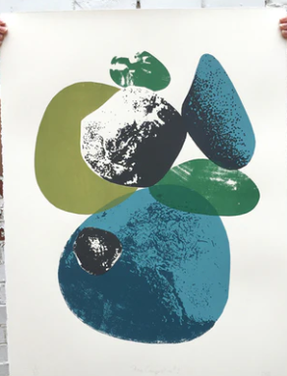 |  | Combine topics of printing and painting.  To improve their mastery of art and design techniques.  The children will learn about the historical importance of Lino printing. They will learn about the safety precautions when creating a Lino design and they will have the opportunity to practise this technique.  To identify and explain the different tools used for Lino printing.  To sketch lightly onto lino prior to carving.  To create a final design using lino printing.  Useful links:  https://www.boardingallrows.com/history-of-lino-printing-and-famous-linocut-artists  https://www.youtube.com/watch?v=h-lK2twnrBo  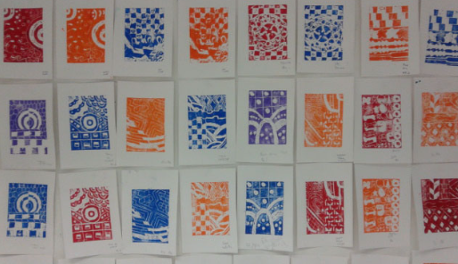
Artist knowledge linked to printing and key vocabulary |  | Artist: Henri Matisse (Violet leaf) create whole class piece.  To understand Henri Matisse as an artist.  To know when and where he lived.  To be able to talk about the artwork he created. | Artist: Andy Warhol.  To understand Andy Warhol as an artist.  To know when and where he lived.  To be able to talk about the artwork he created. |  | Artist: James Green  To understand James Green as an artist.  To understand his life.  To talk about the artwork that he has created.  Print  Push  Press  Roll  Stamp  Rub  Repeating pattern  Precise |  | Artist: Walter Inglis Anderson  To understand the history and method of Lino printing.  To understand Walter Inglis Anderson as an artist.  To understand his life.  To talk about the artwork he created.  Push  Press  Roll  Stamp  Rub  Repeating pattern  Precise  Carve
Collage | Safely use and explore a variety of materials, tools and techniques, experimenting with colour, design, texture, form and function.  Share their creations, explaining the process they have used.  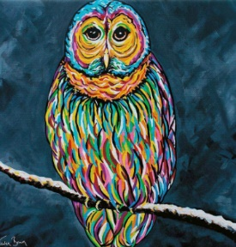  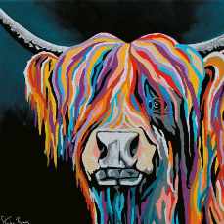 | Combine topics of printing and Collage for final piece.  To develop a wide range of art and design techniques using pattern and texture.  To cut using scissors correctly.  To tear paper for a purpose.  To be able to select the correct amount of glue and apply it to a material with care (not ripping the material).  To select and sort materials.  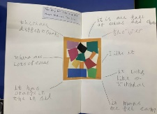  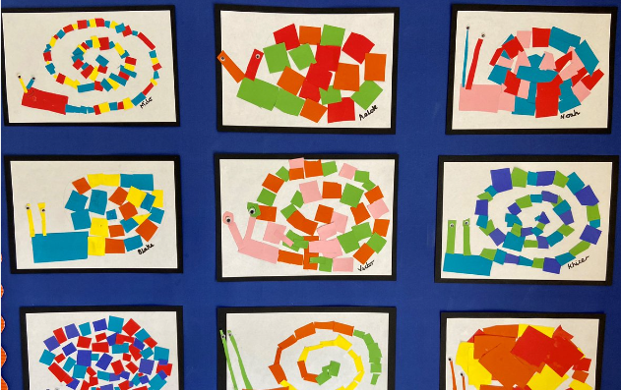 |  | To improve their mastery of a wide range of art and design techniques using pattern and texture to create collage.  To be able to cut, glue and stick accurately.  To practise the overlapping technique.  To practise the spiralling technique.  To suggest a background for a collage in the style of Ben Giles.  Useful videos:  https://www.youtube.com/watch?app=desktop&v=ceGvz3Nthwc  https://benlewisgiles.format.com/collage  https://www.youtube.com/watch?app=desktop&v=0hG-mgQPess  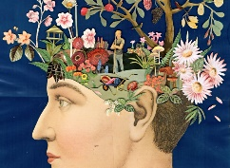  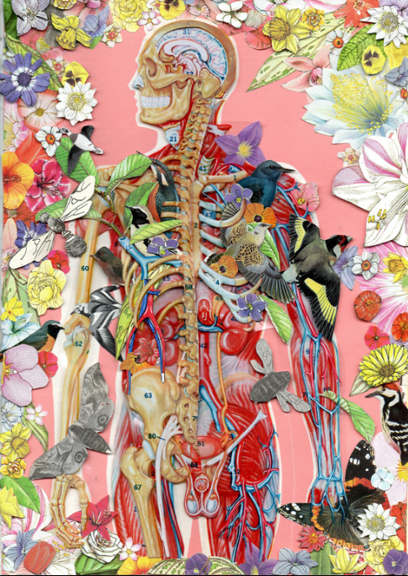 |  | To improve their mastery of a wide range of art and design techniques using pattern and texture to create collage.  The children should now be introduced to the term visual texture within a collage (you may want to recap how they created tactile texture).  https://www.youtube.com/watch?v=dTcAxdVj8Q4  To understand what texture is.  To understand tactile and visual qualities of a collage.  To recap different techniques in collage.  Useful links:  https://www.youtube.com/watch?app=desktop&v=UDnWByRzOQE  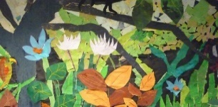  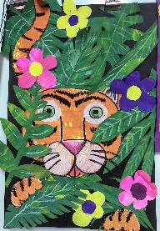
Artist knowledge linked to collage and key vocabulary | Artist: Steven Brown (collaborative work)  To talk about the artist and their background.  Colour  Tear  Cut  Join  Stick  Fold | Artist: Henri Matisse (The snail)  To understand Henri Matisse as an artist.  To know when and where he lived.  To be able to talk about the artwork he created.  Colour  Tear  Cut  Join  Stick  Fold  Collage  Arrange |  | Artist: Ben Giles  To understand Ben Giles as an artist.  To know when and where he lived.  To be able to talk about the artwork he created.  Colour  Tear  Cut  Join  Stick  Fold  Collage  Arrange  Bright  Dull |  | Artist: Henri Rosseau  https://www.tate.org.uk/whats-on/tate-modern/henri-rousseau-jungles-paris  To understand Henri Rosseau as an artist.  To know when and where he lived.  To be able to talk about the artwork he created.  Colour  Tear  Cut  Join  Stick  Fold  Collage  Arrange  Bright  Dull  Mosaic  Tessellation  Montage  Tactile texture  Visual texture
Sculpture | Handles, feels and manipulates rigid and malleable materials including playdough and clay.  Share their creations, explaining the process they have used. | To use sculpture to develop and share their ideas, experiences and imagination.  To develop a wide range of art and design techniques in using texture, shape and form.  Handle and manipulate a variety of materials to create sculpture.  To practise rolling, kneading and shaping.  To practise rolling paper to make a free-standing structure.  To understand how to attach two objects when making a sculpture.  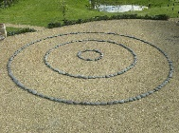  To make a line from plasticine or salt dough to create a sculpture.  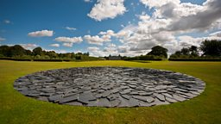  (Natural sculpture) |  | Link to Remembrance Day  To improve their mastery of art and design techniques including sculpture.  To create a shape from clay.  To join the shapes.  To understand how to use slip when joining pieces of clay.  To smooth out marks made on the clay.  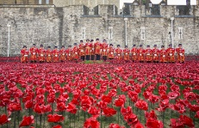  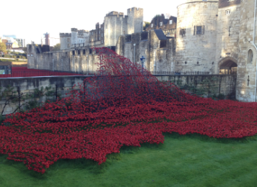  http://marcquinn.com/artworks/flower-sculptures |  |  | Taught in DT
Artist knowledge linked to sculpture and key vocabulary | Roll  Press  Squeeze  Pinch | Artist: Richard Long.  To understand Richard Long as an artist.  To know when and where he lived.  To be able to talk about the artwork he created.  Roll  Press  Squeeze  Pinch  Material  Continuous  Line |  | Artist: Paul Cummins and Tom Piper  Discuss wider historical, cultural impact of this art.  Artist: Marc Quinn.  To understand Marc Quinn as an artist.  To know when and where he lived.  To be able to talk about the artwork he created.  Roll  Press  Squeeze  Pinch  Material  Continuous  Line  Smooth  Join
Digital media |  |  |  |  |  |  | NOT COMPLETED. ISSUES AROUND DEVICES. COMPLETE AT A LATER DATE.
Artist knowledge linked to digital media and key vocabulary |  |  |  |  |  |  | 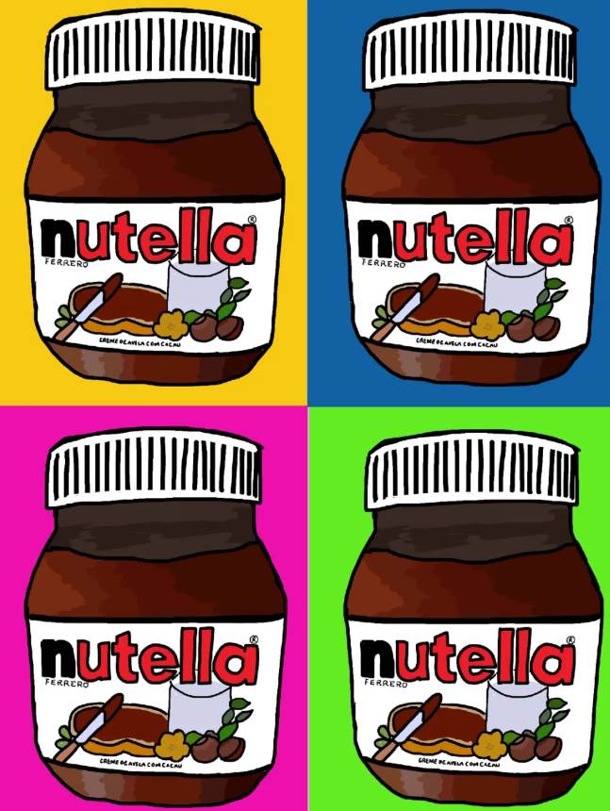

 | EYFS | Y1 | Y2 | Y3 | Y4 | Y5 | Y6
Drawing
Painting
Printing
Collage
Sculpture
Digital media

