Policy statement: Physical Education

This policy statement should not be read in isolation but in conjunction with all other school policies. Particular attention should be paid to the school’s aims, the behaviour policy, the equal opportunities policy and the health and safety policy.

Vision
At Sandal Castle Primary, we strive to offer all of our children extensive opportunities to participate and compete in a wide-range of activities throughout their school life and support them on their journey to achieving lifelong involvement in sport and physical activity. Physical Education (PE), School Sport and Physical Activity (PESSPA) are the key components of our commitment to delivering this aim. The Association for Physical Education (AfPE) define these terms as:

Physical Education
Physical education is the planned, progressive learning that takes place in school curriculum timetabled time and which is delivered to all pupils. This involves both ‘learning to move’ (i.e., becoming more physically competent) and ‘moving to learn’ (e.g., learning through movement, a range of skills and understandings beyond physical activity, such as co-operating with others). The context for the learning is physical activity, with children experiencing a broad range of activities, including sport and dance.

School Sport
School sport is the structured learning that takes place beyond the curriculum (i.e., in the extended curriculum) within school settings; this is sometimes referred to as out-of-school-hours learning. Again, the context for the learning is physical activity. The ‘school sport’ programme has the potential to develop and broaden the foundation learning that takes place in physical education. It also forms a vital link with ‘community sport and activity’.

Physical Activity
Physical activity is a broad term referring to all bodily movement that uses energy. It includes all forms of physical education, sports and dance activities. However, it is wider than this, as it also includes indoor and outdoor play, work-related activity, outdoor and adventurous activities, active travel (e.g., walking, cycling, rollerblading, scooting) and routine, habitual activities such as using the stairs, doing housework and gardening.

PESSPA provides children plentiful opportunities to demonstrate and embed our school rules, we always aim to: be safe, be respectful, be ready and be responsible.

At Sandal Castle Primary, our PE curriculum is progressive, inclusive and aims to develop the skills, abilities and confidence levels of all learners to provide them with the necessary qualities to proficiently participate in PE lessons at high school, encourage participation in activities outside of school and to hopefully form lifelong physically active habits. We use the PE Hub to plan and sequence our PE curriculum in order to teach our children how to develop their physical literacy and participate and compete in all areas of the PE curriculum including swimming, dance, gymnastics, invasion games, net/wall games and striking/fielding games. Our PE curriculum supports children in advancing their cognitive and social skills which are invaluable tools to leading a successful life. They learn to develop their resilience, self-esteem, empathy, decision-making, teamwork, leadership and communication.

We aim to provide our children with as many opportunities as possible to participate and compete in school sport throughout their time at Sandal Castle Primary. Intra-school opportunities are abundant in PE lessons, lunchtime activities and organised events such as tournaments and sports days. We help coordinate an extensive range of activities through the Kettlethorpe Pyramid of schools which gives our children plentiful opportunities to play sport against other schools in a supportive, fun, nurturing and competitive environment. Effort and success are rewarded in equal measure, we strive to promote positive attitudes towards demonstrating hard work, being physically active and competing through fair play.

Sandal Castle Primary aims to encourage physical activity at all times of the day to help drive the Active 30:30 initiative outlined by the Chief Medical Officers. Active 30:30 states that children should be active for 60 minutes a day with schools being responsible for delivering 30 of those active minutes. During their school life, we encourage our children to be physically active through: active travel to and from school; supporting them during lunchtimes and playtimes with the help of sports leaders and planned activities; physical education lessons; active breaks throughout the day; an extensive range of after-school activity clubs; intra and inter-school sports competitions and festivals; sports days; wrap-around care activities.

Curriculum Aims
Our progressive and sequential curriculum aims to provide high-quality PE lessons that inspire and support all pupils to succeed in competitive sport and other physically demanding activities. We highlight the importance of leading an active and healthy lifestyle and give children the knowledge and skills to do this.

EYFS and KS1
Our children are taught to:
- Master basic movements including running, jumping, throwing and catching as well as developing their agility, balance and coordination
- Begin to participate in team games and demonstrate and ability to attack and defend
- Perform dances and gymnastic routines with increasing control and fluidity.

KS2
Our children are taught to:
- Use fundamental movement skills more sport-specific skills in context
- Play competitive games with increased ability to attack and defend
- Develop flexibility, strength, technique and control
- Perform dances through a range of movement patterns

Swimming and Water Safety
Our children are taught to:
- Swim competently, confidently and proficiently over a distance of at least 25m
- Use a range of strokes effectively including front crawl, back crawl and breaststroke
- Perform safe self-rescue in different water-based situations

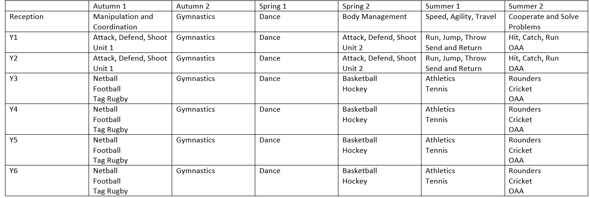
Teaching and Learning

Our children have two PE lessons a week, one indoor taught by class teachers and one outdoor taught by external coaches. During outdoor lessons, teachers accompany the coaches to share practice and develop their knowledge and skills when delivering PE lessons. Every child in KS2 accesses our on-site swimming pool for one term every year, where they receive one lesson every week.

Assessment
TBC

Resources and Equipment
It is the responsibility of all staff to ensure the safe storage and appropriate use of equipment whether this be for PE lessons, activity clubs, playtimes and lunchtimes, wrap-around care or otherwise. Any equipment used should be securely stored away properly after use. In the event of any equipment being lost/damaged, the member of staff responsible at the time should inform the PE lead in order to ensure proper maintenance of equipment.

PE Kit
Children are expected to arrive at school in their PE kit on their PE day. They require:
- Red t-shirt
- Black shorts/jogging bottoms (outdoor)
- Plain black zip-up hoody
- Black trainers
Swimming kit:
- Plain navy-blue trunks (not shorts)
- Plain navy-blue swimming costume
- Towel
- Hair brush and bobble (if necessary)

Long hair needs to be tied back for both swimming and PE. In accordance with the uniform policy, only one watch and one pair of stud earrings in pierced ears are allowed in school. All jewellery must be removed before partaking in PE and swimming lessons.

Health and Safety
All practices and procedures are in accordance with the health and safety policy and AfPE’s ‘Safe Practice: in Physical Education, School Sport and Physical Activity’.

